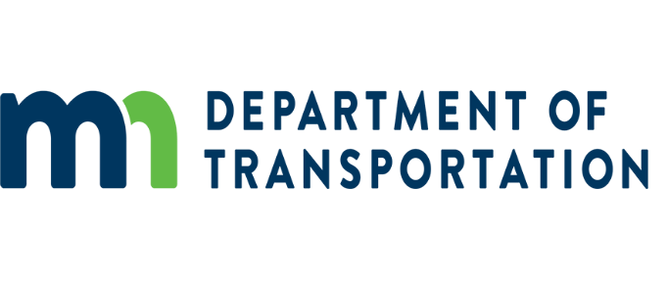

Audit of Office
395 John Ireland Blvd.
St. Paul, MN 55155

Dear Recipient:

In order for the MnDOT Office of Audit to perform a Pre-Award, we need the following items:
- Pre-Award Questionnaire – A brief set of questions regarding the most current company information.
- The most recent financial statements
- Sample of an Employee Timesheet
- Sample of an Employee Expense Report
- Fee Schedule and/or a Billing Rate Schedule, if applicable.
- Most recent Fiscal Years Overhead Rate Development workpapers. We have created a list of Common unallowable costs for your reference.
- Certification of Final Indirect Cost (Overhead) Rate
- If applicable, Cognizant and/or Acceptance letters from other State DOT’s regarding the most current fiscal years overhead rate.

If this Pre-Award is in response to an RFP, the following information will need to be submitted:
- A Cost Proposal. Please submit this in the Microsoft Excel format.

A Pre-Award is required for all sub-consultants listed in your cost proposal, if their costs are $10,000.00 or more; it is the Prime Consultant’s responsibility to coordinate their submittals.

The Pre-Award cannot be completed without all the information listed above. Missing information can delay the Pre-Award process therefore, it is important to provide all information for the Pre-Award at the time of submittal, including the sub-consultants information, if applicable.

If you have any questions regarding the Pre-Awards, please call Danielle Plocher at 651-366-4153.

Sincerely,

Danielle Plocher

Office of Audit
651-366-4153
Danielle.plocher@state.mn.us

