
Maintenance Research

Bulletin: July 2018

NTREC New Technology Research Equipment Committee
MOR Maintenance Operations Research

Upcoming Events

SPOT 2018
Camp Ripley, MN

Train the Trainer
Sept 12th -15th

Trainees / Session One
Sept 17th - 21st
&
Sept 24th - 28th

Trainees / Session Two
Oct 15th - 19th
&
Oct 22nd - 26th

MN Maintenance Fall Expo
St. Cloud, MN
October 3rd & 4th

Maintenance Research
Website:
http://www.dot.state.mn.us/maintenance/research.html

Comments / Questions
Maintenance Research Program Administrator
651/366-3585
Mindy Heinkel

Canycom SC75 Rubber Track Concrete Buggy with Pivot

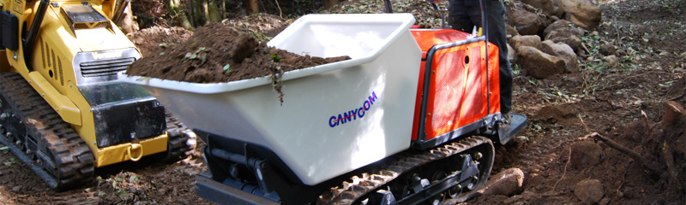

The CanycomSC75 Concrete Buggy is a motorized walk behind tracked concrete buggy. The project was submitted by Jason Miller from District 8. The intended use is to move rocks under bridge decks for slope protection next to abutments. It can also be used to remove concrete debris from inside box culverts.

Heavy duty rubber tracks offer balanced weight distribution to travel with ease over wet, muddy ground, rough, uneven terrain and loose sand and gravel. The SC75 concrete buggy outshines in efficiency and maneuverability compared to wheeled buggies. It has a dump bucket, an easy to operate control panel and a 90° dump angle.

The Canycom SC75 Rubber Track Concrete Buggy will be evaluated during the placement of new concrete flooring in a 5 x5 box culvert as well as slope repair on numerous bridges. This project will provide cost savings by not having to rent equipment. Safety is expected to be improved by using the tub for placement of riprap under bridges instead of doing it by hand.

For more information contact:
Jason Miller
Jason.miller@state.mn.us

