Snowplow Driver Assist System Implementation Pilot Program
System helps in low visibility conditions

Need
Snowplow operators often maintain Minnesota roads in the worst weather conditions, working to ensure safe travel for emergency services, motorists, and freight and transit communities. Heavy snow, blowing snow and fog often cause visibility to drop to near zero, creating problematic and even dangerous conditions for road maintenance tasks.

To lessen the effects of these issues, the Minnesota Department of Transportation, University of Minnesota and local government agencies in the state developed the Driver Assist System over a 15-year period. The DAS allows for safe plowing in zero visibility by projecting an image of the road and any road obstacles (e.g., guardrail, jersey barriers, stopped vehicles) in front of the operator on a monitor inside the cab of the plow. The system vibrates the operator's seat as a warning if the plow veers too close to the roadway's centerline or fog line (edge). The system also has a feature that allows the operator to disarm or deactivate this warning feature to clear snow from the shoulder without continuously receiving a fog line crossing warning.
Since 1998, DAS technology has been tried and continues to be used in several areas. It has proven its effectiveness in areas with chronic poor visibility as well as on snow-covered roads where lane markings are obscured. The system requires precise road network data to function correctly and reliably; the most critical data is the accurate location of the road centerline. The centerline is especially important on two-lane roads since maintaining safe operating conditions is challenging with oncoming traffic.
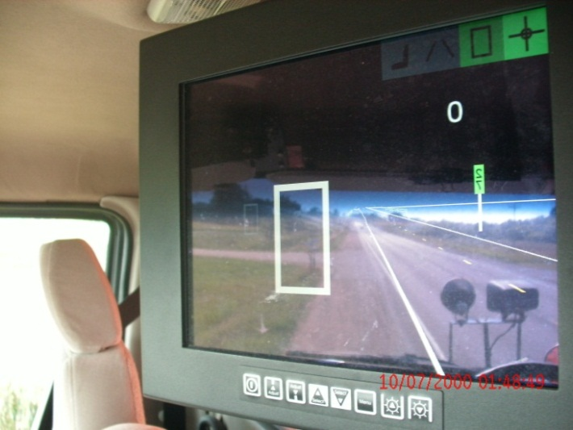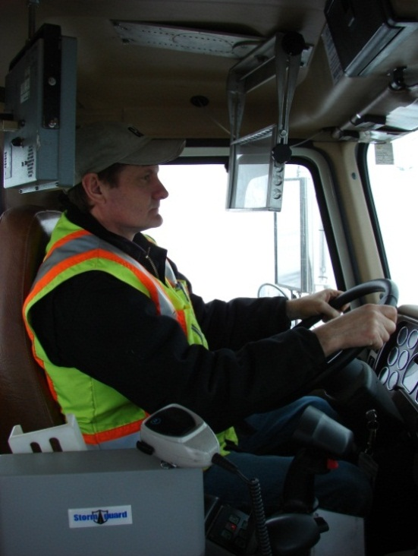
Figure caption (include alt text in image)

Goal

This project initially sought to implement and test the DAS in MnDOT’s District 7, which covers southwestern Minnesota The pilot included research to determine a cost efficient and practical method to collect the data needed to generate the system's maps. It also included creating a maintenance protocol for updating the data following roadway changes. The long-term goal is to implement the DAS statewide using state and local government data.

Method

A GPS-equipped vehicle drove selected roads in District 7 to collect centerline data. Researchers processed the resulting information to calculate locations of lane boundaries, guardrail and reference posts, and created geospatial data with an estimated accuracy of 8 to14 centimeters (3.5 to 5 inches).

MnDOT installed the DAS and processed geospatial data on one snowplow in District 7 to evaluate the system’s performance. The DAS platform resides on the same computer in the plow that contains the Automatic Vehicle Location system, thus reducing hardware costs and space usage in the snowplow cab. Additionally, the DAS uses the AVL’s bandwidth and data collectively to allow the GPS module to collect location data needed to project the plow’s position on the mapping display.
Researchers tested data integrity, response time from truck to data source and back, effectiveness of the computer screen readability and position, as well as the durability of the hardware. Plow operators also provided feedback on the system via a survey. MnDOT is currently evaluating the responses to the Minnesota State University – Mankato survey.
The manual data collection method used in this project would require too much time, labor and expense to use on a larger scale. Researchers therefore compared the data collected in this project with other MnDOT and local government geospatial data sources, and developed a decision matrix to identify which sources meet business needs for providing compatible formatted road data statewide in the future.

Results
Tests of the DAS demonstrated its potential to make plowing in low-visibility conditions safer and easier.
The Minnesota State University survey of the six snowplow drivers who tested the DAS indicated approval of the DAS features, including seat vibration warning if the plow goes off course. Respondents generally felt comfortable with the system and indicated that the training process was valuable to their understanding of the system’s functionality. Snowplow drivers expressed concern, however, about system reliability.
Although the relatively labor-intensive manual method of processing road data used in the project was not ideal for statewide usage, researchers identified existing and planned data sources. Existing sources include as-built survey data, while planned sources include requirements and protocols necessary and suitable for the future implementation of DAS. .
Preliminary findings point to the fact that the process of GPS data capture and the use of an automated ETL (extract/ transform/ load) process is the most efficient method of data acquisition for high accuracy data (due to ease of collection and repeatable processes). It also is the most cost effective because data capture uses low-cost equipment and few staff resources to collect and process data.

Next steps
Researchers discovered minor technical issues with the DAS equipment and workflow that must be corrected. New GPS receivers are being tested to determine whether the receivers can provide adequate data quality and accuracy to meet multiple business system needs. Researchers plan to evaluate both survey data and GPS data capture to determine their utility for DAS and other applications and databases. Further efforts will be aimed at reducing the DAS cost and developing a data maintenance protocol to ensure that future geospatial data meets the accuracy and business needs of MnDOT, local government and other statewide agencies.
A practical and repeatable protocol containing standardized processes will make data compatible and accessible to other projects throughout the state. The protocol will be informed by the business and data requirements necessary for comprehensive data use and integration across systems, departments, agencies and organizations that may use the data, including the DAS. The protocol will be comprised of interoperable data strategies, configurable tools and authoritative data sources.
Successfully identifying geospatial data sources and a maintenance protocol will pave the way for statewide implementation of the DAS and similar types of applications. In addition, MnDOT and local government agencies will further benefit from the development and acquisition of standardized, accurate data through integration of the data with related systems, including alignment with the land records systems.
An ongoing protocol will be developed to acquire or develop, and maintain the geospatial data sources for statewide use, aligning with the MnDOT Linear Referencing System.

For More Information
Or contact: Clark Moe, 651-366-3545, clark.moe@state.mn.us

