Mn/DOT Metro District

2005 NPDES MS4 Annual Report

for

MPCA General Permit MN R 040000



Prepared by:
Minnesota Department of Transportation
Metro District
1500 West County Road B2
Roseville, MN 55113

Prepared for:
Minnesota Pollution Control Agency
520 Lafayette Road North
St. Paul, MN 55155-4914

Table of Contents
Introduction 3
BMP 1: Storm Water Pollution Prevention Program Annual Report 4
BMP 2: Annual Public Meeting 5
BMP 3: Public Comment Management 6
BMP 4: Storm Water Informational Displays 7
BMP 5: Storm Water Web Page 9
BMP 6: Illicit Discharge and Outfall Inspections 10
BMP 7: Illicit Discharge and Outfall Reporting 13
BMP 8: Storm Sewer System Inventory Map 14
BMP 9: Illicit Discharge and Outfall Inspection Training 16
BMP 10: Non-Storm Water Discharges 17
BMP 11: Erosion / Sediment Control Certification Programs 18
BMP 12: Construction Site Plan Review 19
BMP 13: Contract Provisions 20
BMP 14: NPDES Construction Permit Program 22
BMP 15: Construction Complaint Management 24
BMP 16: Historic and Archeological and Threatened and Endangered Species Review 26
BMP 17: Environmental Review 28
BMP18: Post Construction Regulatory Mechanism 30
BMP 19: Routine Maintenance Activities 31
BMP 20: Routine Structural BMP Inspections 33
BMP 21: Routine Maintenance Inspection Program Review 34
BMP 22: Vegetation Management Program 35
BMP 23: Industrial Facility Storm Water Plans 36
BMP 25: Anti-icing/Deicing Program 38
Appendices 39
Appendix A 40
Appendix B 42
Appendix C 43
Table 1: WRE 2006-2009 Tentative Project List 44
Figure 1: 2005 Inventoried Areas 46
Figure 2: Metro Hydraulic Structure Inventory and Networks 47
Figure 3: Metro Inventory 48
Figure 4: Poor to Failing Storm Sewer 49
Figure 5: Standard Operating Procedure Form for Tunnel Washing 50
Appendix D 51

Introduction
The following summaries are for the 25 Best Management Practices (BMP’s) which comprise the NPDES Storm Water Pollution Prevention Program (SWPPP) for the Minnesota Department of Transportation (Mn/DOT) Metro District. They summarize the activities for 2005 and also include anticipated 2006 activities.

Each BMP is assigned a Responsible Person who is in charge of BMP implementation, tracking and reporting the activities which have taken place each year. The following summaries were composed and approved by these Responsible Persons. (Appendix A lists the 25 BMP’s.)

Each BMP summary is in the following format:
- Title
- BMP Description
- 2005 Measurable Goals
- 2005 Accomplishments
- 2006 Anticipated Activities

Changes to the current 25 BMP’s are occurring per the new NPDES MS4 permit requirements. All current BMP’s have been examined and are in the process of being re-organized into the new BMP summary format required by the MPCA. All pertinent information, requirements, measurable goals and contact information will be transferred into the updated BMP’s. Mn/DOT Metro’s current SWPPP will then be updated with these BMP’s. The SWPPP will be submitted to the MPCA by June 1, 2006 and will be available for public review once approved. The 2006 Annual Report will be based on the updated BMP’s.
BMP 1: Storm Water Pollution Prevention Program Annual Report

BMP Description
Summaries of each BMP’s activities and accomplishments will be collected and a document will be prepared which is the Annual Report.

2005 Measurable Goals
- Prepare a draft SWPPP Annual Report
- Gather and Address pertinent public comments
- Submit the Annual Report to the MPCA

2005 Accomplishments
Mn/DOT Metro completed the draft 2005 SWPPP Annual Report in March. After the Annual Meeting in April, pertinent public comments and internal comments were added and a final Annual Report was submitted to the MPCA before June 30, 2006.

2006 Anticipated Activities
After the submission of the 2005 Annual Report the reporting process will be reviewed and changes will be made during 2006. The 2006 Annual Reporting process will begin in January 2007.
BMP 2: Annual Public Meeting

BMP Description
Notify the public and hold an annual meeting on the SWPPP Annual Report.

2005 Measurable Goals
- Update MS4 Mailing List
- Mail Annual Meeting Notice to those on the MS4 Mailing List at least 30 days prior to Annual Meeting
- Publish Annual Meeting Notice in Newspaper at least 30 days prior to Annual Meeting

2005 Accomplishments
The MS4 Mailing List was updated in January 2006. The notice for the Annual Meeting was published in the St. Paul Pioneer Press on March 6, 2006. The notice was then sent to those on the MS4 Mailing list on March 14, 2006. The Annual Meeting took place on April 11, 2006 at Metro’s headquarters from 3:30-6pm.

2006 Anticipated Activities
Mn/DOT Metro will continue to hold the Annual Meeting, perhaps in conjunction with other MS4’s next year.
BMP 3: Public Comment Management

BMP Description
Establish and maintain procedures for managing public comments on the SWPPP and the SWPPP Annual Report.

2005 Measurable Goals
- Establish and implement procedures for managing comments from the public on the MS4 SWPPP and Annual Report

2005 Accomplishments
Comments were collected at the Annual Meeting. Comment cards were available for participants to make written comments. Oral comments were taken by Mn/DOT Metro MS4 staff.

2006 Anticipated Activities
Continue to collect verbal and written comments from the public.
BMP 4: Storm Water Informational Displays

BMP Description
Develop storm water educational displays to inform the general public of common storm water pollution sources and what can be done to prevent them. Present the display in appropriate forums (schools, state fair, traveler information centers, etc.).

2005 Measurable Goals
- Develop display(s) by 2005.
- Track and report the number, type and location of displays.
2005 Accomplishments
Metro district has developed a storm water display, which features information about Metro’s compliance manual BMP’s and their relation to the six minimum control measures. The display also features several pictures of appropriate and non-appropriate erosion control measures as well as a map of the MS4 areas within Metro and the TMDL impaired waters. This display has been used at several events and this surpasses our 2006 start time proposed in the SWPPP. Listed below are the events in which Metro District showed our MS4 Storm Water Display:
Event | Location | Date | Attendees
Highway 610 Open House | Maple Grove Government Center | January 11, 2005 | Approximately 35
Presentation to Wildwood Lions Club | Picadilly Restaurant, Willernie | February 3, 2005 | Approximately 50
Storm Water Pollution Prevention Plan Public Open House | Waters Edge, 1500 W. County Road B-2, Roseville | March 16, 2005 | Approximately 5
Inver Grove Heights Safety Fair | I.G.H. Armory 80th Street, Inver Grove Heights | April 7, 2005 | Approximately 300
2005 Wakota Project Construction Open Houses | Newport City Hall, 596 7th Ave., Newport | April 20, 2005 | Approximately 70
2005 Wakota Project Construction Open Houses | St. Paul Park City Hall, 600 Portland Ave., St. Paul Park | April 27, 2005 | Approximately 60
2005 Water Fest sponsored by the Ramsey-Washington Metro Watershed District | Phalen Park, St. Paul | May 21, 2005 | Approximately 250
Highway 65/242 Environmental Assessment Open House | Blaine City Hall | April 28, 2006 | Approximately 10
I-694 E to W Open House | Marsden Meeting Room, Arden Hills | August 18, 2005 | Approximately 30
Highway 212 Open Houses | Chaska | August 2, 2006 | Approximately 100
Highway 212 Open Houses | Chanhassen | August 3, 2006 | Approximately 150
Highway 212 Open Houses | Eden Prairie | August 4, 2006 | Approximately 90
N/A | Ramsey County Public Works, | August 19, 2006 | Approximately 40
Project Design and Visual Quality Open Houses for the St. Croix River Project | Stillwater Senior High School | Sept. 14 | Approximately 350
 | Houlton Elementary School | Sept. 15 | Approximately 480
2006 Anticipated Activities
Metro will continue to update and present the information display for the MS4 annual public meeting as well as other public outreach events through out the year.
BMP 5: Storm Water Web Page

BMP Description
Develop a web page to inform the public on the Mn/DOT Metro Storm Water Pollution Prevention Program and provide general storm water awareness.

2005 Measurable Goals
Track and report annual visitation to the web page.

2005 Accomplishments
Metro created the website http://www.dot.state.mn.us/metro/waterresources/index.html in 2004/05 and was activated January 31, 2005. The website provides information on Metro’s MS4 Permit, the NPDES Permit, annual meeting information, contact information and provides links to other informational websites. The annual report will also be available on the website for comments and the web address will be given within the public notice. The table below lists the number of visitors for 2005.

Monthly history
Month | Unique visitors | Number of visits | Pages | Hits | Bandwidth
Jan 2005 | 0 | 0 | 0 | 0 | 0
Feb 2005 | 0 | 0 | 0 | 0 | 0
Mar 2005 | 115 | 204 | 642 | 2337 | 62.72 MB
Apr 2005 | 74 | 117 | 290 | 928 | 24.33 MB
May 2005 | 61 | 109 | 344 | 1044 | 25.52 MB
Jun 2005 | 58 | 81 | 166 | 601 | 58.64 MB
Jul 2005 | 47 | 67 | 104 | 328 | 51.73 MB
Aug 2005 | 60 | 82 | 159 | 512 | 41.90 MB
Sep 2005 | 63 | 97 | 225 | 663 | 97.01 MB
Oct 2005 | 87 | 144 | 307 | 818 | 138.19 MB
Nov 2005 | 78 | 113 | 174 | 586 | 81.39 MB
Dec 2005 | 67 | 98 | 172 | 504 | 109.37 MB
Total | 710 | 1112 | 2583 | 8321 | 690.80 MB

2006 Anticipated Activities
Metro will continue to update the website as needed as well as adding more links and educational information. The number of visitors will be tracked annually.
BMP 6: Illicit Discharge and Outfall Inspections

BMP Description
Modify existing procedures and design new procedures for the implementation of an outfall and illicit discharge inspection program within Metro right-of-way, to include coordinating efforts with volunteer groups or other governmental entities programs.

2005 Measurable Goals
- Continued with inventory and inspection schedule
- Tracked and reported results within the document management system
- Identified outfall and structural failures and followed up with the appropriate corrective actions
- Conducted maintenance projects at those sites identified as high priority
- Trained inspection crews
- Updated data management system

2005 Accomplishments
Metro WRE conducts rotational inspections on the drainage system within Mn/DOT’s right-of-way. Currently the storm water discharge outfall inspections are performed in coordination with all other hydraulic inspections. The inspection program documents surface and subsurface hydraulic features associated with Metro’s roadway by the use of Global Position System (GPS) and remote control pipe televising. Metro’s surface inspection team consists of (2-4) trained inspectors, while the subsurface inspections are primarily contracted out to consultant firms. Figure #1, Appendix C, depicts areas inventoried in 2005.

The current inventory & inspection data management system is based on a Statewide Mn/DOT Oracle database structure referred to as Hydinfra. The input of existing and new data is continually fed into this database system. Collected data is tracked and edited providing Metro with the ability to manage the infrastructure system to meet the MS4 permit requirements. Metro will continue to work towards the identification of the entire hydraulic infrastructure under jurisdictional authority, including the identification of MS4 outfalls. Currently about 75% of Metro’s system has been inventoried.

Infrastructure that rated poorly during the 2004 inspection season was repaired in 2005. These structures shall be inspected again in 2006 to insure that other problems do not exist. Structural failures that either had an immediate or potential impact to the vehicular traffic or effects to the environment were brought to the supervisor’s attention and then corrected within an appropriate time frame. Figure #4, Appendix C, is a map of known structure and pipes rated in poor or failed condition has been established. This map is being used to coordinate future repair projects. A tentative list based on field inspection and Hydinfra data has also been established for 2006-2009 fiscal years; see Appendix C, Table 1.

Surface and subsurface inspection personnel were certified and continually trained to meet the existing data management system protocols. GPS and inspection training occurs in the spring of each year. The data management systems have undergone some changes at the end of 2005. These changes included: new parameters on tracking and inventorying ponds, SPCDS, pipes, special structures, hydraulic structures, ditches and illicit discharges.

Coordination with MS4s that have infrastructure adjacent to, or within, Mn/DOT’s MS4 commenced in 2005 and included the City of Minneapolis and the City of Brooklyn of Park. Additional coordination with other MS4s will continue in 2006.

2005 Inspections*
 | Rated ‘0’  ‘Plugged’ | Rated ‘1’  Good | Rated ‘2’  Fair | Rated ‘3’  Poor | Rated ‘4’  Failed | Total
Special Structures | 77 | 579 | 1816 | 201 | 100 | 2773
Pipes | 58 | 360 | 1281 | 142 | 56 | 1897
Hydraulic Structures | 13 | 269 | 1100 | 31 | 5 | 1418
 |  |  |  |  |  | 6088
*Not all numbers listed are new entries, most are re-inspections.

Total Metro Inventory / Inspections
 | Rated ‘0’ Plugged | Rated ‘1’  Good | Rated ‘2’  Fair | Rated ‘3’  Poor | Rated ‘4’ Failed | Total
Special Structures | 799 | 2231 | 11641 | 2493 | 839 | 18003
Pipes | 383 | 2856 | 9180 | 2577 | 813 | 15809
Hydraulic Structures | 131 | 3448 | 11549 | 1337 | 278 | 16743
 |  |  |  |  | Not Rated* | 7381
 |  |  |  |  | Metro Total | 57936
*Not Rated – the special structure, pipe or hydraulic structure could not be physically seen to be given a rating, but was able to be located and inventoried; i.e. a pipe connecting two catch basins together or a special structure under water. Definitions:
Special Structure is what is located at the end of a culvert (flared apron, head wall/ wing wall, etc.); Hydraulic Structure is considered to be an enclosed structure such as a manhole, catch basin, drop inlet, etc.).

2006 Anticipated Activities
- Continue coordination with adjacent MS4’s to share available mapping data relating to inflows and outfalls.
- Continue with the inspection and data management program.
- Continue mapping development of Metro’s infrastructure system.
- Correct infrastructure related failures that are associated with the MS4 permit.
- Complete the Illicit Discharge Video and corresponding incident tracking and reporting sheets.
BMP 7: Illicit Discharge and Outfall Reporting

BMP Description
Modify existing processes and implement new methodologies to manage outfall inspection and illicit discharge reports, including the tracking of discharge resolution.

2005 Measurable Goals
- Reviewed and updated illicit discharge and outfall inspection / reporting data management and procedures
- Establish a central reporting contact for illicit discharge

2005 Accomplishments
The internal central reporting contact for illicit discharges is the Metro District Maintenance Dispatch Center at 651-582-1550.

In 2005, one illicit discharge was reported which was located within the Lakeville sub-area. As a culvert was being cleaned, an oily residue was noticed and traced back to a convenience store / car wash / mechanic’s shop. The storm sewer grate within this owner’s property had evidence of oil being poured onto it. After finding the illicit discharge, the MPCA was contacted. The MPCA interviewed the property owner and discovered that illegal actions had taken place on the property as well as accidental spills of oil which were washed down the drain. After the initial investigation by the MPCA, the Dakota Department of Health carried out the enforcement actions with property owner.

The existing data management structure is continually improving to accommodate all of the MS4 Permit related items such as inspection/inventory of ponds, illicit discharges, outfalls/infalls, ditches and SPCDs. A new Hydinfra data library was given trial status in the fall of 2005 and will be the new Mn/DOT data management system for inventory and inspections for 2006.

2006 Anticipated Activities
- Continue coordination with adjacent MS4’s to share available mapping data relating to inflows and outfalls.
- Continue with the inspection and data management program.
- Continue developing Metro’s infrastructure system.
- Develop a more effective and efficient data management system for subsurface inspection for 2006.
- Correct infrastructure related failures that are associated with the MS4 permit
- Complete the Illicit Discharge video and corresponding incident tracking and reporting sheets.

BMP 8: Storm Sewer System Inventory Map

BMP Description
Develop a Metro storm sewer system inventory map by June 30, 2008 and periodically update the map to keep it current.

2005 Measurable Goals
The 2005 measurable goals for BMP 8 were as follows:

- Develop and implement a process to locate Metro area ponds and sediment basins and display them on the storm system inventory map.

2005 Accomplishments – Meeting Measurable Goals
BMP #6 describes details of inventory and inspection activities conducted in 2005. The 2005 areas inventoried are shown in Appendix C, Figure #1.

Figure #2, Appendix C, titled Metro Hydraulic Structure Inventory and Networks example presents all of the general conditions for all of the known features in the metro area. This map illustrates an example of the information that is collected throughout the entire area. Data for this map was gathered from internal Mn/DOT sources only, including the HydInfra database, pond shape files, aerial photo library and some Mn/DOT construction plan sheets. Not all of the roadway segments have the same level of detail inventoried to date.

Figure #3, Appendix C, titled Metro Inventory Years, depicts the years in which road segments were inventoried. The map depicts three groups including Not Inspected, 1998-2001 and 2002-2005. The years were grouped together based on age of inspections. Since WRE rotates their inspection schedule, it was decided that anything older than 2002 (4 years) would need re-inspection. Inspection schedules for 2006 will be gathered from inspected areas older than 2002 and those which have not been inspected. Some inspection schedules have also been set-up to follow Metro’s Mill and Overlay project scoping schedules for future years.

The HydInfra database stores a multitude of drainage features and characteristics of those features. Standard collection forms have been prepared to facilitate the reporting of these datasets.

The number of Mn/DOT Metro ponds is currently known to be 348. This number represents ponds that have been located and verified in a Mn/DOT Design Plan. Known sediment basins also are being located and added to the inventory. The features in the inventory are being located and inventoried in a process that involves a variety of data sources, and are ultimately verified by drainage plans. They are currently stored as point data in shape file. Additional features that are identified during on-going storm sewer inventory will be incorporated. To date, wetlands have not been inventoried as part of the inventory process.

Development of an Internet Mapping Service on the internet will allow access to, and viewing of, Mn/DOT storm sewer inventory data in real time by the general public. The Internet Mapping Service is being developed, and the posting of ponds to this Mapping Service will serve as the first piece of the storm sewer inventory map. Other pieces of storm sewer infrastructure will follow.

HydInfra structural pollution control devices (SPCDs) data was queried in 2004 to identify these structures and create an inventory for mapping and inspection purposes. SPCDs in HydInfra are identified as grit chambers. All structures in HydInfra that were flagged as grit chambers were checked and a list was developed. A Metro-wide, systematic process of locating, verifying, and mapping additional SPCDs is expected to be developed in 2006.

A video library is in the process of being created. This library is stored on a WRE server and contains all the video from past consultant video inspects. Once all the video is loaded and organized, a video map will be created with hyperlinks will be created so that WRE personal can pull up video when connected to the video map.

Coordination with MS4s that have infrastructure adjacent to, or within, Mn/DOT’s MS4 included the Cities of Minneapolis, Brooklyn Park and Bloomington commenced in 2005 and additional coordination with other MS4s will continue on a continuing basis.

2006 Anticipated Activities
- Continue identifying ponds and sediment basins and adding them to the database.

- Upload versions of the pond shape file to the Internet Mapping Service as more complete versions become available.

- Continue to coordinate with adjacent MS4s to share available mapping data relating to inflows and outfalls.

- Develop a systematic, Metro-wide process and procedure to examine all possible data sources for SPCDs. This will likely include examination of Hydrinfra, interviews with Maintenance and Water Resources personnel, review of construction bid letting abstracts and examination of design plans. Addition of verified SPCD’s to the database will then occur.

- Develop procedures for adding new storm sewer to the map. Construction project files and plans will be reviewed on an as let basis. New drainage features will be inspected, mapped and incorporated into the storm sewer system map based on the aging schedule as discussed in BMP #6.

BMP 9: Illicit Discharge and Outfall Inspection Training

BMP Description
Train Water Resources Engineering and Maintenance staff to perform outfall inspections and identify and report potential illicit discharges.

2005 Measurable Goals
- Conduct annual storm water training that includes how to perform outfall inspections and identify illicit discharges.
- Ensure all Maintenance and Water Resources staff is properly trained.
- Reduce number of illicit discharges in each subsequent permit year.
- Receive useful feedback from course attendees

2005 Accomplishments
Metro Human Resources met with Water Resources and Maintenance in 2005 to outline specific requirements for developing a training program and identifying a funding source for a training video. Training for illicit discharge and outfall inspection will be achieved through the use of an Illicit Discharge and Inspection video. The video will be shown at Metro District’s new employee orientation and annually for Metro Maintenance, WRE and other pertinent employees/volunteers.

2006 Anticipated Activities
The following tasks were identified as the basis for training appropriate Metro employees in 2006:
- A vendor has been selected to develop a training video and educational material on illicit discharge.
- Central Office (CO) Hydraulics has developed training to include outfall inspection. Training on “Prequalification Video Inspections of Pipes” will be delivered to Water Resources, consultants and Maintenance staff in spring 2006.
- Train identified audiences (e.g. Metro WRE staff, Metro Maintenance and others) to meet BMP 9 objectives.
- Partner with Metro Safety to include the general overview training as a component of Metro District’s new employee orientation.
BMP 10: Non-Storm Water Discharges

BMP Description
Evaluate Metro’s non-storm water discharges from maintenance activities as a potential source of pollutants and address those that are significant.

2005 Measurable Goals
- Evaluate tunnel-cleaning operations and determine trigger mechanisms to move to item two below by 2005.
- If tunnel-cleaning operations are determined to require BMP’s, then develop a Standard Operating Procedure (SOP) and corresponding BMP’s to reduce pollution from tunnel cleaning by 2006.

2005 Accomplishments
In 2004 a consultant was hired to determine if current tunnel-cleaning operations were sufficient as per permit recommendations. Internal and external observations of the tunnel-cleaning processes occurred and did not produce any feedback. As per recommendation a Standard Operating Procedure (SOP) was created (see figure #5) and is currently in use.

Metro’s seven tunnels were cleaned in 2005 once in April and once in September. Certified tunnel operators are used during the cleaning process and the SOP is filled out per tunnel.

Besides tunnel cleaning operations, Metro District has a variety of spills which occur on its roadways. In 2005, there were 16 incidents where non-storm water could have discharged into our storm sewer system. Prevention of spills getting into the storm sewer is one of the top priorities of clean-up crews. Due to this, very little, to no, non-storm water discharges from spills occurred in 2005.

2006 Anticipated Activities
Metro will continue to adhere to the SOP and update tunnel-cleaning operations as needed. Tracking other non-storm water discharges will continue to occur.
BMP 11: Erosion / Sediment Control Certification Programs

BMP Description
Continue to coordinate with the University of Minnesota to implement the Erosion / Sediment Control Certification Program.

2005 Measurable Goals
- Continue to coordinate with the University of Minnesota to implement the Erosion / Sediment Control Certification Programs; including instruction, exams and certification.

2005 Accomplishments
Erosion / Sediment Control classes were offered through a partnership between the University of Minnesota and MN/DOT. See table #1 below which lists names of classes, locations, dates and number of attendees. Table #2 depicts current Mn/DOT Construction employees that are certified in erosion / sediment control per Resident Engineer.

Table #1
*** NEED TO GET LIST OF CLASSES FOR EROSION / SEDIMENT CONTROL – INCLUDE EVENT NAME, START DATE, CITY AND # OF ATTENDEES****

Table #2 – Current Certified Mn/DOT Construction Employees
Resident Engineer | Certifications | Revocations
Michael Beer | 19 | 0
Steve Kordosky
Steve Barrett | 22 | 0
Dan Penn | 30 | 0
Elizabeth Benjamin
Jon Chiglo | 9 | 0
Kevin Anderson | 3 | 0

2006 Anticipated Activities
Coordination with the University of Minnesota Erosion / Sediment Control Program will continue to occur.
BMP 12: Construction Site Plan Review

BMP Description
Hold construction coordination meetings and include water quality components in written plans, inspections, meeting agendas, etc.

2005 Measurable Goals
- Hold construction coordination meetings.
- Review inspection forms and amend to include water quality (sediment and erosion control) components, if necessary, by 2005.
- Review standard construction specifications and revise to include water quality (sediment and erosion control) components, if necessary, by 2005.

2005 Accomplishments
Pre-construction meetings as well as weekly meeting are a standard procedure within Mn/DOT. Erosion and sediment control are either discussed at the pre-construction meetings or during the weekly meeting with the Metro Construction Project Engineer. Erosion and sediment control plans are an essential part of the site plan review process. The site plans, including the erosion and sediment control plans, are reviewed on a routine basis on construction sites and during weekly meetings. See table below depicting the type and amount of meetings, pertaining to erosion control, which have taken place within the 2005 construction season.

Resident Engineer | Pre - Construction Meetings | Weekly Meetings | Other meetings in which Erosion Control is discussed
Michael Beer | 15 | 246 | 1 mtg with Dakota Cnty MPCA rep & Dwayne Stenlund (Mn/DOT)
Steve Kordosky
Steve Barrett | 7 | 115
Dan Penn | 9 | 150 | TH. 610 & TH 12 Weekly Erosion Control Meetings
Elizabeth Benjamin
Jon Chiglo |  | 25+ | TH 212 Erosion Kickoff Meeting
Kevin Anderson |  | 40+ | I 494 Environmental Compliance Meeting. Attendees include representatives from Contractor, Mn/DOT, City, County, and Watershed Districts.

2006 Anticipated Activities
Continue with current procedure and revise forms as necessary.
BMP 13: Contract Provisions

BMP Description
Incorporate language in contracts to require certified erosion and sediment control personnel and construction site waste management for Metro construction projects, including sanctions for non-compliance.

2005 Measurable Goals
- Provide contract language requiring certified Erosion and Sediment Control personnel on construction projects.
- Provide contract language requiring construction site waste management on construction projects.
- Specify sanctions for non-compliance with Erosion and Sediment Control Plans and construction site waste management in contract documents.

2005 Accomplishments (November 2004 to October 2005)
Very clear language has been written into the Mn/DOT Standard Specifications for use on all projects that involve grading, that personnel who are certified and trained in erosion control principles and practices shall be provided for the projects by the contractors and subcontractors. They are also to provide an Erosion Control Supervisor who is responsible to oversee all erosion control activities on the project.

Language has been written into special provisions that require correct management of construction site waste. These provisions are either incorporated into the plans or into the contract specifications, but are used for all projects. They require collection and disposal in accordance with MPCA requirements.

Contract provisions are written for each grading project that provide for penalties to the contractors and subcontractors if the erosion and sediment control plans and construction site waste management provisions in the contract documents are not complied with. The penalties are project specific and are in terms of dollars per day of noncompliance. The amount of the penalties is determined in consultation with construction and the Office of Environmental Services.

NPDES permit requirements have been incorporated into the Standard Specifications, and special provisions and specifications are written that are project specific.

As Metro goes through the project development process, contractors, vendors, consultants, and project stakeholders are being informed and educated about the requirements to comply with the NPDES permit.

Mn/DOT Metro sent Design personnel for training to be certified erosion control designers, so we have current expertise on staff. They were certified by the University of Minnesota in 2003, 2004 and 2005.

Mn/DOT Metro has provided both temporary and permanent erosion control devices in our project designs in accordance with the specifications, standard plan sheets, and recommendations from Metro Water Resource Engineering and Environmental Services. Those devices include such things as rock logs, biorolls, geotextiles, erosion control blankets, riprap, ditch checks, catch basin inlet protection, sod, and seeding.

Mn/DOT Metro also incorporated into 11 projects over the past year, structural pollution control devices including 12 weir control structures, 2 rock weepers for ponds, 3 special design 4020 structures to remove sediment, and 2 filtration trenches. Metro included a total of 40 ponds.

2006 Anticipated Activities
- Continue to provide contract language to require certified erosion and sediment control personnel (inspector/installer, site management, SWPPP design) on construction projects.

- Continue to provide contract language to require construction site waste management on construction projects.

- Continue to specify sanctions for non-compliance with erosion and sediment control plans and construction site waste management in contract documents.

- Report the number of enforcement actions and revoked certifications.

BMP 14: NPDES Construction Permit Program

BMP Description
Comply with the MPCA NPDES Construction General Permit Program guidelines for permanent storm water management systems and discharges to special waters.

2005 Measurable Goals
- Continue to comply with MPCA Permit MNR100001

2005 Accomplishments
Design Accomplishments -
During the 2005 construction season 23 Storm Water Pollution Prevention Plans (SWPPP’s) were created by Metro Water Resources, consultants and contractors. Also during 2005, 24 Metro Employees were certified in Design of SWPPP by the University of Minnesota.

As per the permit requirements and Metro’s own standards, temporary and permanent erosion control devices are designed for each project. These devices include rock logs, biorolls, geotextiles, erosion control blankets, riprap, ditch checks, catch basin inlet protection, sod and seeding. While this is not the complete list, these are the most commonly used. When conventional erosion and sediment control can not be installed, alternative methods are considered.

Structural pollution control devices, ponds and sediment basins are also incorporated into projects per Mn/DOT standards, NPDES requirements and Watershed District requirements. In 2005, SPCD’s were incorporated into 11 projects. The SPCD’s included 12 weir control structures, 2 rock weepers for ponds, 3 special design 4020 structures to remove sediment and 2 filtration trenches. 40 ponds were also constructed in 2005.

Construction Accomplishments -
As per requirements of the NPDES permit, Watershed Permits, Department of Natural Resources, Corps of Engineers, Mn/DOT and other governing agencies; all construction site are inspected on a routine basis. Most construction sites have weekly meetings pertaining specifically to erosion control (See BMP 12) as well as coordination with the Mn/DOT Office of Environmental Services (OES) to review and inspect construction sites which have critical environmental concerns / complaints.

All Metro Construction projects have certified Construction Site Managers per requirement of the Phase II permit. This requirement is for both Mn/DOT and contractors. Metro Construction projects, where applicable, are also required to have a Certified Erosion Control Supervisor on site. Failure to perform required duties as an Erosion Control Specialist has financial consequences which are written into the Special Provisions and Standard Construction Specifications for each project.

2006 Anticipated Activities
The SWPPP process will continue as is it currently with a focus on Water Resources, Design and Construction Communication. Updates to the SWPPP process will be done as needed.

BMP 15: Construction Complaint Management

BMP Description
Manage complaints from public and private entities on Metro construction projects.

2005 Measurable Goals
- Establish a single point of contact for construction complaints.
- Establish a database and reporting mechanism for tracking public complaint resolution.

2005 Accomplishments
During the 2005 Construction season it was realized that a single point of contract was not the most efficient means of collecting complaints. Instead, a single database was created in order to store the complaints each Resident Engineer reports on a yearly basis. Table #1 list the number of erosion control / drainage complaints for the 2005 construction season. Also, any erosion control / drainage complaints which were received by people other than the Construction Engineers were reported separately (see table 2 below).

Table #1 – Construction Engineer Reports
Resident Engineer | Number of Complaints | Status of Complaint(s) | Misc information about Complaint(s)
Michael Beer | 5 | all resolved | 2 from public, 1 from MPCA, 1 from Mn/DOT, 1 from County Engineer
Steve Kordosky | 8 | all resolved | 2 from Ramsey County , 1 from Land Owners, 1 from Lake Association, 4 from Mn/DOT
Steve Barrett | 10 | all resolved | minor erosion from public
Dan Penn | 0 | N/A
Elizabeth Benjamin | 0 | N/A
Jon Chiglo | 2 | all resolved
Kevin Anderson | 10 | all resolved

Table #2 – Complaints Received by Others
DATE received | TOPIC/INQUIRY TYPE | COMMENTS
10-24-05 | Letter to Molnau re: TH 12 Long Lake | Dan Penn and Lucas Smith worked on response for Molnau 11-7-05
8-10-05 | E-mail to Governor re: Drainage inlet on TH 52-flooding property | Gary Workman responded directly 8-29-05
8-10-05 | Letter to Molnau re: TH 8 crossing watershed issues | Rick Arnebeck worked on response for Molnau 8-25-05
8-9-05 | Phone Call re: concern of drainage on TH 52&Southview project. | Referred to Zoller, Freese, Kordosky and Workman. Workman sent E-mail response 8-10-05.
7-25-05 | Letter from City of G.V. re: TH 100 project – Breck School – drainage problem etc. | O’Keefe worked on response for Molnau 8-23-05
2006 Anticipated Accomplishments
Resident Engineers and others will continue to collect complaints for the 2006 season. The database will be reconfigured to become more user friendly and training will be given on its use.
BMP 16: Historic and Archeological and Threatened and Endangered Species Review

BMP Description
Perform applicable historic and archeological reviews and threatened and endangered species reviews on Metro projects.

2005 Measurable Goals
- Determine if historic or archeological reviews are applicable.
- Perform applicable reviews and store in electronic format for easy retrieval.

2005 Accomplishments
The Metro District Project Documentation Unit follows Highway Project Development Process (HPDP) Website guidance, when deciding if these two reviews are needed.

The guidance for historic and archaeological review is at:
http://www.dot.state.mn.us/tecsup/xyz/plu/hpdp/book2sg/hist/index.html

The website for threatened and endangered species (federal) review is at:
http://www.dot.state.mn.us/tecsup/xyz/plu/hpdp/book2sg/fte/index.html

Compliance has been achieved for BMP 16 through the normal environmental review process. In 2005, Metro decided environmental project reports were not needed on 35 projects, and approved 23 Project Memorandums and 3 EAs or EAWs, which document the environmental review process. These documents contain correspondence documenting historic and archaeological review, and threatened and endangered species (federal) review, as required in the HPDP guidance referenced above.

The 2005 Performance goal in the 2004 Annual Report noted that historical and archaeological reviews, and threatened and endangered reviews were not tracked separately from environmental review documents in 2004. In 2005 we expected to track these two items in separate columns in Metro District’s Report Log so that a more accurate count can be provided at the end of calendar year 2005. These reviews were tracked in 2005. The table below summarizes the results for environmental reviews completed in 2005 (according to PPMS “actual completion dates”) by environmental review type.
2005 Reviews
Environmental Review Report | Total reports | Threatened and Endangered Species (Federal) Review | Historic and Archaeological Review
EA or EAW | 3 | 3 | 3
PM (long or short) | 23 | 15 | 18
PM not needed | 35 | 2 | 13
Total | 61 | 20 | 34

Threatened and Endangered Species (Federal) Review
Threatened and Endangered Species (Federal) Reviews are performed on federally funded projects, but not state-funded projects. Further review of the data shows three federally funded projects where review was not completed. These projects were bridge projects and the most likely reason that the review was not performed was due to changes from state to federal funding after the environmental review was completed.

Historic and Archaeological Review
Historic and Archaeological Review is to be performed on all projects under Mn/DOT policy, and is required on all federally-funded projects under federal regulations.
- Mn/DOT policy – 27 out of 64 environmental reviews (42%) did not receive historical review. These projects were minor, and did not involve historical structures. These projects included three bridge repair projects, seven lighting replacement projects, seven pavement repair projects, four sign replacement projects, two signal projects and four projects proposed by others (where Mn/DOT was not the lead agency).
- Federal regulation - Further review of the data for federally funded projects shows two federally funded projects where review was not completed. These projects were bridge projects and the most likely reason that the review was not performed was due to changes from state to federal funding after the environmental review was completed.

2006 Anticipated Activities
- Historical and archaeological reviews, and threatened and endangered reviews will continue to be tracked.
- The percentage of all environmental reviews including historical review will likely increase in 2006 due to Metro’s scoping efforts.
- An effort is needed to be better informed of changes in state to federal funding for bridge improvement projects.

BMP 17: Environmental Review

BMP Description
Continue to perform environmental reviews on State and Federal funded Metro construction projects.

2005 Measurable Goals
- Determine if environmental reviews are applicable.
- Perform applicable environmental reviews and store in electronic format to allow easy retrieval.

2005 Accomplishments
The Metro District Project Documentation Unit follows Highway Project Development Process (HPDP) Website guidance, when deciding if environmental documentation is needed for a project.

The guidance for used in making these decisions is at:
http://www.dot.state.mn.us/tecsup/xyz/plu/prdt/index.html

The guidance for “larger” projects is at:
http://www.dot.state.mn.us/tecsup/xyz/plu/prdt/indexlp.html

Compliance has been achieved for BMP 17 by following the guidance listed above, and completing these environmental documents when needed. In 2005, Metro decided project reports were not needed on 35 projects, and approved 23 Project Memorandums and 3 EAs or EAWs.

This information was gathered through the Metro District Report Log maintained by the Project Documentation Unit, and stored in Mn/DOT’s EDMS.

2006 Anticipated Activities
The 2005 Annual report noted that Mn/DOT formed a committee to consider (in part) not doing Project Memorandums for state-funded projects that are exempt from state environmental review under Minnesota Rule 4410.4600. Another possibility was that Project Memorandums would not be completed for state-funded projects at all; EAWs would be completed where required under Minnesota Rule 4410.4300 (Mandatory EAW Categories).

Mn/DOT' Highway Project Development Process (HPDP) Environmental Document
Decision Tree web-page at:
http://www.dot.state.mn.us/tecsup/xyz/plu/hpdp/book1/2cpr/documentation/environ_decision.html
Steps 4 and 5 have been revised to implement both the changes noted in the 2005 Annual report. Therefore fewer Project Memorandums are expected to be approved in 2006. However, Metro District will continue to request historical reviews, and threatened and endangered species reviews for federally funded projects, even when Project Memorandums are not required. These reviews will be stored in EDMS.

BMP18: Post Construction Regulatory Mechanism

BMP Description
Work with the Minnesota State Legislature to develop the necessary statutory amendments to empower Mn/DOT to obtain post-construction control mechanisms on properties which adversely impact the quality of runoff flowing to Mn/DOT’s MS4.

2005 Measurable Goals
There were no measurable goals for 2005. This BMP does not have measurable goals until 2006.

2005 Accomplishments
This BMP is currently in the process of being revised due to the new permit and also a change in the responsible person for this BMP.

2006 Anticipated Activities
Mn/DOT Water Resources will be working with our planning and permit offices to add language to our plat, site plan and permit review letters which will help protect our MS4 in post-construction. These letters will be sent out to the cities which have developments adjacent to our MS4 which advises them of our policy on the quality and quantity of storm water runoff that they are sending to our MS4. Mn/DOT will also being working with cities and Watersheds, etc. in an effort to minimize post-construction impacts.
BMP 19: Routine Maintenance Activities

BMP Description
Schedule and perform routine maintenance of outfalls, drainage structures, sediment basins, ponds and structural pollution control devices.

2005 Measurable Goals
- Formalize routine maintenance schedule by 2005 and annually review and revise as appropriate thereafter.
- Update maintenance reporting / tracking database annually.
- Assist Personnel Director with development of storm water BMP Operation and Maintenance training curriculum.
- Investigate revising the Maintenance Manual to include a storm water quality management chapter.

2005 Accomplishments
Maintenance schedules were formalized for the 2005 season. There were two lists created for cleaning; Priority One, which were pipes and structures within an half mile of a Special Water (Wild & Scenic Rivers, Scientific and Natural Areas, Calcareous Fens, Trout Lakes and Trout Streams) and Priority Two, which were pipes and structures within an half mile of a TMDL Water. In order to track the cleaning, a data dictionary was created which records the following:
- Structure / Pipe ID
- Date / Time
- Sub-Area in which the pipe / structure is located
- Who cleaned it
- Who collected the information
- Highway
- Type Cleaned
- Percent Full
- Erosion Control Used
- If the structure was an Structural Pollution Control Device
This data was collected on Trimble GPS units which were downloaded weekly and post processed into shapefile format. The shapefiles were then stored on the GIS Server.

Training for each of the Metro Truck Station Supervisors occurred in the spring of 2005. The training consisted of educational handouts, discussion on appropriated cleaning procedures, locations of special waters, procedure for data collection and contact information for MS4 related issues.

In December of 2005, a paper discussing Metro Maintenance operations in relation to MS4 requirements was submitted and accepted for the AASHTO – TRB Maintenance Management Conference. The content of this paper pertained to the creation and implementation of new maintenance operations required by the MS4 permit (see Appendix D: AASHTO Paper). The paper will be presented at the AASHTO – TRB Conference in Charleston, N.C. in July of 2006.
2006 Anticipated Activities
- Maintenance will continue to work with Water Resources in implementing a cleaning schedule.
- Training will continue in the spring of 2006 at each truck station
BMP 20: Routine Structural BMP Inspections

BMP Description
To inspect all structural pollution control devices on an annual basis, including 20% of the sediment treatment features, including ponds, during a rotational basis.

2005 Measurable Goals
The goals listed for this BMP in the SWPPP are to be met with tasks to be performed beginning in 2006.

2005 Accomplishments
Beginning in 2005, this BMP was in the developmental stage. The inspection and inventory of SPCD’s has begun and shall continue until this MS4 requirement has been met. Metro continues to develop inspection and data collection methodologies. Data from new construction, structural identification during system mapping, and those structures identified during maintenance or video televising shall be documented in the data management system.

All other storm water treatment devices shall be inventoried and inspected with a similar format yet to be determined. More than half of Metro’s treatment ponds have been identified and shall be documented within the data management system.

2006 Anticipated Activities
- Amend existing inventory & inspection forms and procedures, as described in BMP 19, as necessary to incorporate all required structural pollution control devices and ponds.
- Continue to maintain & develop the data management system.

BMP 21: Routine Maintenance Inspection Program Review

BMP Description
Inventory and inspection program for outfalls, treatment basins, storm water ponds, and all other structural pollution control devices to be developed in 2006-2008.

2005 Measurable Goals
The goals listed for this BMP in the SWPPP are to be met with tasks to begin in 2006.

2005 Accomplishments
Goals for BMP 21 shall be developed in 2006 – 2008

2006 Anticipated Activities
- Conduct inventory and inspection on features identified above beginning in 2006

BMP 22: Vegetation Management Program

BMP Description
Continue to integrate methods of vegetation management including mechanical, cultural, chemical, and biological methods to achieve a sustainable roadside vegetative cover that provides safety plus environmental and visual quality.

2005 Measurable Goals
Implement the vegetation management program.

2005 Accomplishments
In addition to full compliance with the work requirements for the Vegetation Management program as listed in our Integrated Roadside Vegetation Management Plan, the following are additional accomplishments and facts:

- 1, 250 gallons of herbicide was sprayed on 2,300 acres of right of way throughout the Metro District. Heavily infested noxious weed areas were mowed and treated according to the IRVM Guidelines. Selective mowing has been done to aid in the effectiveness of herbicide chemical, enabling a lower application rate to achieve the same results.

- Over 775 Dutch Elm infected trees were removed and chipped. This is an ongoing process in an effort to slow and eliminate the deadly beetles.

- On going Herbicide Applicator Certification and training is required every other year for every sprayer operator. In addition, seminars and informational classes are offered.

- Biological weed control has increased over the past year.

- Six additional plant partnerships were added this year. Plant communities filter impurities in water supplies by trapping harmful chemicals. All plantings are designed for environmental impact as well as aesthetics.

2006 Anticipated Activities
The Vegetation Management Program will continue to be implemented.
BMP 23: Industrial Facility Storm Water Plans

BMP Description
Prepare and implement site-specific Facility Storm Water Plans (FSWPs) for those facilities owned by Metro District, falling within the Metro District's boundaries, and identified as part of this work as “industrial facilities.” Train appropriate facility staff on storm water pollution prevention / good housekeeping, BMP implementation, and use of the FSWPs.

2005 Measurable Goals
- Review / update all FSWPs annually.
- Develop staff FSWP training program by the end of 2005.
- Provide annual staff training on FSWPs beginning by the end of 2005.

2005 Accomplishments
FSWPs have been developed and distributed to the appropriate facility locations in the Mn/DOT Metro District. Each location has been asked to review the FSWP for their location and provide information as indicated on forms 1-9 throughout the year. (See MS4 Spreadsheet data.)

A “pollution prevention / good housekeeping” training video was developed. The video’s content is about pollution prevention which includes how to handle certain chemicals, equipment, sand and salt piles. The video also describes how to inspect the facilities storm sewer outfalls for signs of pollution and how to prevent pollutants from entering their storm sewer system. The training video is available for all locations to view as part of their on-going training program with facility staff.
Beginning in 2005, many of the Mn/DOT – Metro District facility locations utilized the training video as part of their on-going employee training and development program. As a result of the in-house training video, a substantial number of employees at many of the Mn/DOT – Metro District facility locations have attended the video training in regard to FSWP.

2006 Anticipated Activities
Metro will continue the training program created in 2005 with a focus on multiple training sessions per facility locations. Metro will continue to add to the training program as needed. Annual review and updating of the FSWPs will also occur.
BMP 24: Street Sweeping Program

BMP Description
Perform regular street sweeping following the winter de-icing and snow removal season.

2005 Measurable Goals
The 2005 Measurable Goal for BMP 24 is as follows:
- Perform street sweeping to remove salt and sand from the roadways.

2005 Accomplishments
Metro swept approximately 2,272 lane miles of highway in 2005. Sweeping is conducted once per year on 100 percent of curb and gutter in the Metro highway system.

Sweeping was conducted in April, May and June starting on the inner highways and working out to the edges of the Metro District. Approximately 12,328 tons of sweepings were collected in 2005. The sweepings are stored at five truck station locations: Mendota Heights, Oakdale Shakopee, Maple Grove and Cedar.

The sweepings are screened for debris, tested and stocked piled at the truck stations.
The sweepings are later used as fill material on construction projects.

Anticipated 2006
The 2006 street sweeping program will be conducted in the same manner as 2005.
BMP 25: Anti-icing/Deicing Program

BMP Description
Evaluate current technologies and equipment to improve anti-icing/deicing application and reduce the amount of chemicals needed to achieve results.

2005 Measurable Goals
The 2005 Measurable Goals for BMP 25 are as follows:
- Training of new employees in the use of chemicals
- Refresher training for existing employees in the use of chemicals
- Increase the number of anti-icing equipment
- Promote new equipment technology

2005 Accomplishments
Metro District continues to track and report its chemical usage in 2005. Approximately 50,000 tons of salt and 90,000 gallons of liquid chemical have been applied so far during the 2005 - 2006 winter season.

We continue to report our chemical usage within the Shingle Creek Watershed Management Organization. We have purchased a new pre-wet/anti-icing machine for that area in order to minimize the chemical used. We have switched to an acetate based liquid chemical in order to reduce the sodium applied as well. This product also has an anti-corrosive additive added to the liquid. Metro District has spent in excess of $300,000 since July 1, 2005 on new pre-wet and anti-icing equipment in order to maximize our effectiveness in the snow and ice business.

All new operators receive extensive training in the operation of our equipment and the use of chemicals. Refresher training is provided to all current operators in late fall. All Metro salt stockpiles and anti-icing/deicing chemical storage tanks have been examined as part of the FSWP site assessments, and appropriate storm water pollution/good housekeeping best management practices have been documented at the truck stations.

2006 Anticipated Accomplishments
Continue the anti-icing/ deicing program as is, specifically including:
- Tracking and reporting chemical usage for the MS4 permit.
- Analyses of measures, equipment and/or chemicals which are currently available.
- High impact measures will continue to be substituted for low impact measures where appropriate.

Appendices

Appendix A
BMP Summary Table

Best Management Practice Summary Table
BMP No. | Best Management Practices | BMP* | Public Education & Involvement | Public Participation & Involvement | Illicit Discharge Detection & Elimination | Construction Site Runoff Controls | Post-Const. Stormwater Management | Pollution Prevention/Good Housekeeping
1 | SWPPP | New | X | X
2 | Annual Public Meeting | New | X | X
3 | Public Comment Management | New |  | X
4 | Storm Water Informational Displays | New | X
5 | Storm Water Web page | Modified | X
6 | Illicit Discharge & Outfall Inspections | Modified | X |  | X |  | X | X
7 | Illicit Discharge & Outfall Inspections Reporting | Modified |  |  | X |  | X | X
8 | Storm Sewer System Inventory Map | Modified |  |  | X |  | X | X
9 | Illicit Discharge & Outfall Inspection Training | Modified | X |  | X |  | X | X
10 | Non-Storm Water Discharge | New |  |  | X |  | X | X
11 | Erosion/Sediment Control Certification Programs | Existing | X |  |  | X
12 | Construction Site Plan Review | Modified |  |  |  | X
13 | Contract Provisions | Existing |  |  |  | X
14 | NPDES Construction Permit Program | Existing |  |  |  |  | X
15 | Construction Complaint Management | Modified |  | X |  | X
16 | Historic & Archeological/Threatened & Endangered Species Review | Existing |  |  |  | X
17 | Environmental Review | Existing |  |  |  | X
18 | Post-Construction Regulatory Mechanism | Existing |  |  |  |  | X
19 | Routine Maintenance Activities | Modified |  |  |  |  | X | X
20 | Routine Structural BMP Inspections | Modified |  |  |  |  | X | X
21 | Routine Maintenance Inspection Program Review | New |  |  |  |  | X | X
22 | Vegetation Management Program | Existing |  |  |  |  | X | X
23 | Facility Storm Water Plans | New |  |  |  |  | X | X
24 | Street Sweeping Program | Existing |  |  |  |  | X | X
25 | Anti-Icing/Deicing Program | Existing |  |  |  |  | X | X
*Existing Mn/DOT activity (Existing), an existing activity that needs to be modified (Modified), an altogether new activity (New)

Appendix B
Public Comment and Response Document
(will be completed after annual meeting)

Appendix C
Figures
Table 1: WRE 2006-2009 Tentative Project List
Proposed Fiscal Year | Tentative Let Date | Funds | Road | Location | Description
2007 | late June 2006 | BARC | I35W | Black Dog Road (WB 35W and under MN River Bridge) | 48" culvert on west side of I35W flood gate and needs replacement. Also pond under bridge needs to be reconstructed.
2006 | Maintenance will fix summer 2006 | BARC | MN25 | MN25 NB north of CR 40 | The drainage failures consist of a 72" pipe which has rusted through and a hanging plastic pipe. (Maintenance is handling - $15,000 is to buy equipment only.)
2006 | early June 2006 | BARC | US212 | Purgatory Creek Bridge | Erosion under bridge is causing sediment to be transferred into Purgatory Creek. Sediment removal of East Bridge Pond is also needed. Maintenance assisting with design.
2007 | Aug-06 | BARC | I35E | Lexington Bridge | Pipes on south end of bridge
2007 | Jul-06 | WRE | I35W | Between Cliff Rd and MN13 (in EB drainage ditch) | 72" culvert stormwater eroding steep slope on ditch close to the road and is near Black Dog SNA and Calcareous Fen
2008 | Jun-07 | BARC | I494 | MN5 | East Pond outlet is plugged by beavers and berm eroded due to pond over flow into wetland and MN River. West Pond erosion repair and fence repair.
2007 | May-07 | BARC | MN41 | MN41 NB at MP 6 north side of road | The project will repair a 36" concrete pipe which is causing rapid bank failure and has the potential for road bed failure. The may cause sedimentation of the protected waters immediately downstream from this area.
2007 | Aug-06 | BARC | I494 | MSP Airport | MAC / Almaz Pond - "Bridge" construction and sediment removal - URS designing
2007 |  | BARC | MN5 | North of Airport Road | The proposed project would upgrade the current storm sewer system. The inplace pipes are undersized and their outlet are deformed causing damage to the shoulder and potentially the road bed. Maintenance assisting with design.
2007 |  | BARC | MN77 | At MN13 in the SW quad | Noland Pond. Maintenance assisting with design.
2007 | Jan-07 | WRE | MN96 | MN96 between Stone Bridge Trail N and MN95 | This project will repair failing hydraulic structures to prevent and repair road bed failure, large scale erosion and negative environmental impacts to Brown's Creek, a DNR designated Trout Stream. Currently there is large scale erosion with complete pipe failure at one section of the project area. This is putting the road bed in jeopardy and transferring large amounts of sediment into Brown's creek.
2008 | Aug-07 | WRE | I494 | Wakota | Sandy Draw - repair eroision
2008 | Aug-07 | WRE | US61 | Wakota | Big Ravine - repair erosion and pipe
2008 | Jul-07 | BARC | MN7 | Carver park (between King Point RD and County Highway 44) | Erosion formed a large gully into Carver Park Reserve.
2008 | Dec-07 | WRE | I35E | I494 area | Erosion under and with bridge
2009 | Jun-08 | WRE | MN95 | Falls Creek (north of MN 97 intersection) - SP 8210-94 add to SP8210-93 instead. | Treatment of stormwater runoff before in flows in to a trout stream.
2009 | Jul-08 | WRE | TH282 | TH 21 to Jordan Ravine | Erosion, Slumping, pipe and structure repair and cleaning

Figure 1: 2005 Inventoried Areas
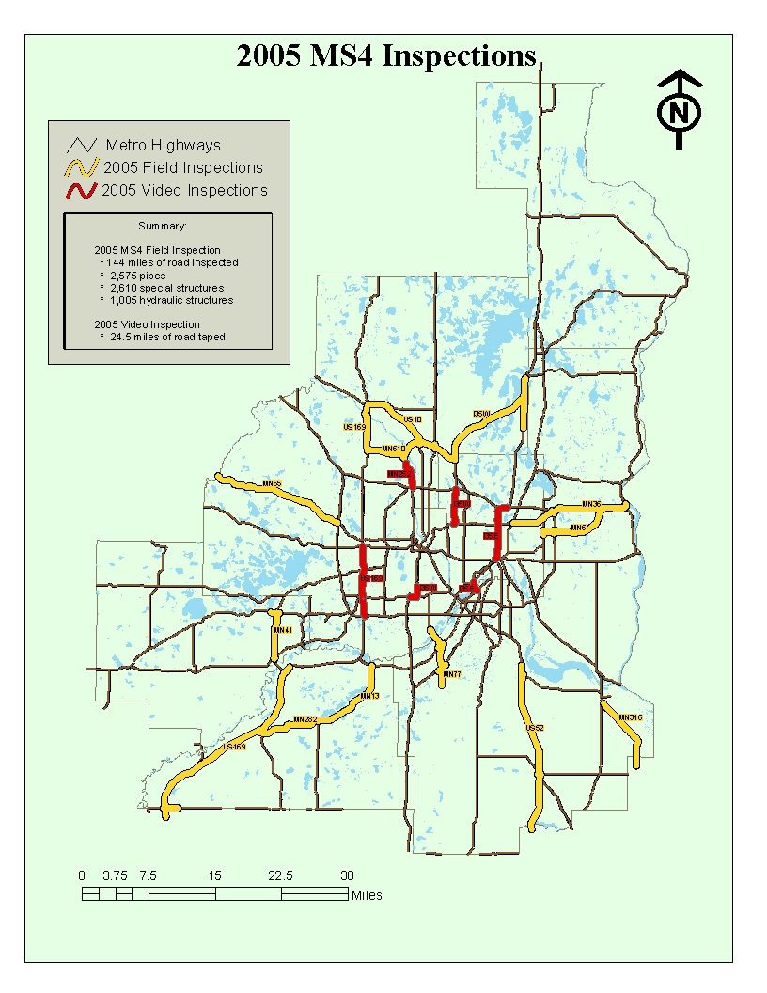
Figure 2: Metro Hydraulic Structure Inventory and Networks

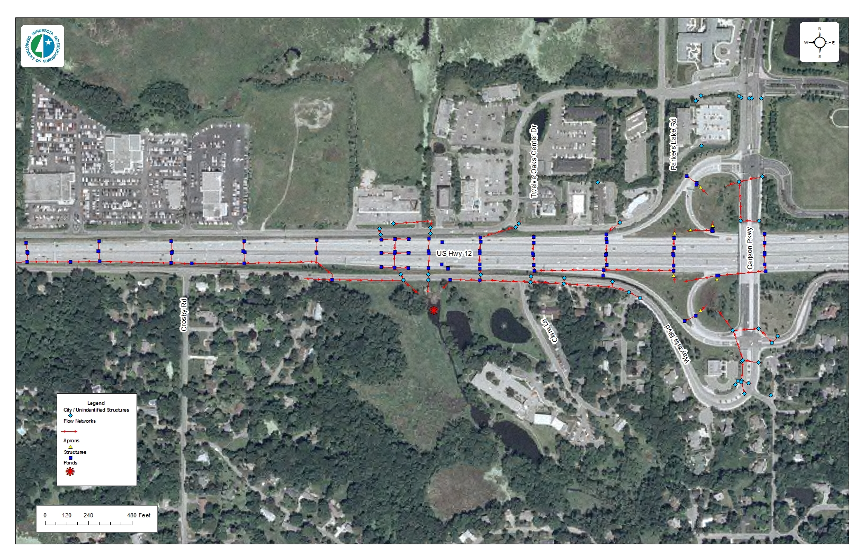
Figure 3: Metro Inventory

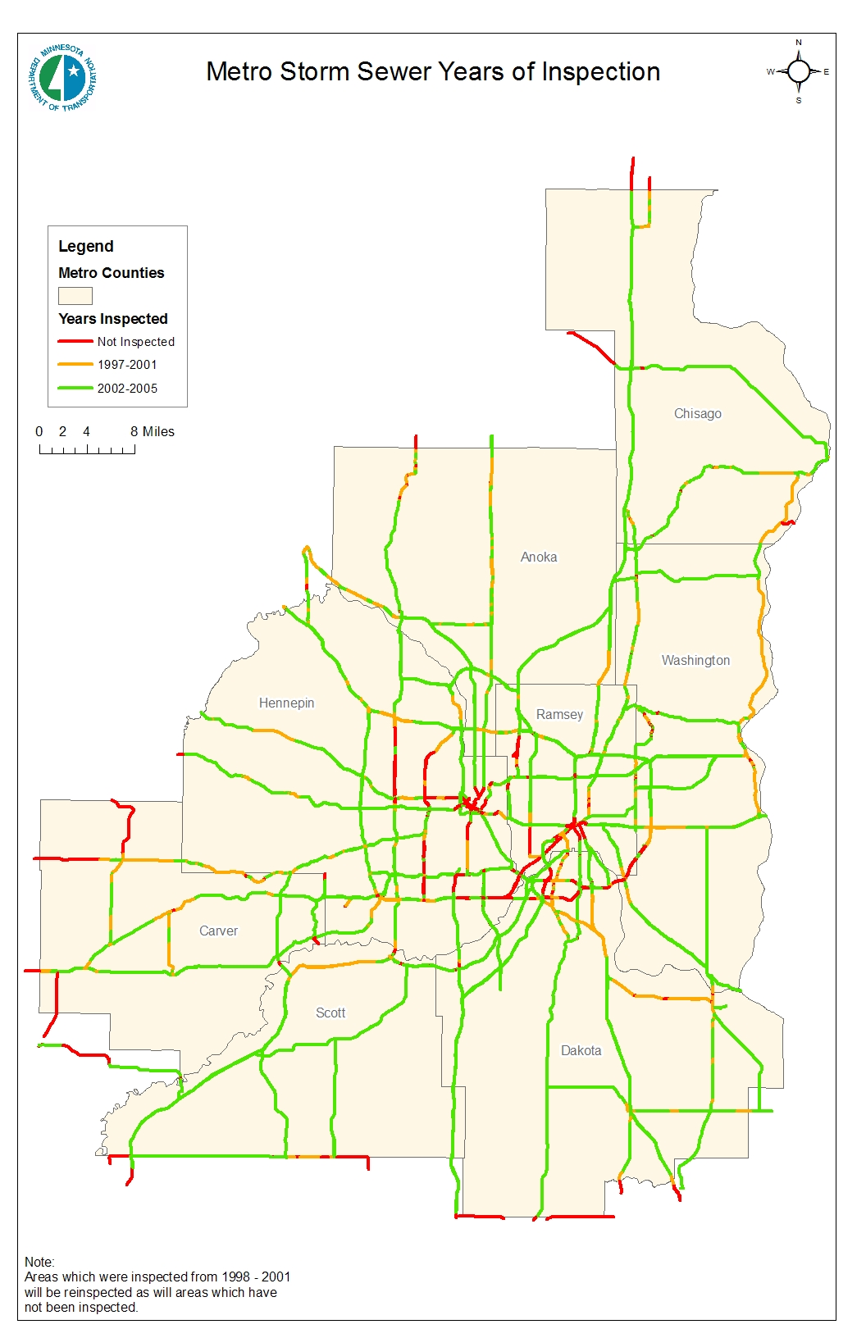
Figure 4: Poor to Failing Storm Sewer
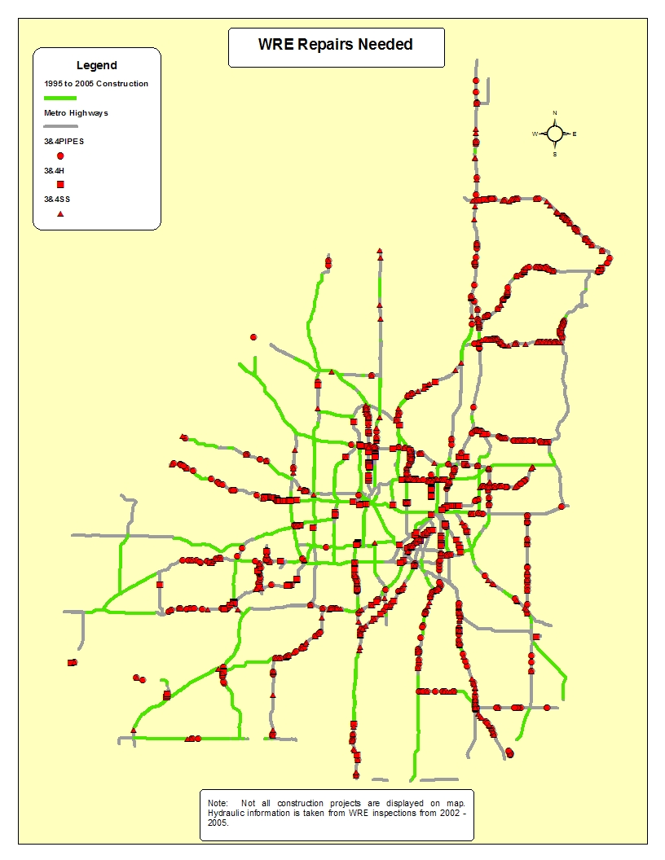
Figure 5: Standard Operating Procedure Form for Tunnel Washing

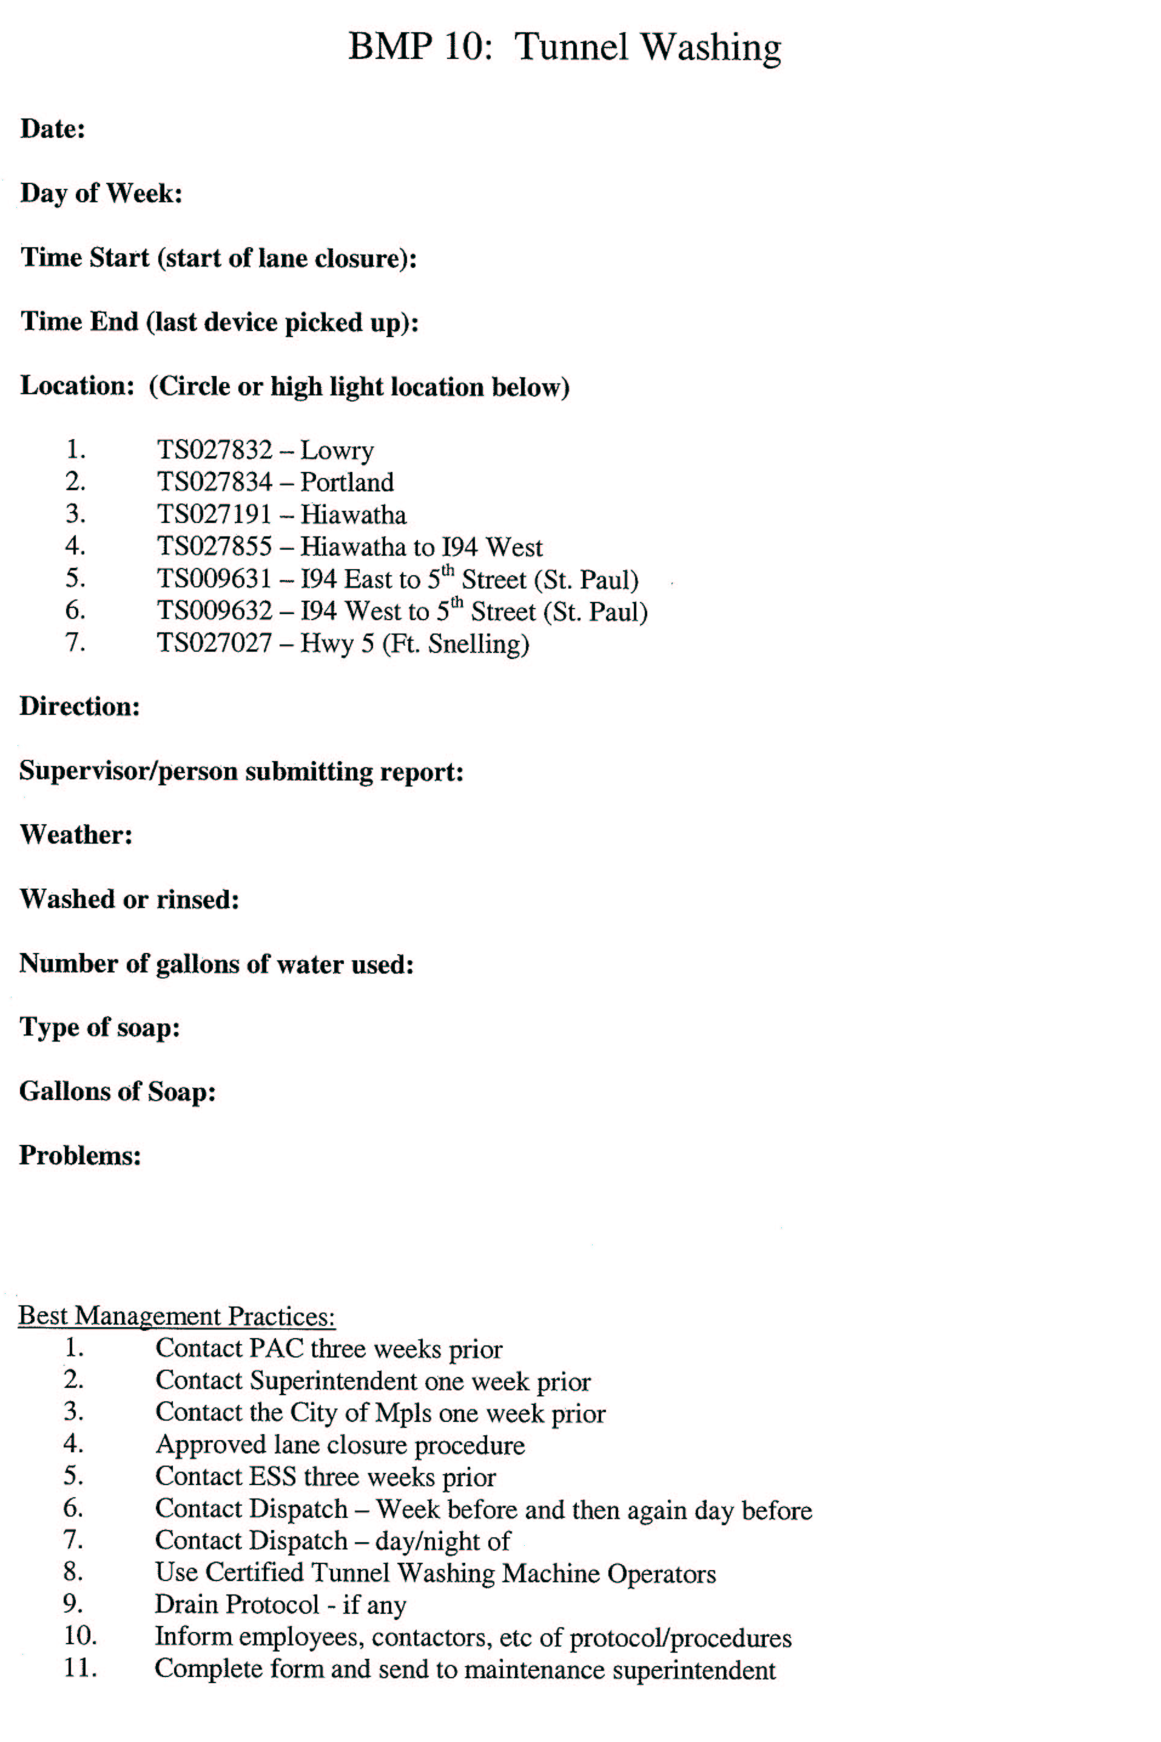

Appendix D
AASHTO Paper
MS4 Permit Compliance
Maintenance Operations Activities
12/05/2005

4,447 words (1,000 of which are 4 graphic images in 2 figures)

Author:
James Michael
Maintenance Superintendent, Metro District
Mn/DOT
Waters Edge Building
1500 West County Road B2
Roseville, MN 55113
Phone: 651-582-1436
Fax: 651-582-1008
james.michael@dot.state.mn.us

Co-Author:
Kellie Thom
Hydrologist, Metro District
Mn/DOT
Waters Edge Building
1500 West County Road B2
Roseville MN, 55113
Phone: 651-634-2400
Fax: 651-634-2411
kellie.thom@dot.state.mn.us

ABSTRACT – 11th AASHTO/TRB Maintenance Management Conference
MS4 Permit Compliance – Maintenance Operations Activities

Author: Co-Author:
James Michael Kellie Thom
Maintenance Superintendent, Metro District Hydrologist, Metro District
Mn/DOT Mn/DOT
Waters Edge Building Waters Edge Building
1500 West County Road B2 1500 West County Road B2
Roseville, MN 55113 Roseville, MN 55113
james.michael@dot.state.mn.us kellie.thom@dot.state.mn.us

Applicable within the topic areas of: Management, Environmental Stewardship, and Technologies

This paper discusses the practical approach that the Minnesota Department of Transportation (Mn/DOT) Metro District has taken to implement the Environmental Protection Agency’s (EPA’s) National Pollutant Discharge Elimination System (NPDES) Phase II Municipal Separate Storm Sewer Systems (MS4) permit compliance activities for maintenance operations. To comply with these worthwhile environmental goals within a limited operations budget, technology, effective communications, shared goals and coordinated planning, effective education efforts, and rigorous project planning have been critical to a successful program.

The BMPs involving maintenance operations include ongoing inspection and maintenance of drainage infrastructure, materials management, and compliance with correct operation processes within such areas as street sweeping and tunnel washing. In each of these areas, Mn/DOT is expected to perform to a certain level and to document its activities.

Global positioning and geographic information systems technology have been used to identify in place drainage infrastructure and to document work that needed – repairs or periodic cleaning. Effective communication between Maintenance Operations personnel and Water Resources personnel allows for clear understanding of resources available, shared inventory and management data, establishing GIS mapping to determine drainage infrastructure project priorities based on type of system, work needed, and proximity to special waters, as well as documentation of completed projects.

While many agencies have taken actions to become compliant with the NPDES requirements, Metro District’s efforts are a powerful example of how to be compliant with limited resources and reap other environmental and operational benefits.

Biographical Sketch – James Michael
Jim Michael is a Maintenance Superintendent with the Minnesota Department of Transportation’s Metro District which covers the eight county metropolitan area of Minneapolis, St. Paul and surrounding communities. He is responsible for the Metro District transportation system drainage infrastructure maintenance and operation (5,000 lane miles). Additionally, he is responsible for the day to day management of the four maintenance sub areas in the northeast portion of the Metro District. Jim has been with Mn/DOT for 25 years.

Biographical Sketch – Kellie Thom
Kellie Thom is a Hydrologist II with the Minnesota Department of Transportation’s Metro District. She is part of Water Resources Engineering functional area and works with the MS4 operations group. Kellie is a graduate of the University of Minnesota with a Bachelor of Science in Environmental Science. She has been with Mn/DOT for 4 years.

INTRODUCTION – ENVIRONMENTAL REQUIREMENTS
In 1972, the United States passed the Federal Water Pollution Control Act which has since been renamed the Clean Water Act (CWA). The bill was created to reduce pollution and improve water quality in the United States. Under this bill, a national program called National Pollution Discharge Elimination System (NPDES) was created to regulate point source pollution to confined surface waters and underground waters (i.e. Waters of the State). In 1990, Phase I of the NPDES program was implemented. This required agencies that manage large Municipal Separate Storm Sewer Systems (MS4s) (100,000 people or greater) to create a storm water program to aid in the control and elimination of pollution from their point sources. In 1999, Phase II of this program began which targeted smaller MS4s as designated by the Bureau of Census to have a population greater than 50,000 and less than 100,000.
Phase II of the NPDES permit program has six minimum control measures which, when implemented, are stated to have the capability of significantly reducing point source pollution in relation to stormwater discharge. The six control measures are as follows:
- Public Education and Outreach
- Public Participation/Involvement
- Illicit Discharge Detection and Elimination
- Construction Site Runoff Control
- Post Construction Runoff Control
- Pollution Prevention/Good Housekeeping
For each of the six minimum control measures the MS4 must create Best Management Practices (BMPs) and measurable goals to satisfy them.

MN/DOT METRO BEST MANAGEMENT PRACTICES
The Minnesota Department of Transportation (Mn/DOT) Metro District has been designated a small MS4 under Phase II. Mn/DOT Metro District, commonly referred to as Metro, is composed of eight counties, which surround and include the cities of Minneapolis and St. Paul. Seven of the eight counties in Metro are urban which include 114 local government Phase II MS4s and two Phase I MS4s (Minneapolis and St. Paul). Metro has 1,500 employees, 18 truck stations/sub-areas, 4,800 lane miles of interstate and trunk highways and 40,000 acres of right-of-way.
Metro applied for the NPDES Phase II MS4 permit from the Minnesota Pollution Control Agency (MPCA), the state’s governing agency, through the creation of a Storm Water Pollution Prevention Program (SWPPP). The SWPPP includes twenty-five Best Management Practices (BMPs) with measurable goals to address all of the six minimum control measures. The BMP’s require involvement from several functional offices within Metro, however the bulk of the BMPs are for Water Resources Engineering (WRE) and Metro Maintenance Operations. This paper will focus on the Metro Maintenance BMPs and the problems, solutions and improvements associated with them.
Metro Maintenance Operations consists of 548 employees, 638 pieces of mobile equipment, 18 sub-areas and an annual operating budget of $42,800,000. Each sub-area is a geographic work area that has assigned personnel (including a supervisor) and equipment housed in a maintenance facility for the purpose of maintaining the roadway infrastructure in their and surrounding areas.
Metro Maintenance has five of the twenty-five BMPs:
- Non-Storm Water Discharges (BMP 10)
- Routine Maintenance Activities (BMP 19)
- Vegetation Management Program (BMP 22)
- Street Sweeping Program (BMP 24)
- Anti-Icing/Deicing Program (BMP 25)
Each BMP has one or more measurable goals and includes an implementation schedule.
Non-Stormwater Discharges, Street Sweeping and Anti-Icing/De-Icing measurable goals have been met by using processes, which have been evaluated by consultants on their ability to reduce pollution originating from a single point, i.e. point source pollution. The Vegetation Management Program BMP measurable goal has also been met and exceeded it through the use of technology. The Routine Maintenance BMP measurable goals have not all been met.

Non-Stormwater Discharges
Non-Stormwater Discharges, BMP 10, is a new BMP created to identify non-stormwater discharges from maintenance activities which have significant potential to impact stormwater. Those impacts are then to be addressed through source removal/reduction, implementation of BMPs and/or developing appropriate standard operating procedures for these activities. During the permit process for Metro there were two non-stormwater discharges identified; tunnel cleaning and outdoor vehicle washing. Outdoor vehicle washing has been addressed in the Facility Storm Water Plan and employee training. As for tunnel cleaning, Metro has seven tunnels in the district, all of which drain to significant surface waters through city and Mn/DOT storm sewer systems. The measurable goals of this BMP are:
- Evaluate tunnel-cleaning operations and determine trigger mechanisms to move to measurable goal 2 by 2005.
- If tunnel-cleaning operations are determined to require BMPs, then develop a Standard Operating Procedure (SOP) and corresponding BMPs to reduce pollution from tunnel cleaning by 2006.
- Evaluate other non-stormwater discharges as they are identified through Illicit Discharge and Outfall Inspections (BMP 6).
The problem associated with this BMP was how to determine if Metro’s tunnel cleaning methods were affecting the environment. To solve this problem a consultant was hired to observe their cleaning methods and determine if the environment was at risk. Due to the low ratio of cleanser to water it was decided that the current procedure was acceptable. The procedure was then standardized with corresponding BMPs.

Street Sweeping
Street Sweeping, BMP 24, was an existing BMP prior to Phase II of the NPDES permit and its main objective was to ensure that Metro District was aware of current technologies for street sweeping, the benefits of performing routine street sweeping and the importance of tracking and reporting street sweeping activities. As stated above Metro, has 3950 lane miles of truck highways and interstates, all of which have to be cleaned routinely. The measurable goal of this BMP is:
- Perform street sweeping to remove salt, sand, debris and other potential contaminants from roadways annually in the spring.
The problems with street sweeping were how to ensure the sweepings were not full of contaminants and where to dispose of the sweepings. It was determined that sweepings should be screened to separate out the sand and aggregates from other materials (some of which is recycled). The sweepings were routinely tested to determine if and where they could be reused and the results have shown that the sand can be used for roadway fill on Mn/DOT property. The sweepings will be tested every three years.

Anti-Icing/De-Icing for Snow and Ice Removal Operations
Anti-Icing/De-Icing, BMP 25, is an existing BMP that ensures that Metro is aware of current technologies for anti-icing/de-icing within snow and ice removal operations, is working to reduce harmful amounts of chemicals and salt used, and employs good housekeeping practices related to anti-icing/de-icing operations. Due to snow and ice on the roadways during the winter season in Minnesota and the large amount of vehicles traveling at all times within the metropolitan area, Mn/DOT works diligently to ensure safe travel in winter conditions. To accomplish this, Metro Maintenance uses the most efficient chemicals and technology possible. The measurable goals for this BMP are:
- Develop tracking / reporting mechanism for materials applied to roads for inclusion in the annual report by the end of 2004.
- Analyze current and available measures, equipment and/or chemicals annually.
- Substitute high impact measures for low impact measures as appropriate.
The challenge associated with this BMP was over-application. In the urgency to de-ice roads, over application can occur due to non-calibrated application systems and operator error. There were also corrosive problems associated with chemical/salt mixtures.
The solution to the above-mentioned problems was obtained through education, research and experimentation. To avoid over-application of salt, a Dickey John calibrator controller was installed and calibrated on all plow/de-icing trucks. This allows operators, who are increasingly better educated, to control the amount of chemical/salt applied to the roadway. To reduce the corrosive potential from anti-icing, various anti-icing agents are in use and others are routinely tested.

Vegetation Management
Vegetation Management, BMP 22, is another existing BMP. This BMP was created to minimize Metro’s use of herbicides and fertilizers and to properly apply these products when used, as well as incorporate native vegetation and biological agents along roadside shoulders and medians for ease of maintenance and soil stabilization. The measurable goal for this BMP is:
- Continue to implement the vegetation management program on a continual basis.
Problems associated with this BMP were and are the continual search for low cost and highly effective means of managing vegetation. The solution to this problem is research of new techniques, chemicals and biological methods to reduce invasive vegetative species and environmental impacts. Currently, the vegetation management program is using Purple Loosestrife and Leafy Spurge Flea beetles to control invasive species in over 100 sites recorded with GPS units. The program has also been researching new technologically advanced machinery for herbicide application to reduce over applications.

Routine Maintenance Activities
Routine Maintenance Activities, BMP 19, is a new BMP. This BMP was created for Metro Maintenance Operations to schedule and perform routine maintenance of outfalls, sediment basins/ponds and structural pollution control devices (SPCDs). The measurable goals associated with this BMP are:
- Formalize a routine maintenance schedule and review and revise it as appropriate by 2005 and annually thereafter.
- Amend the maintenance reporting / tracking database annually.
- Train maintenance staff on storm water awareness and BMP operation and maintenance annually.
- Investigate revising the Maintenance Manual to include a storm water quality management chapter and/or using Mn/DOT Intranet to post SOPs, policies and memos for easy accessibility and up to date information by 2006.
The problems associated with this BMP were that Metro Water Resources Engineering (WRE), not Maintenance, was charged with finding the locations and conditions of hydraulic structures, SPCDs and ponds. Beyond finding the locations and conditions of these drainage items, issues of concern included: how to get to those areas which needed maintenance, how to schedule maintenance activities and what to base that schedule on, what type of activities to focus on, how to track maintenance activities, and how to train staff.
Solutions for these problems took a joint partnership between Metro WRE and Maintenance. The two functional areas worked closely together since many of WRE BMPs intertwine with this BMP. Throughout training workshops, data mining and product delivery this partnership ensured that both sides worked together to achieve their BMP goals.

Process
To make the process efficient, a decision was made that cleaning would be the first maintenance activity to be scheduled. In order to organize all the different hydraulic structures to be cleaned, three hydraulic groups were created. Hydraulic group one consisted of hydraulic structures such as catch basins, manholes, aprons and pipes. Hydraulic group two consisted of Special Pollution Control Devices (SPCDs). Hydraulic group three consisted of ponds.

Group One – Hydraulic Structures Since Metro WRE was already collecting global position systems (GPS) location and condition information on hydraulic structures within Metro, it was decided that they would provide location information on hydraulic structures where cleaning was needed. This was accomplished through querying the Mn/DOT hydraulic database and importing that information into a geographic information system (GIS) dataset. The information was then broken down into Priority 1, Priority 2 and Priority 3 datasets. Priority 1 stood for those structures in need of cleaning which were within a mile of any protected waters. Priority 2 stood for those structures that needed cleaning which were within one mile of any Total Maximum Daily Load (TMDL) waters. Priority 3 was the remainder of the structures that needed to be cleaned.
While this GPS location information could be plotted on a map, the problem arose of how to get to the Priority One, Two or Three project site(s) in the field. Uploading the information on the map to GPS units solved this problem by allowing the users to navigate to the project location(s). With the priority datasets loaded onto the GPS units, a select group of maintenance personnel (Locators) were chosen to receive MS4 GPS training. While most of these individuals had training on how to use a GPS unit for collecting data, they had not received training on how to use one for navigation purposes.
The one-day training workshop consisted of explaining data collection, navigation with the GPS unit, and the type of data with which they were working. After covering the processes of collecting and navigating with the GPS units, an explanation was given regarding what they were looking for and why Metro needed this done as compared to numerous other field work requests. Once everyone understood the basis for the extra work, they learned the process of how the work was to be done. Each of these Locators was then assigned one quarter of the Metro to carry out these duties. First, each sub-area supervisor would call their Locator to locate all their Priority One sites to be cleaned in their area (if they had none, Priority Two projects were located). The Locator would then mark them with lath. Once they were marked, the sub-area personnel would then clean and/or repair the structures and notify the Locator when each project was complete. The Locator would then go back to the project’s location and record the needed information. Once the Priority One locations were completed within a sub-area, then the Priority Two locations would follow. In order for the data collection to be efficient and uniform, a form was loaded onto the GPS units (a data dictionary) which the Locators would fill out each time they visited a cleaned or repaired structure. The form consists of the following:
- ID Number (Provided By WRE)
- Date
- Time
- Sub-Area
- Cleaned By
- Recorded By
- HWY
- HWY Type
- Direction
- Location
- Type Cleaned
- Percent Full
- Erosion Control Used
- SPCD
- Miscellaneous Information
These forms are electronically downloaded weekly at the district office. They are used for tracking cleaning projects’ completion and updating the Mn/DOT Hydraulic database which is linked through the ID number of the hydraulic structure. See figure 1 below.

Group Two- Special Pollution Control Devices (SPCD) Metro WRE located grit chambers and other SPCD’s through plan sheet inventories and communication with WRE designers. While efforts to complete the inventory are ongoing, the SPCDs inventoried were inspected by WRE, Maintenance and Environmental Services personnel. In the field, the amount of sediment was determined by measuring from the top of sediment in the chamber to the top of the grit chamber and comparing that measurement to the designed depth. Upon inspection, most of the grit chambers needed to be cleaned. The cleaning of the grit chambers was performed by Maintenance.

Group Three – Ponds Metro WRE is currently locating and identifying all ponds within the Metro area. A dataset was initially formed through the use of GIS and aerial photography. After the initial dataset was formed, WRE again joined forces with Maintenance to use their knowledge, via a field visit, to aid in filtering out the ponds within Mn/DOT right-of-way and maintained by Metro Maintenance. At each visit an explanation was given regarding the need to collect this information, what it would be used for, and how it affected maintenance. Once all 18 sub-areas were visited, WRE updated their data set and went through construction plan sheets to find all possible information about individual ponds. This information was incorporated into the final data set, which will be assessed by designers to determine cleaning recommendations for each pond based on original design criteria. Once a recommendation has been received by Maintenance, they will determine if the project is to be completed with internal staff or done under contract. Some of the factors used in this determination are size and location of pond, special equipment needed, vegetation restoration, pond lining, if any, proximity to Waters of the State, and workload/other priorities.
Since these activities are cyclical, after completion of all cleaning activities WRE will update all datasets and begin the process of creating new datasets. The new datasets will be given to Maintenance as project lists for their crews to work on during the next spring/summer/fall. Hydraulic structures, pond and SPCD’s which were cleaned this year will be monitored each year to see when re-cleaning needs to occur. This will allow a schedule to emerge on the frequency of cleaning needed which will in turn allow more rigorous work planning.

Training for Routine Maintenance Activities
During the implementation of the cleaning schedules, training workshops were given to the sub-area supervisors. The supervisors learned about the MS4 permit and how it affected them. They were each given an informational packet which included an agenda, copy of the MS4 general permit, definitions of special waters of the state, Priority 1, 2, and 3 cleaning projects, list of Watershed Districts within Metro, photo examples of good and poor project work, an Erosion and Sediment Control Pocketbook Guide, a list of erosion control contract vendors, plan sheets showing ditch typical sections, the Locator for their sub-area, and a data flow diagram. The training was very well received.

Tracking of Routine Maintenance Activities
Tracking of projects and data for each BMP is required for the MS4 permit. This requirement has been achieved through the use of an ArcIMS site. ArcIMS is a web-based tool that allows users to access geographical information such as the datasets mentioned above. Data that is being produced for meeting BMP requirements/goals is uploaded to the ArcIMS site that can be seen by those who need to verify and use the data. Currently Maintenance and WRE each have their own ArcIMS sites to display data specific to their own MS4 BMP’s. See Figure 2 at the end of this paper for an example of the Maintenance ArcIMS site.

LESSONS LEARNED
While all of the BMPs have not yet been fully met, there have been lessons learned through the BMP creation and implementation process. As stated previously, technology, communication, flexibility, research and experimentation all have been, and will continue to be, necessary to meet the measurable goals of each BMP.
Technology has been an important implementation tool for BMP 19 (Routine Maintenance Activities) and BMP 22 (Vegetation Management Program). Global positioning systems and geographic information systems have allowed tracking work progress and record keeping of completed projects with a minimal workforce. These, and other technologies such as digital recording cameras, have eased the transition from past to the new procedures. The equipment that is used must be designed for field application and user friendly so field personnel do not get frustrated and lose interest in the process.
Communication has been, and will continue to be, a very important element in the implementation process. Much coordination was needed between three different functional areas: Maintenance, WRE and the Website Administrative Group within Metro. Representatives from each of these units met regularly to discuss problems that arose and the possible corrective action or procedure for each. Communication is also important with the field employees. Anyone that is affected by, or is responsible for, MS4 activities that have questions or problems is responded to with answers as soon as possible.
Flexibility has been difficult, but also rewarding. Through training and the awareness of the MS4 permit, standard procedures have changed to meet the new BMP requirements. While these new operational procedures have been implemented and followed for the most part, continued training is needed to ensure that all procedures are followed.
Research and experimentation have been some of the most important tools in meeting and improving all of the BMPs. Through research, low cost/ high productivity technology, equipment and tools have been found. This has been important because a limited number of available employees and stagnant or decreasing budgets are, and will be, the operational reality. Experimentation has been equally important in finding the most efficient process for carrying out the BMPs. From data collection methods to type of chemicals used to de-ice roadways, experimentation and research has been, and will continue to be, necessary to implement current and future BMPs.
Each of the above mentioned processes will continue to be updated as environmental rules and regulations change. It is almost certain that all of the BMPs mentioned will be modified, as will the processes used to meet their requirements. The most important lesson learned though the implementation of these BMPs is that modifying current standard operating procedures is necessary. ‘Out of the Box’ thinking is a key requirement for anyone going through this process and it also happens to be the most challenging.
Figure 1: GPS Data Form
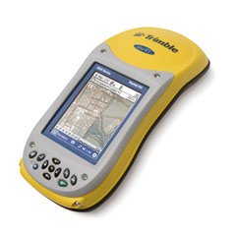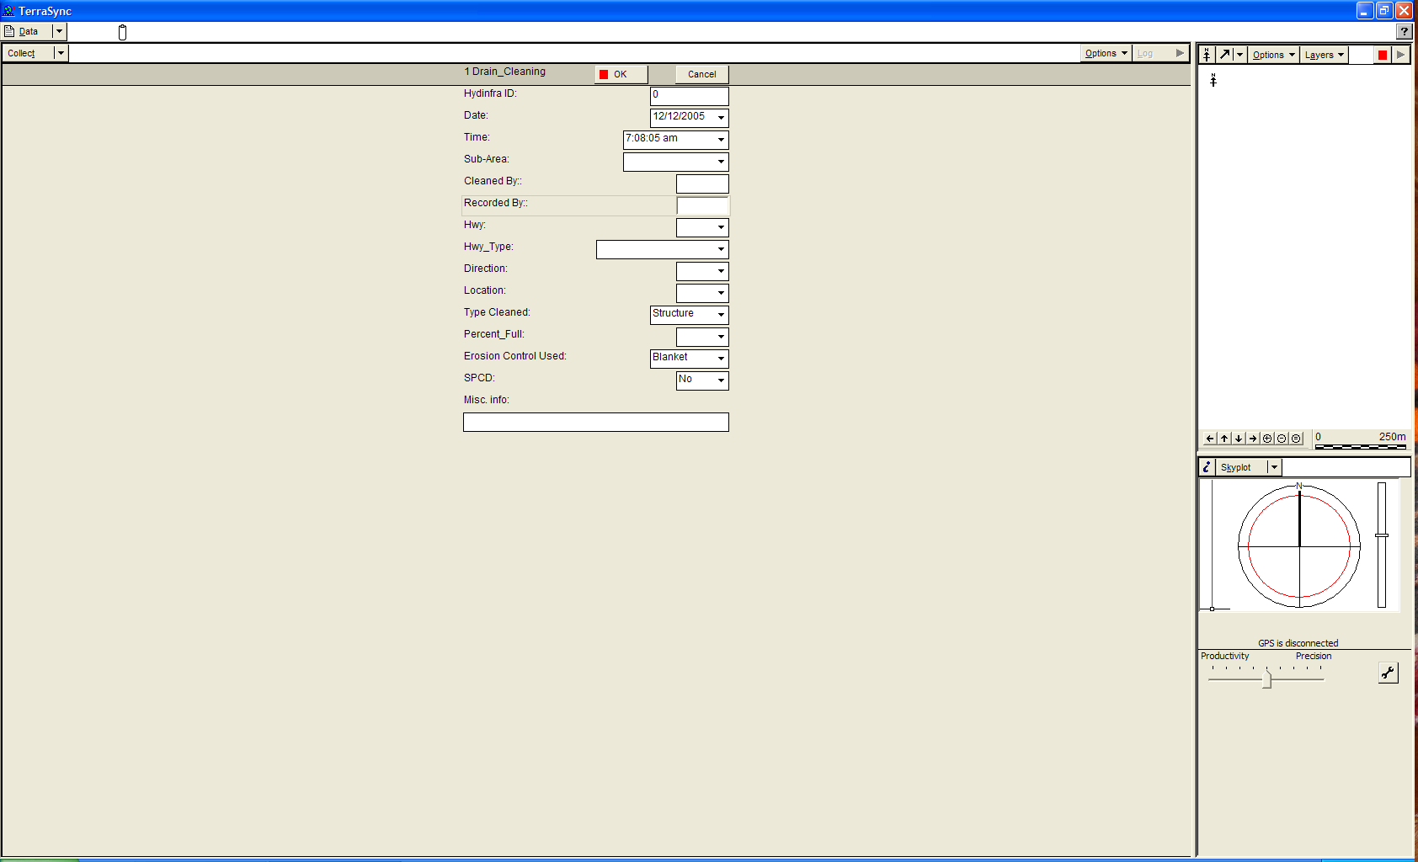
GPS handheld Form to be filled out after hydraulic structure has been cleaned. The completed form(s) are downloaded weekly.
Figure 2: Maintenance ArcIMS Site
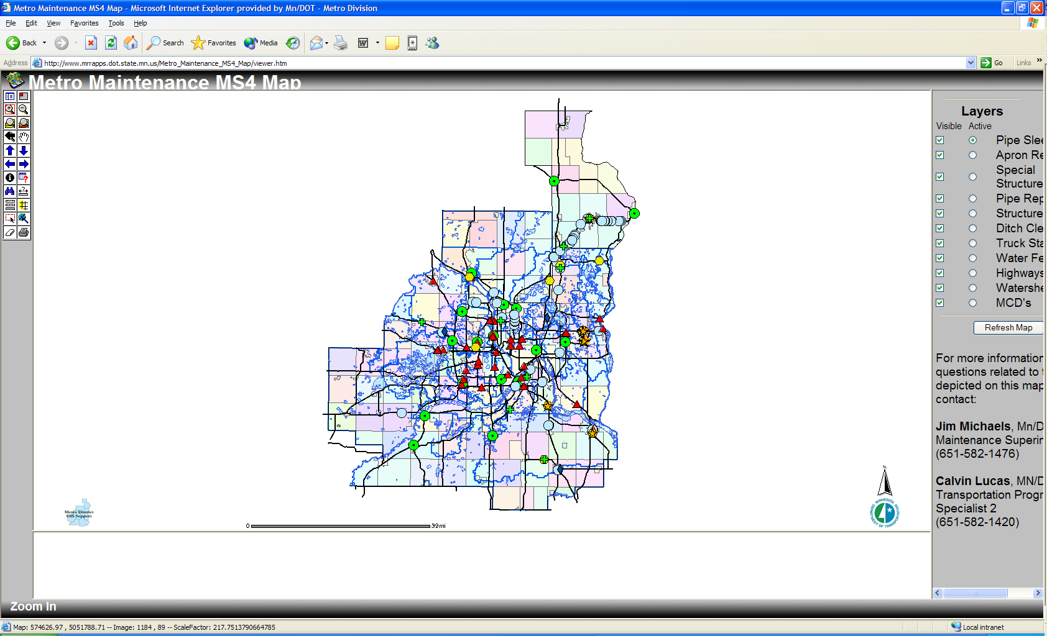

Maintenance ArcIMS Site – http://www.mrrapps.dot.state.mn.us/Metro_Maintenance_MS4_Map/viewer.htm

ACKNOWLEDGEMENTS
The authors would like to thank Beverley Farraher, Metro Maintenance Operations Administrative Engineer; Cory Johnson, Water Resources Engineering MS4 Senior Engineer; Christine Beckwith, Metro Maintenance Operations Senior Engineer; and Cal Lucas, Metro Maintenance Operations Transportation Specialist 2 for their knowledge, help and support.

Minnesota Pollution Control Agency, Stormwater Program for Municipal Separate Storm Sewer Systems (MS4), September 2005, http://www.pca.state.mn.us/water/stormwater/stormwater-ms4.html. Accessed Oct 2005.
Minnesota Pollution Control Agency, Stormwater Program for Municipal Separate Storm Sewer Systems (MS4), September 2005, http://www.pca.state.mn.us/water/stormwater/stormwater-ms4.html. Accessed Oct 2005.
Water-Technology.net, http://www.water-technology.net/glossary/point-source-pollution.html. Accessed Dec 2005.

