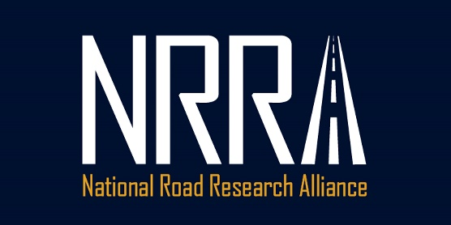

2020 Call for Innovation
The National Road Research Alliance (NRRA) was formed over 4 years ago to improve the sustainability of our roads through cooperative research and a commitment to implementation. The NRRA sponsors research though the FHWA pooled fund process by funding provided through our state agency DOTs, private companies, academic institutions and industry associations. The Technical Teams have worked collaboratively to guide the research and construction effort to date. Each team has carefully defined what they wanted to accomplish and have several well defined experiments that include the test sections built at MnROAD in 2017.
While the research has been well thought out and complete, it has generally leaned heavily towards the conventional. We have not really ventured out in the world of new materials, design and construction methods. This effort is intended to further expand our past efforts and build on the projects funded in the 2019 Call for Innovation.

Program Details
The NRRA has approximately $350,000 in funding that is currently uncommitted. We are looking for proposals on how we can best use those funds. For consideration, proposals must demonstrate a possible impact to road design, construction, materials testing and maintenance with a potential for broad national impact. Eligibility is limited to current NRRA members. The Program anticipates making multiple awards, subject to funding availability.
Each of the proposals must follow each of these requirements. Proposals not following all the requirements will be rejected.
- Only NRRA Associate members can apply.
- NRRA Associate members must contribute at least 20% of the funding for the projects.
- The 20% match must be itemized and documented in the proposal.
- The maximum NRRA contribution for each project is $100,000.
- The proposal will not exceed 10 pages including all attachments.
The proposals will be judged on the following criteria:
- Potential Impact on the Industry
- Cost including contributions
- Ease of Implementation
- Study Team Members Participation
- Documentation of Findings / Impact made
- Proof of concept

Schedule
- The proposals are due on May 1, 2020. During the weeks of June 8 and 15, 2020 the NRRA will inform the proposers of decision.
Thanks and good luck!

Contact
Glenn Engstrom, NRRA Executive Committee Chair, MnDOT, Director of Materials and Road Research
651-366-5531 glenn.engstrom@state.mn.us

NRRA Innovation Proposal Guidelines
- Title: It should be concise and descriptive.
- Author: Contact information for the proposal submission
- Abstract: It is a brief (one page maximum) summary.
- Introduction: The introduction provides the readers with the background information.
- Objectives: Research objectives are the goals to be achieved by conducting the research.
- Variables: During the planning stage, it is necessary to identify the key variables of the study and their method of measurement and unit of measurement must be clearly indicated.
- Questions and/or hypotheses: In other words, the hypothesis translates the problem statement into a precise, unambiguous prediction of expected outcomes.
- Methodology: The method section is very important because it explains how you plan to tackle your research problem.
- Collection of data: A short description of the protocol of data collection.
- Data analysis: The description should include the design of the analysis, plans for processing and coding the data and the choice of the statistical method to be applied to each data set.
- Communication of Results: How will the results be shared/reported and what implementation opportunities are expected.
- Schedule: List all the major tasks
- Budget: A proposal budget with item/activity breakdown and justification. Indicate how the project will be financed and detailed cost sharing involved.
- Partnerships: List of supporting authors or partners supporting this proposal.
- References: The proposal should end with relevant references on the subject.
- Appendixes: Include the appropriate appendixes in the proposal.

