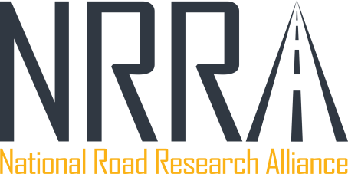

Initial Research Request
08/05/2016
Flexible

Research Title: | Tack Coats – A Synthesis of Best Practices
Developed By: | Charles Wienrank, Illinois Department of Transportation
Email: | Charles.Wienrank@illinois.gov
Phone: | 217-782-0570

Request Type:
❑ Tech Transfer Topic (“Quick” summary or synthesis)

Process:
- Teams develop an initial topic research request (this form) for Executive Committee review/approval.
- Teams develop a detailed work plan (form will be provided) for Executive Committee review/approval to initiate funding and contract development.
- Once approved, the funding and contract development process begins.

Project Overview and Goals:
A tack coat is a light application of asphalt cement or asphalt emulsion used to ensure a good bond between a) an existing pavement surface and a new hot mix asphalt (HMA) overlay or b) between the layers of each lift of HMA in multi-lift overlays or full-depth asphalt pavements. Adequate bonding between construction lifts, and especially between the existing roadway surface (bare or milled) and an overlay, is critical so that the completed pavement structure behaves as a single unit and provides adequate strength. Inadequate bonding between layers can result in delamination (debonding), followed by premature failures and a reduction in pavement life.

Various factors may affect the bonding condition at the interface. These include HMA material, tack coat material, tack coat application rate, pavement surface texture and cleanliness, temperature, and moisture conditions. Several agencies have conducted research in this area to improve construction practices and ensure good performance of their HMA pavements. Trackless tack coat materials and spray pavers (where available) are now being used more frequently.

The purpose of this tech transfer project is to compile a synthesis of best practices being used by NRRA members in the area of tack coats and to identify any gaps in the research that can be filled during the next round of construction activities at MnROAD.

Time to Complete: |  | Expected Funding Required:
6 months |  | $ 7,500

Expected Tasks:
Summarize each state’s current activities with regard to tack coats and develop a list of potential research ideas that can be investigated at MnROAD during future test section construction.

Potential Benefits for NRRA Members:
Proper use of tack coats in HMA construction will ensure good bond between layers and long-lived HMA pavements.

How Does This Build Upon Previous Research?
This tech transfer activity will be a synthesis of prior research activities conducted by NRRA members.

NRRA Contacts to Assist in Project (Technical Advisory Panel):
Paul Denkler, Missouri Department of Transportation

REVIEW AND APPROVAL:
Double click the signature line to the right to add your full name and NRRA team name. Both digital and handwritten signatures will be accepted.

APPROVALS (SIGN AND DATE):

I hereby certify sufficient staff time will be scheduled for the Project Manager and staff to complete the project as outlined in the attached work plan, and commit any Office or District funds as listed above.

COMMENTS (EC USE ONLY)

Please send completed form to the following persons below to be submitted to the executive committee.

Ben Worel
651-366-5522
ben.worel@state.mn.us

Cassandra Petersen
651-366-5593
Cassandra.petersen@state.mn.us

