1 Scope

1.1 This test procedure covers the determination of the percentages of flat particles, elongated particles, or flat and elongated particles in coarse aggregates.

1.2 The values stated in inch-pound units are to be regarded as standard. The values given in parentheses are mathematical conversions to SI units that are provided for information only and are not considered standard.

1.2.1 Exception – (Regarding sieves, per ASTM E 11. The values stated in SI units shall be considered standard for the dimensions of the wire cloth openings and the diameter of the wires used in the wire cloth. When sieve mesh sizes are referenced, the alternate inch-pound designations are provided for information purposes and enclosed in parentheses.

1.3 This standard does not purport to address all of the safety concerns, if any, associated with its use. It is the responsibility of the user of this procedure to establish appropriate safety and health practices and determine the applicability of regulatory limitations prior to use.

2 REFERENCED DOCUMENTS

2.1 Illinois Test Procedures (ITP):

- ITP 2, Sampling of Aggregate
- ITP 27, Sieve Analysis of Fine and Coarse Aggregate
- ITP 248, Reducing Field Samples of Aggregate to Testing Size

2.2 ASTM Standards:

- C670, Practice for Preparing Precision and Bias Statements for Test Methods for Construction Materials
- E 11, Woven Wire Test Sieve Cloth and Test Sieves

3 TERMINOLOGY

3.1 Definitions:

3.1.1 Flat and Elongated Particles of Aggregate – those particles having a ratio of length to thickness greater than a specified value.

3.1.2 Length – maximum dimension of the particle, as illustrated in Fig. 1.

3.1.3 Thickness – minimum dimension of the particle. It is the maximum dimension perpendicular to the length and width as illustrated in Fig. 1.

3.1.4 Width – intermediate dimension of the particle. It is the maximum dimension in the plane perpendicular to the length and thickness. The width dimensions is greater than or equal to the thickness as illustrated in Fig.1.

4 SUMMARY OF TEST METHOD

4.1 Individual particles of aggregate of specific sieve sizes are measured to determine the ratios of length to thickness.

5 SIGNIFICANCE AND USE

5.1 The particles shape of coarse aggregates influences the properties of some construction materials and may affect their placement and consolidation.

5.2 This test method provides a means for checking compliance with specifications that limit such particles or to determine the relative shape characteristics of coarse aggregates.

6 APPARATUS

6.1 The apparatus used shall be equipment suitable for testing aggregate particles for compliance with the definitions in 3.1, at the dimensional ratios desired.

6.1.1 Proportional Caliper Device – The proportional caliper devices illustrated in Fig. 2 and Fig. 3, are examples of devices suitable for this test method. The device illustrated in Fig. 2 and Fig. 3 consists of a base plate with two fixed posts and a swinging arm mounted between them so that the openings between the arms and the posts maintain a constant ratio. The axis position can be adjusted to provide the desired ratio of opening dimensions, Fig. 2 illustrates a device on which ratios of 1:2, 1:3, and 1:5 may be set. (see Note 1)

6.1.1.1 Verification of Ratio – The ratio settings on the proportional caliper device shall be verified by the use of a machined block, micrometer, or other appropriate device.

6.1.2 Balance – The balance or scales used shall be accurate to 0.5% of the mass of the sample.

Note 1 – Fig. 2 and 3 provide examples of possible devices that may be used for this test. Other devices may be found suitable if they are able to meet the verification requirements listed in 6.1.1.1.

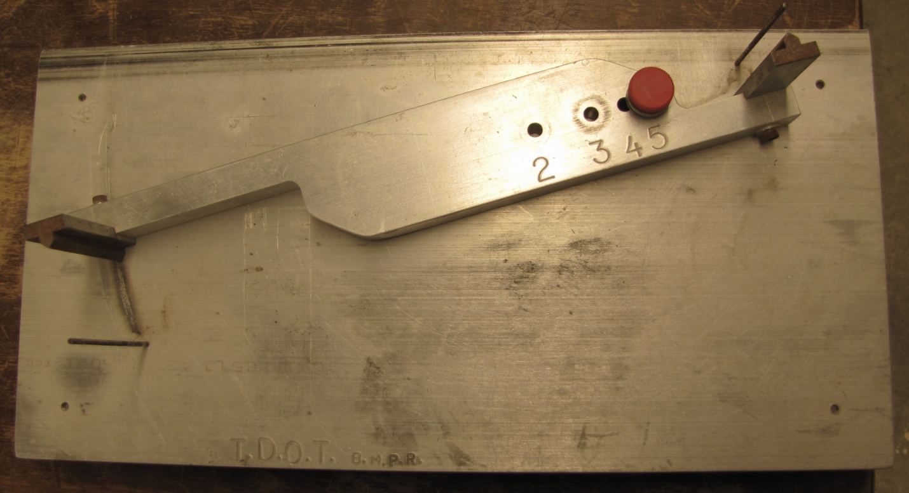

FIG. 3 Proportional Caliper

7 SAMPLING

7.1 Sample the coarse aggregate according to ITP 2. The field sample size shall meet the minimum requirements in Illinois Specification 201.

7.2 Field samples of aggregate shall be reduced to approximate test sample size before testing according to ITP 248. Reduction to an exact predetermined mass shall not be permitted. Sieve the approximate test sample according to ITP 27 and retain all plus 4.75mm (No. 4) material as the test sample. The mass of the test samples shall conform to the following:

Nominal Maximum Size Square Openingsin. | Minimum Mass of Test Sample, g
3/8 | 500
1/2 | 500
3/4 | 750
1 | 750

8 PROCEDURE

8.1 The test sample shall be dried back to constant mass in an oven specifically designed for drying, set at and capable of maintaining a uniform temperature of 110±5˚C (230±9˚F). Constant mass is defined as the sample mass at which there has not been more than a 0.5 gram mass loss during one hour of drying. This should be verified occasionally.

8.2 Flat and Elongated Particle Test – Test each of the particles in the test sample and place in one of two groups: (1) flat and elongated or (2) not flat and elongated.

8.2.1 Use the proportional caliper device, positioned at the proper ratio, shown in Fig. 4, as follows:

8.2.1.1 Flat and Elongated Particle Test – Set the larger opening equal to the maximum particle length. The particle is considered flat and elongated if the maximum thickness can be placed through the smaller opening.

8.2.2 After the particles have been classified into the groups described in 8.3, determine the proportion of the sample in each group by count or mass, as required. The particle is flat and elongated if the particle thickness can be completely passed through the smaller opening.

8.2.3 Determine the mass of each group.

9 Calculation

9.1 Calculate the percentage of flat and elongated particles to the nearest 1 percent in using the following formula:

$\%=\frac{GM}{TSM}$ x 100

where:
GM = each group mass, and
TSM = test sample mass.

10 Report

10.1 Include the following information in the report:

10.1.1 Identification of the coarse aggregate tested, and

10.1.2 Percentages, calculated by mass for total flat and elongated particles.

10.1.3.1 The dimensional ratios used in the tests.

11 Precision and Bias

11.1 Precision – The precision values listed in Table 1, and Table 2, and Table 3 are averages obtained from AMRL proficiency samples used in the Aggregate Proficiency Sample Program (see Note 2). The 1S % and D2S % limits provided are described in Practice C670.

Note 2 - A 1:3 ratio was used.

TABLE 1 19.0-mm to 12-5mm Flat and Elongated (Percent)
Precision | Test Result (%) | (1S) % | (D2S) %
Single Operator | 2.7 | 51.2 | 144.8
Multi-laboratory |  | 88.5 | 250.3

TABLE 2 12.5-mm to 9-5mm Flat and Elongated (Percent)
Precision | Test Result (%) | (1S) % | (D2S) %
Single Operator | 34.9 | 22.9 | 64.7
Multi-laboratory |  | 43.0 | 121.8

TABLE 3 9.5-mm to 4.75mm Flat and Elongated (Percent)
Precision | Test Result (%) | (1S) % | (D2S) %
Single Operator | 24.1 | 19.0 | 53.6
Multi-laboratory |  | 46.1 | 130.3†
†Value corrected

11.2 Bias – Since there is no accepted reference material suitable for determining the bias for this test method, no statement on bias is being made.

This Page Reserved

