1 Scope

1.1 This test procedure covers the determination of the percentage, by mass of a coarse aggregate sample that consists of fractured particles meeting specified requirements.

1.2 The values stated in SI units are to be regarded as the standard. The values in parentheses are provided for information only.

1.3 This standard does not purport to address all of the safety concerns, if any, associated with its use. It is the responsibility of the user of this procedure to establish appropriate safety and health practices and determine the applicability of regulatory limitations prior to use.

2 Referenced Documents

2.1 Illinois Test Procedures (ITP):
- ITP 2, Sampling of Aggregate
- ITP 27, Sieve Analysis of Fine and Coarse Aggregate
- ITP 248, Reducing Field Samples of Aggregate to Testing Size

2.2 ASTM Standards:
- E 11, Woven Wire Test Sieve Cloth and Test Sieves

3 Terminology

3.1 Definitions:

3.1.1 Fractured face, n – a broken surface of an aggregate particle created by crushing.

3.1.2 fractured particle, n – a particle of aggregate having at least the minimum number of fractured faces specified (usually one or two)

4 Significance and Use

4.1 Some specifications contain requirements relating to percentage of fractured particles in coarse aggregates. One purpose of such requirements is to maximize shear strength by increasing inter-particle friction in either bound or unbound aggregate mixtures. Another purpose is to provide stability for surface treatment aggregates and to provide increased friction and texture for aggregates used in pavement surface courses. This test method provides a standard procedure for determining the acceptability of coarse aggregate with respect to such requirements.

4.2 Specifications differ as to the number of fractured faces required on a fractured particle, and they also differ as to whether percentage by mass or percentage by particle count shall be used. If the specification does not specify, use the criterion of at least one fractured face and calculate percentage by mass.

5 Apparatus

5.1 Balance – A balance or scale accurate and readable to within 0.1% of the test sample mass at any point within the range of use.

5.2 Sieves – Sieves conforming to ASMT E 11.

5.3 Splitter – A sample splitter suitable for dividing field samples into test portion sizes in accordance with ITP 248.

5.4 Forceps or similar tool to aid in sorting.

5.5 Other Apparatus – A lighted magnifying lamp.

5.6 Oven – An oven of sufficient size, capable of maintaining a uniform temperature of 230±9˚F (110±5˚C). The oven shall be specifically designed for drying. In addition, a gas burner or electric hot plate may be used. Microwave ovens are not permitted for drying aggregate gradation samples.

6 Sampling

6.1 Sample the aggregate in accordance with ITP 2.

7 Sample Preparation

7.1 Dry the sample sufficiently to obtain a clean separation of fine and coarse material in the sieving operation. Sieve the sample over the 1.75mm (No. 4) sieve in accordance with ITP 27 and then reduce the portion retained on the sieve using a splitter in accordance with ITP 248 to appropriate size for test.

7.2 The mass of the test sample shall be according to the following:

Gradation | Sample Size
CA01 through CA05 | 4250g ± 750g
CA06 through CA12 | 2500g ± 500g
CA13 through CA20 | 1250g ± 250g
Fine Aggregate | 100g

8 Procedure

8.1 Wash the sample over the sieve designated for determination of fractured particle to remove any remaining fine material, and dry to constant mass. Constant mass is defined as the sample at which there has not been more than a 0.5 gram mass loss during 1 hour of drying. This should be verified occasionally. Determine the mass of the test sample, and any subsequent determinations of mass, to the nearest 0.1% of the original dry sample mass.

8.2 Spread the dried test sample on a clean flat surface large enough to permit careful inspection of each particle. To verify that a particle meets the fracture criteria, hold the aggregate particle so that the face is viewed directly. If the face constitutes at least one quarter of the maximum cross-sectional area of the rock particle, consider it a fractured face.

8.3 Hand-examine each individual particle of the sample to determine if it is fractured. Separate the particles into specified categories: (1) fractured particles based on whether the particle has the required number of fractured faces, (2) particles not meeting the specified criteria.

8.4 Determine the mass of particles in the fractured particle category, and the mass of the particles not meeting the specified fracture criteria. Use mass to calculate percent fractured particles.

9 Report

9.1 Report the mass percentage of the particles with the specified number(s) of fractured faces to the nearest 0.1% in accordance with the following:

$P=\left(\frac{F}{Q}\right) x 100$

where:
P=percentage of particles with the specified number of fractured faces,
F=Mass of fractured particles with at least the specified number of fractured faces,
Q=total mass of original test specimen.

9.2 Report the specified fracture criteria against which the sample was evaluated.

9.3 Report the total mass in grams of the coarse aggregate sample tested.

9.4 Report the sieve on which the test sample was retained at the start of the test.

FIG. 2 Fractured Particles (Sharp Edges, Rough Surfaces)

FIG. 3 Fractured Particles (Sharp Edges, Smooth Surfaces)

FIG. 4 Fractured Particles (Round Edges, Rough Surfaces)

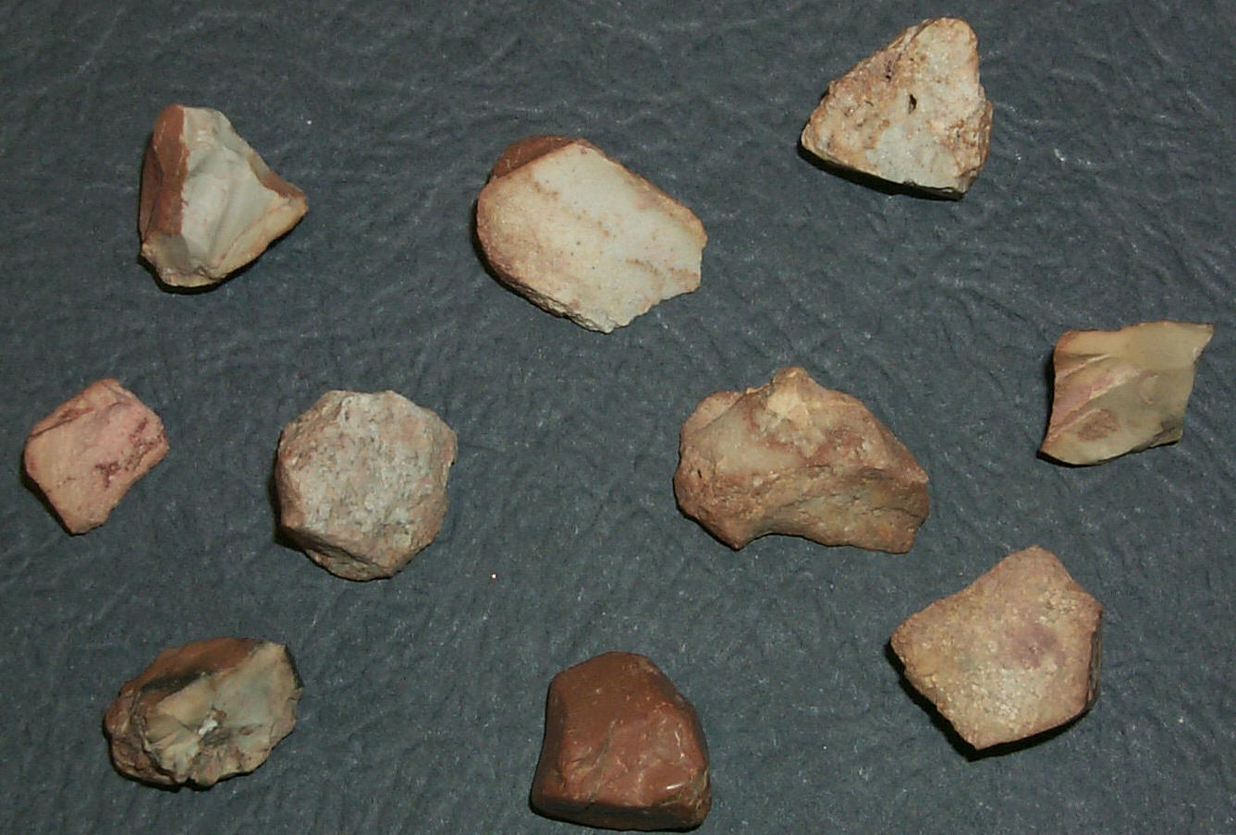

FIG. 5 Fractured Particles (Rough Edges, Smooth Surfaces)

FIG. 6 Fractured Particle (Center) Flanked by Two Non-Fractured Particles (Chipped Only)

FIG. 7 Non-Fractured Particles (Round Edges, Smooth Surfaces)

FIG. 8 Non-Fractured Particles (Rounded Particles, Smooth Surfaces)

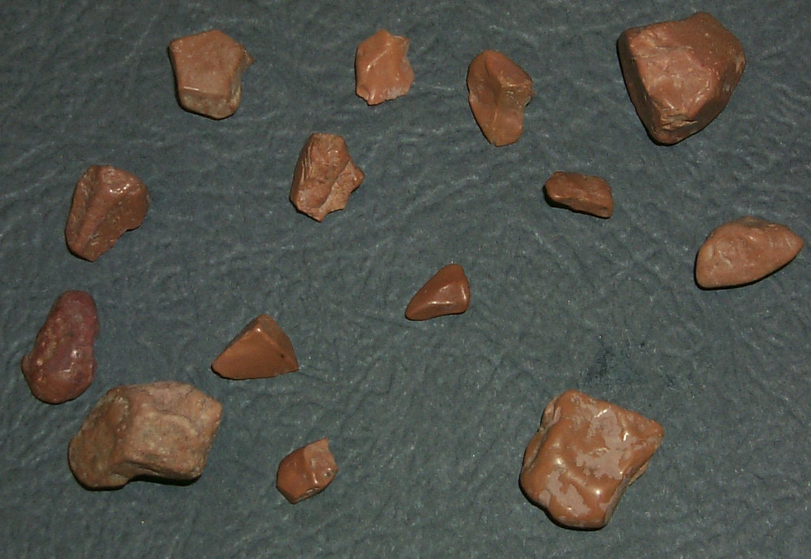

FIG. 9 Non-Fractured Particles (Rounded Particles, Smooth Surfaces)

This Page Reserved

