Experimental Plan for Field Activities at MnROAD
University of Texas El Paso – June 6, 2017

This document contains a brief explanation of field protocols recommended for implementation of rapid nondestructive tests for quality acceptance and design modulus verification.
Goal of Study. The goal of this study is to develop a robust means of extracting stiffness parameters from Intelligent Compaction (IC) rollers.
Objective of Study. The short-term objective is to develop a test procedure that rapidly and rigorously will supplant the design verification given the design parameters. The long term objective is to recommend a robust field test protocol and associated equipment that can evaluate whether the design modulus of a given layer is achieved. The following field devices will be carried out when appropriate:
- Light Weight Deflectometer (LWD)
- Dynamic Cone Penetrometer (DCP)
- Portable Seismic Property Analyzer (PSPA)
Field Testing: The following steps will be followed in the field to achieve the objective:
- Install instrumentation in the subgrade (3-D geophones and pressure cells) as discussed below
- Map the completed subgrade with an intelligent compaction (IC) roller after compaction
- Conduct field tests with nuclear density gauge (NDG), LWD and DCP on prepared subgrade
- Prepare and compact the unbound aggregate base (UAB)
- Install instrumentation in the base as discussed below
- Map the completed base with an IC roller after compaction
- Conduct field tests with NDG, LWD and DCP on prepared base
- Prepare and compact the hot mix asphalt (HMA) layers
- Conduct FWD about two weeks after compaction
Lab Testing: To support the goals of this project, UTEP will conduct laboratory resilient modulus tests on the samples of the subgrade and UAB materials at several moisture contents. In addition, UTEP will carry out index tests (gradation and Atterberg limits) and moisture-density tests if necessary.
Table 1 contains a summary of the activities and an approximate schedule at each site. Each activity is briefly explained below.
- Identification of Test Strip. Tests will be carried out in Cells185 through 189 and Cells 132, 232 and 332. Figures 1 and 2 illustrate the schematics of the test layout in each cell. The pre-mapping process will be performed on each layer before the placement and compaction of the subsequent geomaterial. After the completion of compaction, the mapping process will be conducted to collect the IC data. During the pre-mapping and mapping of each lift, sensors mounted on the IC roller will collect vibration data while embedded ground sensors will collect ground responses (see Figure 3).
- Set up of GPS. As much as possible, MnROAD base station will be used. If necessary UTEP will set up a base station.
- Set up of IC Roller. UTEP in cooperation with CAT will setup the IC roller. The IC roller will be checked for proper data collection and all settings including roller speed, and vibration frequency and amplitude.
- Carry out Construction as normally done. UTEP team may observe the construction but will not become involved in or interfere with the operation.

Table 1-Test Activity and Approximate Schedule
Time | Tasks | Activities
Now until 1 day before Field Tests | Coordination and  Initial Set up | - Sample representative subgrade, lime and base (MnDOT, UTEP)  - Mark the test section and test spots in each cell (UTEP)  - Arrange for field instrumentation (MnDOT, UTEP)  - Obtain GPS coordinates for spot test locations (UTEP)  - Coordinate with IC roller operator on how to collect, record, save, download and transfer data for this project (CAT and UTEP)
First  Visit | Subgrade | - Prepare and compact subgrade layer  - Sample material for laboratory testing during compaction for moisture content (UTEP, MnDOT)  - Install geophones at a depth of 24 in. and 6 in. from the top of subgrade  - Map subgrade with IC roller (CAT and UTEP)  - Carry out in-situ testing with modulus-based devices (UTEP, MnDOT)  - Carry out NDG tests (MnDOT)
Second  Visit | Unbounded Aggregate Base (UAB) | - Pre-map subgrade  - Prepare and compact base  - Sample material for laboratory testing during compaction for moisture content (UTEP, MnDOT)  - Install geophone at a depth of 6 in. within the base  - Map UAB with IC roller (CAT and UTEP)  - Carry out in-situ testing with modulus-based devices and NDG to establish moduli (UTEP, MnDOT)
Third  Visit | HMA | - Prepare and compact the HMA  - Carry out in-situ testing with FWD two weeks after the placement of HMA (MnDOT)

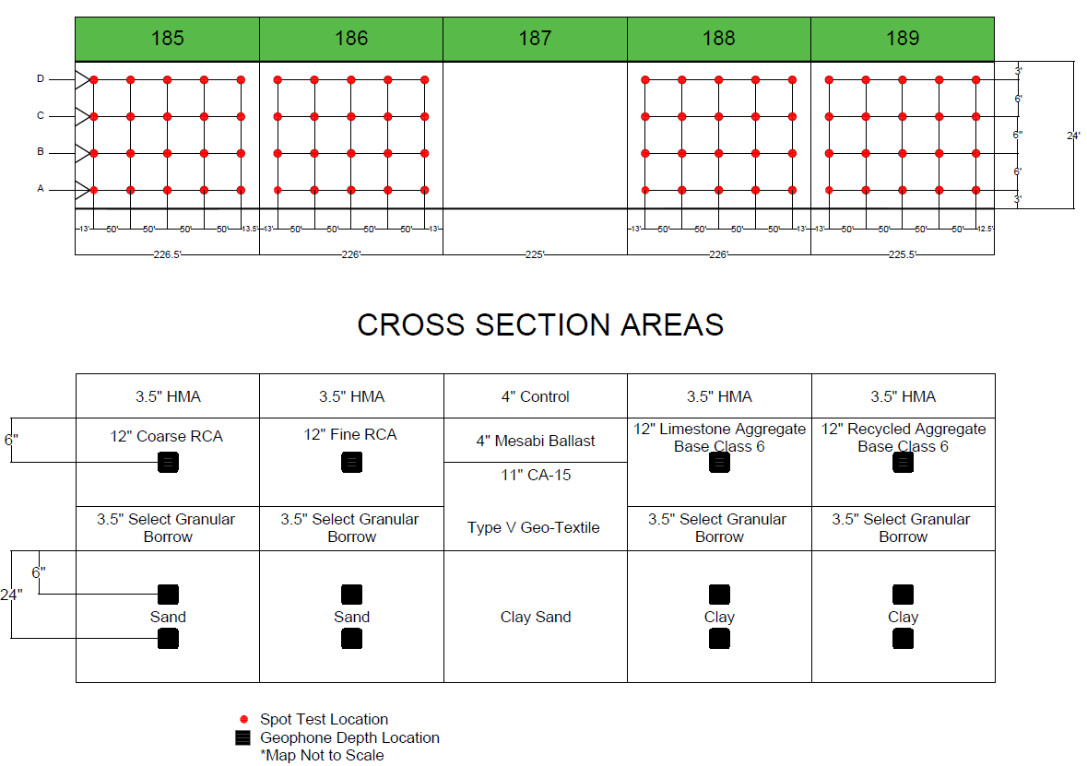
Figure 1 – Schematic of test layout along Cells 185 through 189.
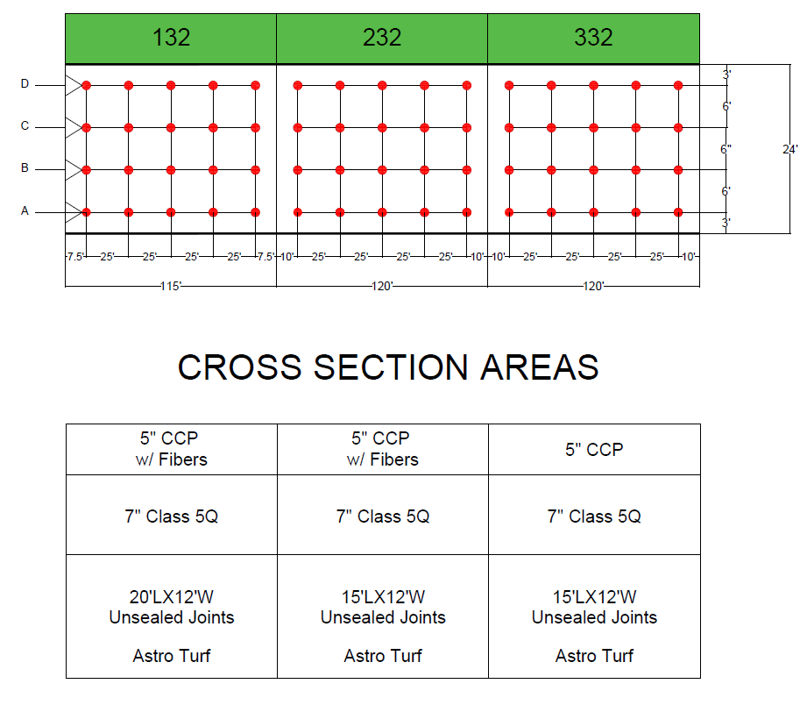 Figure 1 – Schematic of test layout along Cells 132 through 332
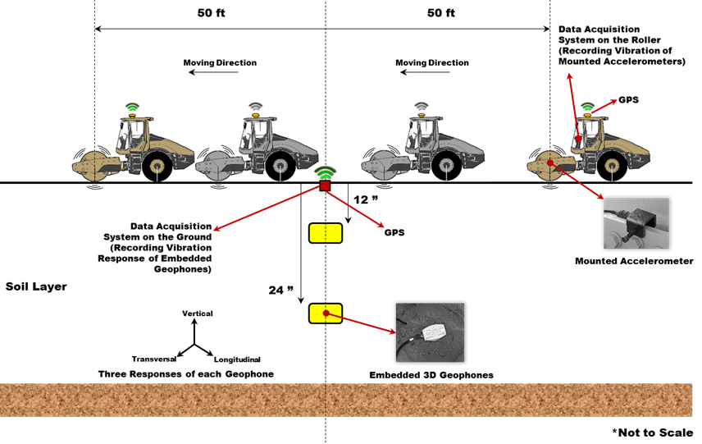
Figure 3 – Data acquisition system for calibration process.
- Carry out Tests on Cells. UTEP with the help of CAT will map the test section using one forward pass of the IC roller. UTEP will carry out spot tests shortly after compaction at a time that is least disruptive to the Contractor. UTEP team members will select a minimum of twenty (20) points for correlation testing as shown in Figures 1 and 2. The proposed NDT devices for these tests include:
- Nuclear Density Gauge (NDG) by MnDOT
- Dynamic Cone Penetrometer (DCP) by UTEP/MnDOT
- Light Weight Deflectometer (LWD) by UTEP/MnDOT
- Portable Seismic Property Analyzer by UTEP
- Moisture sample (five random locations) for validation of NDG
Instrumentation. A data acquisition system (DAQ) has been developed at UTEP to collect vibration data and ground response during IC operations. A schematic of the system is depicted in Figure 4. The system consists of two accelerometers that are mounted on the roller (drum), a data acquisition box, a GPS antenna and receiver, a power supply and a laptop computer to monitor the data collection process.
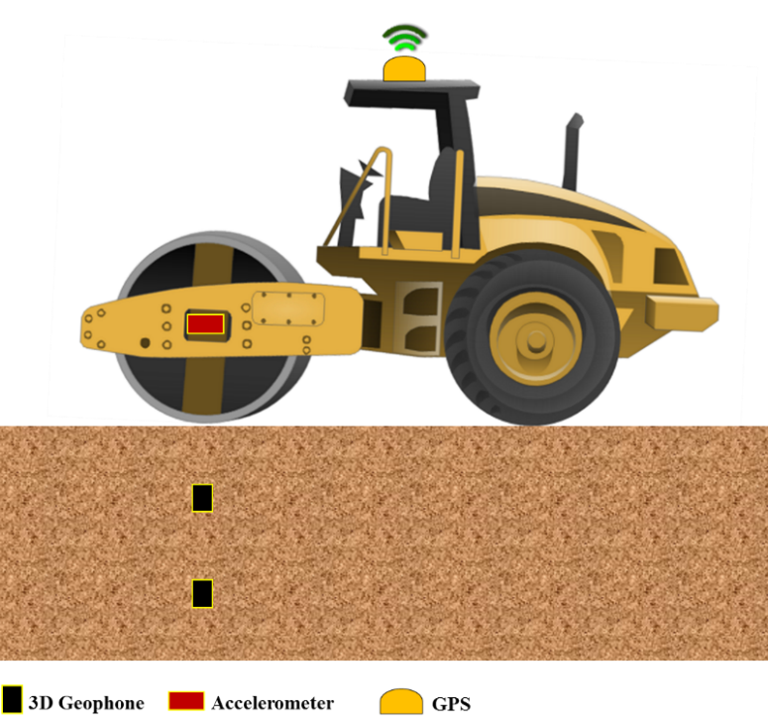
Figure 4 – Schematic of the IC calibration system.
A similar data acquisition system has been developed to monitor the propagation of roller vibration within the geomaterials by embedding geophones at different depths in the subsurface layers. Its components are shown in Figure 5. A second GPS system will be used to synchronize the geophone data with the accelerometers mounted on the rollers. The geophones will be embedded in the existing ground layer (before placement of the new test layers) to monitor the soil layer responses during the IC operation. The geophones record the vertical, transversal and/or longitudinal amplitudes of vibration, with the longitudinal response being in the same direction as the roller movement and the transversal response being perpendicular to the moving direction.
Laboratory Evaluations: the purpose of laboratory evaluations is to determine the correlation between extracted mechanical properties of compacted geomaterials under field conditions with those estimated under laboratory conditions. All necessary index and moisture-density tests will be carried out as per AASHTO test methods. The resilient modulus tests will be carried out as per AASHTO T-307 in duplicate. The laboratory evaluations include traditional repeated load triaxial MR tests at different moisture contents (as successfully utilized in NCHRP 10-84 project for spot tests):
- OMC.
- OMC±1% or OMC±10%OMC (if OMC<10%).
- OMC±2% or OMC±20%OMC (if OMC>10%).
to achieve the following objectives:
- Determine moduli and their variations with moisture under constant compaction energy.
- Validate selected relationships between moisture/degree of saturation and modulus.
- Develop correlation between extracted field mechanical properties and laboratory resilient modulus

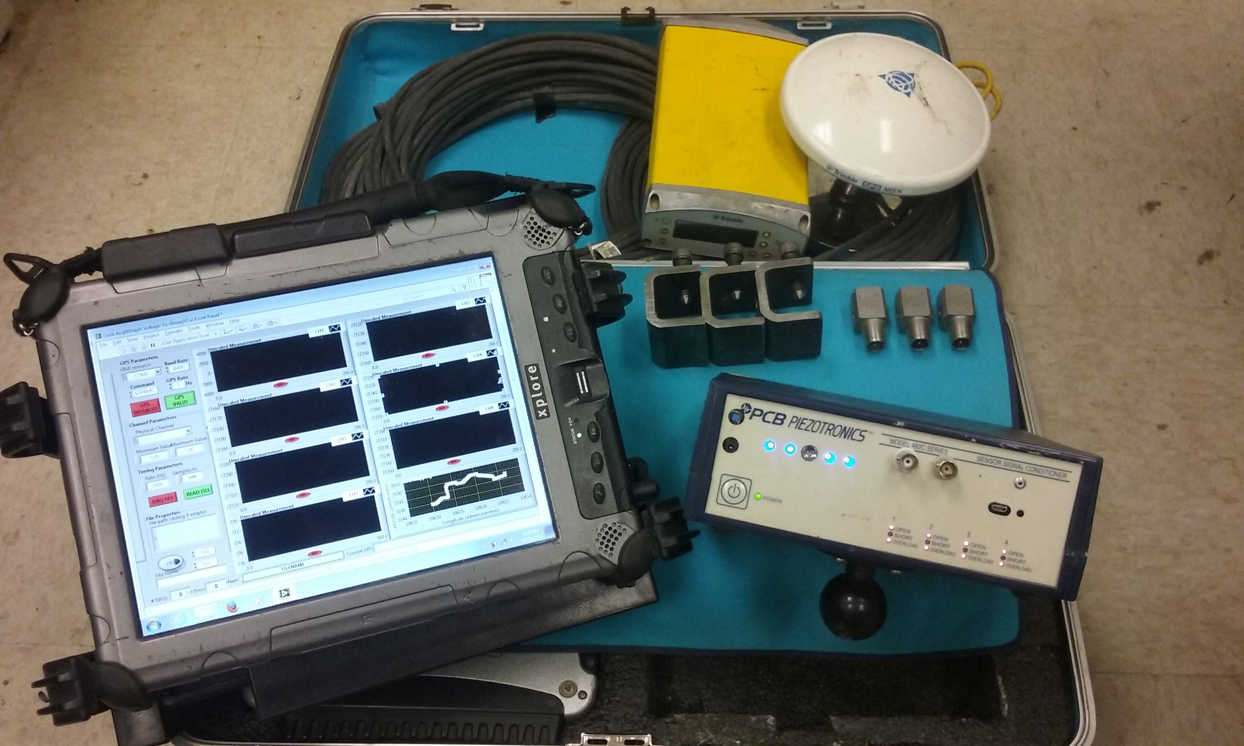
Data Acquisition Box and Laptop
3D Geophone
Accelerometer
Figure 5 – Components of the data acquisition system developed for this research.

Cell 187 will be tested but not the focus of project

