**District 3 Rolling Density Meter Trial:**

**S.P. 1118-21 on TH 371, Contractor Experience**

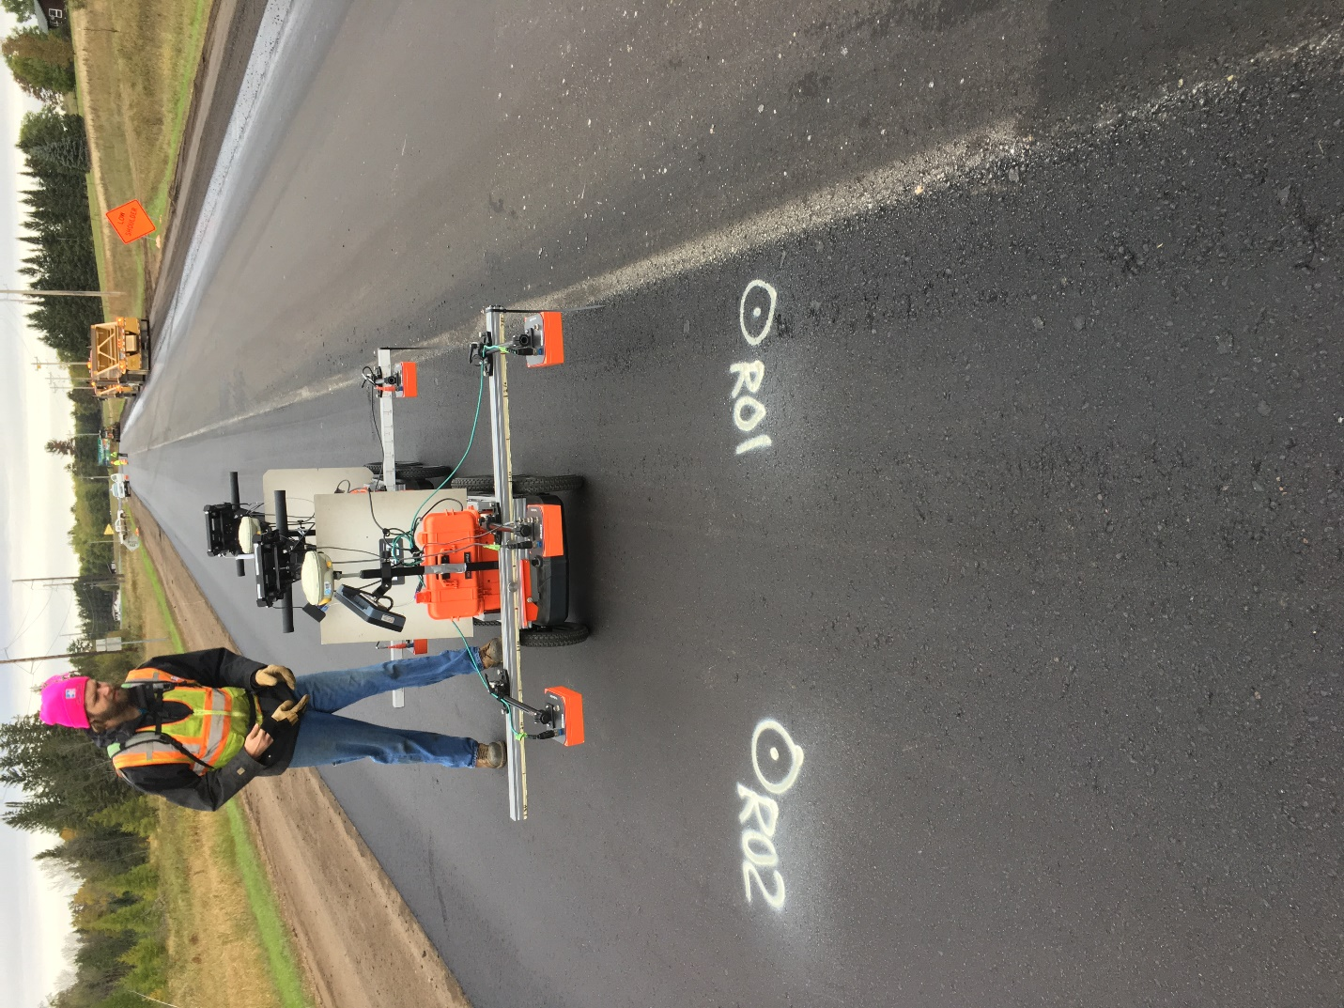

**Kyle Hoegh email: kyle.hoegh@state.mn.us**

**Shongtao Dai email: Shongtao.dai@state.mn.us**

**Minnesota Department of Transportation**

**Materials and Road Research Lab**

October 4th, 2018

**Summary Results**

A rolling density meter (RDM) is currently being used to collect data on a section of highway 371 between Backus and Hackensack, MN. The contractor was hired to collect rolling density meter data to provide feedback on feasibility of the data collection process and usefulness of the technology in providing a continuous asphalt compaction assessment. The following bullets summarize some of the key findings from the RDM testing and analysis the first day of testing October 1st. The contractor is collecting data on the project currently with periodic MnDOT collection side by side. The project is scheduled to finish tomorrow, October 5th:

* RDM measured dielectric results agreed well when comparing the contractor collected data (RDM1) to MnDOT collected data with a second cart (RDM2).
  + Similar swerve calibration results were observed for outside sensors of both carts throughout the day. Figure 1 shows an example swerve pattern of both carts with the geospatially located data (top) and histogram comparison (bottom) showing median dielectrics of outside sensors within 0.04 of each other.
  + Similar compaction profiles on joint versus mat throughout the day
* RDM measurements are able to map real time high and low compaction areas with higher dielectric values indicating better compaction, and lower dielectric values indicating lower compaction. The contractor took cores and measured air void content at an example location with high and low dielectric RDM readings. The contractor measured results confirmed RDM compaction measurements (see figure 2):
  + R01: MnDOT dielectric = 4.0, Contractor Dielectric =4.1, Contractor Core = 87.8% AV
  + R02: MnDOT dielectric = 4.7, Contractor Dielectric =4.6, Contractor Core = 94.2% AV
* RDM geospatial results should be compared with other IC technology on the project, especially the breakdown roller in the area of the low (87.8%) relative density core R01 to investigate possible causes of the poor compation.
* Some connection issues were observed with sensor 22 and 72. Working theories are that there was a possible loose connection in terminal three of RDM1 or a new software setting caused the connection problem. These issues are currently resolved, but are being monitored by current testing on this project.
* Swerve calibrations showed middle sensors on both machines out of the 0.1 spec. A beta version of software to correct for out of spec cores was released to MnDOT October 4th, 2018, and will be trialed October 5th using the MnDOT testing equipment RDM2. This software is designed to account for sensor variability on the fly during the data collection process.
* Initial results indicate that coreless calibration of the RDM dielectric values to field air void content is promising. The travel time measurements of pucks with air void content designed to be 3, 7, and 11, and 15 percent air void content from the test strip predicted the air void content observed in R01 and R02 field cores well. However, this process should be confirmed from pucks for more days of paving. The surface reflection method of the pucks should also be investigated in more detail to confirm travel time results. The scatter of the travel time results should also be reduced for more precise preditions.

**Pictures and Captions of RDM Results**



Figure 1. Example swerve test data from both RDM1 and RDM2 showing similar results , and geospatial mapping of the results. Median dielectrics for the outside sensors of RDM1 and RDM2 were within 0.04 of each other in this test.

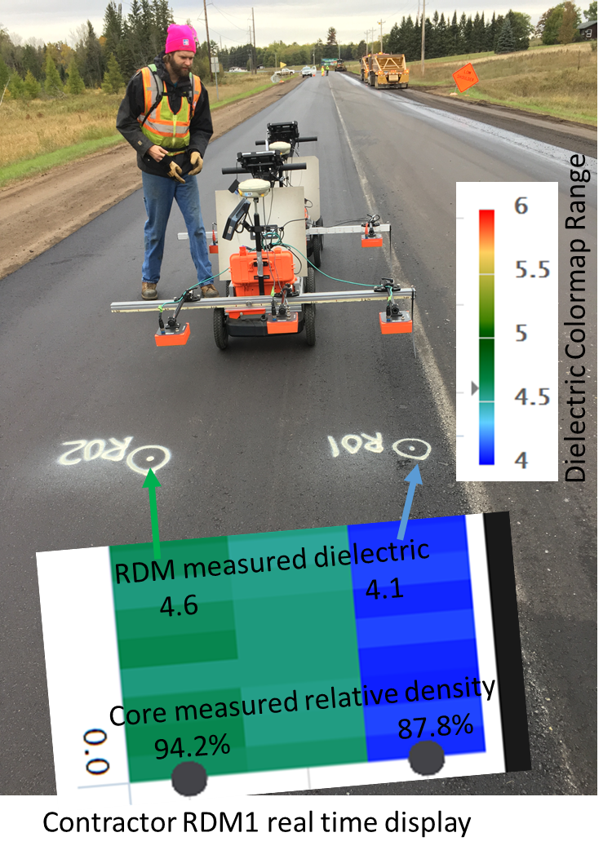

Figure 2. Contractor RDM real-time colormap display of dielectric values indicating a low compaction area at the joint. Blue represents a dielectric of 4.1 and green represents a dielectric of 4.6 on the colorscale shown for this project.

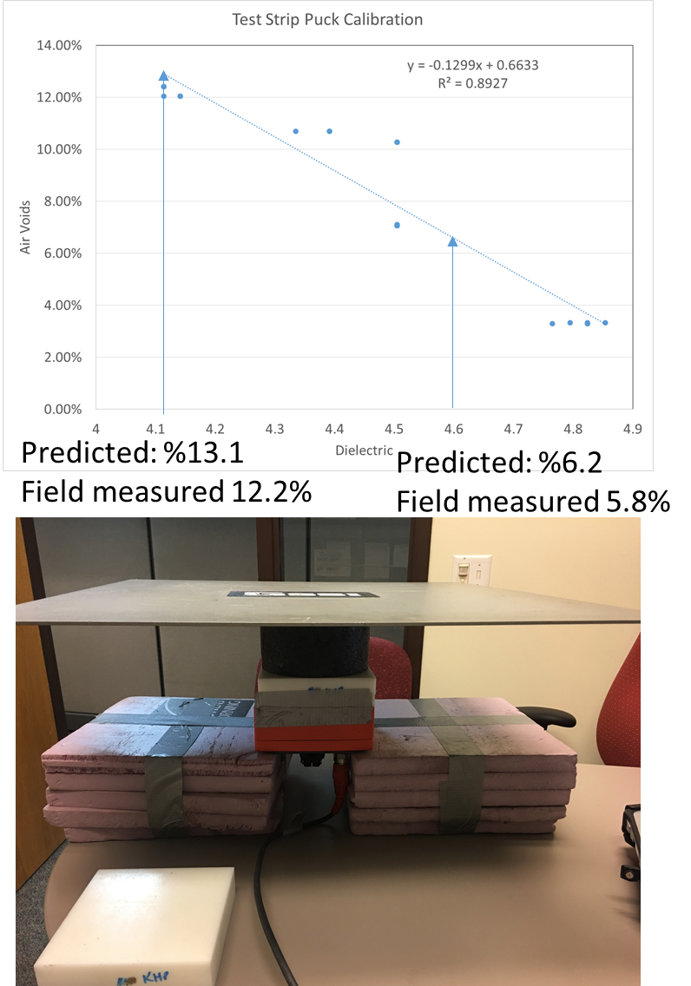

Figure 3. Test strip puck calibration using travel time within the puck to calibrate dielectric to pucks designed to have 3, 7, 11, and 15% air voids. The actual air voids ranged from 3 to 12%. It can be observed that despite the significant scatter, the r-squard of 0.89 and close predictions based on no field cores were very close to the observed cores R01 and R02 in those locations. The surface reflection method, that has been used successfully in the past for puck calibration did not produce meaningful results, and will be investigated.