Draft Meeting Notes

NRRA Intelligent Construction Technologies (ICT) Team

Date: July 9, 2020
Prepared by: John Siekmeier
Location: Skype

Attendance

Agency Members

Participated | Affiliation | State Contact | e-mail
☒ | California | Deepak Maskey | deepak.maskey@dot.ca.gov
☒ | California | Ragu Thangavelautham | raguparan.thangavelautham@dot.ca.gov
☐ | Illinois | Brian Hill | Brian.Hill@illinois.gov
☒ | Minnesota | Rebecca Embacher | rebecca.embacher@state.mn.us
☒ | Minnesota | Kyle Hoegh | kyle.hoegh@state.mn.us
☐ | Missouri | Jen Harper | Jennifer.Harper@modot.mo.gov
☐ | Missouri | Dan Oesch | Daniel.Oesch@modot.mo.gov
☒ | North Dakota | Curt Dunn | cdunn@nd.gov
☒ | North Dakota | Amy Beise | abeise@nd.gov

Associate Members

Participated | Affiliation | Contact | e-mail
☐ | American Engineering and  Testing, Inc. | Derek Tompkins | dtompkins@amengtest.com
☒ | Braun Intertec | Mohammad Sabouri | msabouri@braunintertec.com
☐ | Braun Intertec | Heidi Olson | holson@braunintertec.com
☐ | California State University, Los  Angeles | Mehran Mazari | mmazari2@calstatela.edu
☐ | Caterpillar Global Paving | Bryan Downing | Downing_Bryan_J@cat.com
☐ | Caterpillar Global Paving | Todd Mansell | mansell_todd_w@cat.com
☐ | Concrete Paving Association | Matt Zeller | mjzeller@cpamn.com
☒ | The University of Texas at El  Paso | Nazarian Soheil | nazarian@utep.edu
☐ | GSSI | Roger Roberts | roger@geophysical.com

☐ | GSSI | Rob Sommerfeldt | sommerfeldtr@geophysical.com
☒ | Infrasense | Ken Maser | kmaser@infrasense.com
☐ | Leica Geosystems | Brad Adams | brad.adams@leicaus.com
☒ | Mathy Construction | Erv Dukatz | ervin.dukatz@mathy.com
☐ | Mathy Construction | Matt Oman | matt.oman@mathy.com
☐ | Midstate Reclamation &  Trucking, Inc. | Dan Schellhammer | dans@midstatecompanies.com
☐ | Midstate Reclamation &  Trucking, Inc. | John Peterson | johnp@midstatecompanies.com
☐ | Minnesota Asphalt Paving  Association | Brandon Brever | bbrever@mnapa.org
☒ | Moba | Paul Angerhofer | pangerhofer@moba.de
☒ | The Transtec Group, Inc. | George Change | GKChang@TheTranstecGroup.com
☐ | Topcon Positioning Systems,  Inc. | Evan Monroe | emonroe@topcon.com
☒ | Topcon Positioning Systems,  Inc. | Jim Preston | jpreston@topcon.com
☐ | Trimble | Kevin Garcia | kevin_garcia@trimble.com
☐ | Trimble | Devin Laubhan | devin_laubhan@trimble.com
☒ | Wirtgen Group | Tim Kowalski | Tim.Kowalski@wirtgen-group.com
☒ | Wirtgen Group | Nars Laikram | Laikram.Narsingh@wirtgen- group.com
☐ | WSB & Associates | Mike Rief | mrief@wsbeng.com
☒ | WSB & Associates | Andrea Blanchette | ablanchette@wsbeng.com

Friends

Participated | Affiliation | State Contact | e-mail
☒ | FHWA – MN | Kevin Kliethermes | Kevin.Kliethermes@dot.gov
☐ | Minnesota | Curt Turgeon | curt.turgeon@state.mn.us
☒ | Minnesota | Ben Worel | ben.worel@state.mn.us
☒ | Minnesota | Lauren Dao | Lauren.Dao@state.mn.us
☒ | Minnesota | John Siekmeier | john.siekmeier@state.mn.us
☒ | Minnesota | Shongtao Dai | shongtao.dai@state.mn.us
☒ | Minnesota | Joel Ulring | joel.ulring@state.mn.us
☐ | North Dakota | Jordan Nehls | jnehls@nd.gov
☐ | North Dakota | Darin Lindblom | dlindblom@nd.gov
☐ | North Dakota | Carey Schreiner
☐ | North Dakota | David Bruins
☐ | North Dakota | Nathan Haaland

Other Attendees: Brian Nagel, David Howley

Action items:
Team members will send Veta enhancement ideas to Rebecca.
Team members will send MnROAD construction ideas to Ben.
Ben will send results of NRRA Call for Innovation to members.
Lauren will send reminders/invitations for ICT webinars and team meeting presentations.

Next Meeting

Date: August 6, 2020
Time: 10:30-11:30AM Central Time
Location: Skype

Agenda: NRRA ICT Project Update “Evaluation of Levels 3-4 ICMV for Base & Subbase Compaction”

Meeting Notes

Welcome

NRRA Call for Innovation (Worel)

The NRRA Call for Innovation received more than 20 proposals.

NRRA Call for MnROAD Construction (Worel)

There are test sections at MnROAD available for new experiments. Partnerships are welcome and encouraged. Call for construction is for ideas to build new test cells. Reaching out to private sector funding and ideas for next activities. No due date, but sooner is better because ideas submitted earlier are more likely to be considered by the Executive Committee. Approximately six test sections, which no longer have research value, are available. Ideas for both low volume road and mainline are requested.

Veta Pooled Fund TPF-5[334] (Embacher)

Pooled fund met and discussed remaining budget and phase II being incorporated under NRRA Phase II. Phase I still has some budget remaining to add further enhancements to Veta. Pooled fund participants are working on updating the wish list of items and determining which items to move forward under the current available budget. Let Embacher know if you have any items that you would like added to the wish list.

Tim Kowalski: 3D schematics (layer IC, PMTP, and DPM data)
Curt Dunn: Current Weather Conditions & Forecast Import
Kyle Hoegh: Can Dielectric items be added to wish list. (Embacher – yes, but may not be funding under this pooled fund.

Reminder: GSSI needs to deliver data to Transtec before August 15th. Data must comply with TDS format for this work task to be completed under this contract.

Reminder: Please send dielectric profile method items to Rebecca to get these added to the Veta wish list. MnDOT cannot commit to spending the remaining money from Phase I of the TPF-5 (334) pooled fund on these items as that pooled fund was not set up to include the dielectric profile method, but solely IC and PMTP. Additionally, MnDOT will need to discuss future dielectric profile method funding with the state DOTs participating in both pooled funds about how to navigate dielectric profile method funding going forward (whether it should be included under the dielectric pooled fund or Phase II of the Veta pooled fund). There is overlap between these two pooled funds and there are already Veta enhancements included in the dielectric pooled fund. It is not appropriate for MnDOT to recommend contract tasks without input and consent from all the pooled fund states regarding how their money is spent. The Veta pooled fund has been making decisions by consensus so all the state DOTs determine how their money is spent.

Reminder: Veta 6 with new enhancements is available. Please see this link https://www.intelligentconstruction.com/veta/
Please note that website address changed from “intelligent compaction” to “intelligent construction.” Reminder that you may have web pages that need to updated to include this new address.

Reminder: MnDOT Veta 6 training class is online at http://www.dot.state.mn.us/materials/amt/vetaclass/
Please note that the current focus has been to create videos and workflows, which are intended to provide a learning process useful to individuals with various learning styles. Several mention great job getting all the Veta training online.

Reminder: The pooled fund expires December 31, 2020, and therefore we need to start processing the paperwork for the second phase.

NRRA Workshop Modified to Multiple Webinars (Worel)

A lot of different webinars. Good participation and feedback. Going well.

Registration and Webinar Links can be found at:
http://www.dot.state.mn.us/mnroad/nrra/pavement-workshop/index.html

Webinar #1: Thursday, June 18, 2020

“Paver Technology to Solve Segregation and Smoothness Issues”

Speakers: Narsingh Laikram (Wirtgen Group), Henry Polk (Bomag), Todd Mansell (CAT)

Interactive audience, good attendance, material of significant interest

Webinar #2: Wednesday, July 8, 2020

“Intelligent Construction Technologies (ICT) and What We Learned”

Moderator: George Chang, The Transtec Group

“State Update: Continuous Asphalt Compaction Assessment using Dielectric Profile Method” Speaker: Craig Landefeld, Ohio DOT

“Improving Workmanship using the Paver Mounted Thermal Profile Method”

Speaker: Ed Morison, Shelly and Sands

“Florida DOT’s Experience with e-Ticketing” Speaker: Richard Hewitt, Florida DOT

Interactive audience, good attendance, material of significant interest

Webinar #3: Wednesday, August 12, 2020

"Best Practices of AMG Milling and Paving from Design to Construction"

Speakers: Kyle Klasen (WSB and Associates), Thomas Abell (Ziegler | CAT),

Dan Schellhammer (Midstate Reclamation & Trucking, Inc.)

Moderator: Curt Turgeon (MnDOT)

Project Updates during Monthly ICT Meetings (Embacher)

August 6 “Evaluation of Levels 3-4 Intelligent Compaction Measurement Values (ICMV) for Soils Subgrade and Aggregate Subbase Compaction”
Soheil Nazarian, Ph.D. (UTEP) and George Chang, Ph.D. (The Transtec Group)

September 3 “Seismic Approach to Quality Management of Asphalt Pavement”

Choon Park, Ph.D. (Park Seismic)

Australian Asphalt Pavement Association (AAPA)
Master Class 2020 | Interactive Forum with IC Masters and Veta Training
Day 1 – July 9 – Interactive Forum with IC Masters
- State of the Practice (George Chang)
- State of the Art (Soheil Nazarian)
- Importance of Intelligent Compaction – MnDOT Perspective (Rebecca Embacher)
- Intelligent Compaction in Australia Update – Nacoe Project (Jeffrey Lee)
Day 2 – July 16 – Veta Training (3 hours)
Well received, about 50 participants, interactive questions

E-Ticketing (Embacher)
June 11, 2020: AASHTO Coordination of e-Ticket Activities
AASHTO, AASHTOWare, Infotech, State AASHTO Representatives
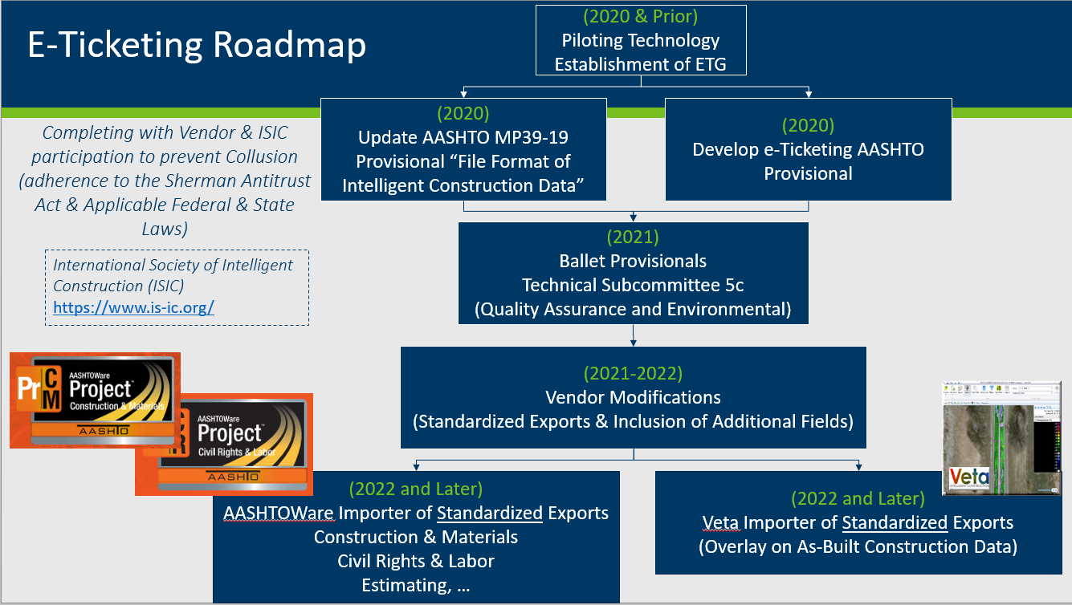
Starting to coordinate meetings for establishment of standardized export from Centralized Plants to e-Ticketing Vendors
API Code | Transfer digital ticket information from Centralized Plants to Vendor Portal
Vendor Portal | Vendor stores and imports digital data into e-ticketing solution

FHWA Every Day Counts (EDC) – 6
Leap Not Creep Training | Develop draft EDC-6 implementation plan to guide the summit and development efforts.
- Digital As-Builts / Digital Construction Delivery
  - Lead: Dave Unkefer (FHWA)
  - Dates: July 14, 21, 23, 28, 30
- E-Ticketing
  - Lead: Kat Weisner (FHWA)
  - Dates: July 15, 21, 23, 28, 30

Please see NRRA ICT team webpage:

http://www.dot.state.mn.us/mnroad/nrra/structure-teams/intelligent-construction/index.html

NRRA Pooled Fund Phase 2

Solicitation has been posted as “National Road Research Alliance - NRRA (Phase-II) https://www.pooledfund.org/Details/Solicitation/1531

DOT contributions per previous, but with Veta development participation option added for $25k.

Reminder for states to look at Phase II NRRA solicitation and show interest/contribution promises. After dollar amount reached can start moving forward. Michigan and Minnesota have currently put in.

