Transportation Pooled Fund Project 5(165)
DEVELOPMENT OF DESIGN GUIDE FOR THIN AND ULTRA-THIN CONCRETE OVERLAYS OF EXISTING ASPHALT PAVEMENTS

TASK 1 REPORT:

COMPILATION AND REVIEW OF EXISTING PERFORMANCE DATA AND INFORMATION

Prepared by
Manik Barman
Dr. Julie Vandenbossche
Feng Mu
Kerri Gatti



Department of Civil and Environmental Engineering
Swanson School of Engineering
University of Pittsburgh

Technical Report Documentation Page
1. Report No. | 2. | 3. Recipients Accession No.
4. Title and Subtitle  Development of Design Guide for Thin and Ultra-thin Concrete Overlays of Existing Asphalt Pavements, |  | 5. Report Date  May 2011
Task 1 Report: Compilation and Review of Existing Performance Data and Information
 |  | 6.
7. Author(s) |  | 8. Performing Organization Report No.
Julie Vandenbossche, Manik Barman, Feng Mu, Kerri Gatti
9. Performing Organization Name and Address |  | 10. Project/Task/Work Unit No.
University of Pittsburgh  Department of Civil and Environmental Engineering  Swanson School of Engineering, Benedum Hall 934  Pittsburgh, PA 15260 |  | TPF 5(165)/Task 1
 |  | 11. Contract (C) or Grant (G) No.
12. Sponsoring Organization Name and Address |  | 13. Type of Report and Period Covered
Minnesota Department of Transportation  395 John Ireland Boulevard  St. Paul, MN 55155 |  | Task 1 Report, 2008-2009
 |  | 14. Sponsoring Agency Code
15. Supplementary Notes
First of 8 task reports from this project.
16. Abstract (Limit: 200 words)
The objective of this pooled fund study is to develop a rational mechanistic-empirical based design guide for bonded whitetopping. In Task 1 of the study, common types of distresses were identified so that the project team could understand how they initiate and progress over the life of the overlay with respect to traffic and environmental loads. Information was collected about the design features and performance of existing bonded whitetopping projects. Findings indicate that the performance of a thin whitetopping section depends to a large extent upon support conditions provided by the existing asphalt. Successfully performing projects had an underlying asphalt layer thickness (after milling) of more than 3 inches, unless a concrete layer was also available underneath. The type of distress that develops in a whitetopping is primarily a function of the thickness of the PCC, while the extent of the deterioration appears to be related to the thickness and quality of the existing HMA and the joint layout. If the stiffness ratio of the PCC and HMA layers falls below one, there is an increase in the potential for reflective cracking into the whitetopping overlay. Additional test sections need to be constructed to help quantify the affect of fibers on joint performance.
17. Document Analysis/Descriptors |  | 18. Availability Statement
MnROAD  Whitetopping  Pavement Rehabilitation | Concrete Overlay  Pavement Design  Pavement Distress | No restrictions. Document available from:  National Technical Information Services,  Springfield, Virginia 22161
19. Security Class (this report) | 20. Security Class (this page) | 21. No. of Pages | 22. Price
 |  | 112

TABLE OF CONTENTS
LIST OF FIGURES v
LIST OF TABLES vii
GLOSSARY OF ACRONYMS ix
FOREWARD x
1 INTRODUCTION 1
2 OBJECTIVE OF TASK 1 2
3 FHWA ALF PROJECT IN VIRGINIA 3
3.1 Summary of distress observations 7
3.2 Analysis of pavement distresses 8
3.2.1 Corner cracking 9
3.2.2 Mid-slab cracking 10
3.2.3 Joint faulting 11
3.2.4 Joint spalling 11
3.3 Conclusion 12
4 MINNESOTA 13
4.1 MnROAD research facility 13
4.1.1 Design features 15
4.1.2 Distress data 17
4.1.3 Factors affecting performance 27
4.1.4 Reflection cracking 33
4.2 Intersections on US-169, Elk River 38
4.2.1 Analysis of performance 40
4.3 LoRay Drive, North Mankato 45
4.4 TH-30, Mankato 45
4.5 Conclusion 48
5 PENNSYLVANIA 48
5.1 Intersection of State Route (SR)-133 and SR-100, Chester County 48
5.2 SR-30, Lancaster County 49
5.3 Conclusion 50
6 TEXAS 50
6.1 Intersections on LP-250 at Wadley Road, Holiday Hill Road and Midland Drive, Midland 50
6.2 Intersection of LP-250 at Midkiff Road and Garfield Road, Midland 52
6.3 Conclusion 53
7 MISSOURI 53
7.1 Intersection of SR-291 and SR-78, Independence 54
7.2 US-60, between US-71 and BUS-71, near Neosho 55
7.3 US-169 and SR-YY intersection, St. Joseph 57
7.4 Other projects in Missouri 58
7.5 Conclusion 59

8 MISSISSIPPI 60
8.1 Intersection of SR-15 and US-80, Newton County 60
8.2 Intersection of 22nd Avenue and North Frontage Road, Lauderdale, MS 61
8.3 Intersection of SR-35 and US-80, Scott County 62
8.4 Conclusion 63
9 NEW YORK 63
9.1 Intersection at Waldon Avenue and Central Avenue, near Buffalo 63
9.2 NY-408 and SH-622, Rochester 64
9.3 Conclusion 64
10 ILLINOIS 65
10.1 IL-146, Anna 65
10.2 Intersection of US-36 and Oakland Avenue, Decatur 69
10.3 US-36, Tuscola 71
10.4 Highway-2, Cumberland County 73
10.5 Highway-4, Piatt County 75
10.6 US-36 and Country Club Road, Decatur 76
10.7 Conclusion 78
11 IOWA 78
11.1 R-16, Dallas County 79
11.2 IA- 21, Iowa County 80
11.3 Conclusion 83
12 MICHIGAN 83
12.1 Patterson Avenue, from 44th Street to 36th Street, Kentwood 83
12.2 Zeeb Road, Ann Arbor, Washtenaw 85
12.3 Schaefer Highway, Detroit, Wayne County 86
12.4 Conclusion 86
13 OKLAHOMA 86
13.1 US-69, North of Stringtown, Atoka County 86
13.2 US-69, North of McAlester, NB and SB Lanes, Pittsburg County 86
13.3 Conclusion 87
14 OVERALL CONCLUSIONS 87
REFERENCES 99

LIST OF FIGURES
Figure 1: Schematic of distress in the UTW lanes at the FHWA ALF (a) Lane 5; (b) Lane 6; (c) Lane 7; (d) Lane 8; (e) Lane 9; (f) Lane 10; (g) Lane 11 and (h) Lane 12. 5
Figure 2: Typical UTW transverse cracking at the FHWA ALF. 6
Figure 3: Typical UTW corner cracking at the FHWA ALF. 6
Figure 4: Typical UTW longitudinal faulting at the FHWA ALF. 6
Figure 5: Comparison of HMA rutting to UTW cracking. 9
Figure 6: Permanent deformation of HMA base. 10
Figure 7: Mid-slab cracking mechanism of an UTW slab. 11
Figure 8: Longitudinal joint faulting mechanism in ALF UTW slabs. 11
Figure 9: Transverse joint faulting mechanism in ALF UTW slabs. 12
Figure 10: Joint spalling mechanism in ALF UTW slabs. 12
Figure 11: Layout of test cells at the MnROAD facility. 14
Figure 12: Test cells constructed during Oct 1997 and 2004. 14
Figure 13: Test cells constructed during 2008. 15
Figure 14: Performance history for (a) Cell 93, (b) Cell 94 and (c) Cell 95 from 1997 to 2001. 19
Figure 15: Longitudinal cracking history for Cells 92, 96 and 97 (11.5 years, 9.8 million ESALs); 60-63 (4.5 years, 3.8 million ESALs). 21
Figure 16: Transverse cracking history for Cells 92, 96 and 97 (11.5 years, 9.8 million ESALs); 60-63 (4.5 years, 3.8 million ESALs). 21
Figure 17: Corner cracking history for Cells 92, 96 and 97 (11.5 years, 9.8 million ESALs); 60-63 (4.5 years, 3.8 million ESALs). 22
Figure 18: Longitudinal cracks in Cell 97. 23
Figure 19: Longitudinal cracks in Cells 60 and 62. 23
Figure 20: Longitudinal cracks in Cells 61 and 63. 24
Figure 21: Reflection transverse cracks in Cell 61. 24
Figure 22: Reflection transverse cracks in Cell 63 at two locations. 25
Figure 23: Faulting history for MnROAD cells until October 2007. 26
Figure 24: IRI history for MnROAD cells until March 2008. 26
Figure 25: Corner cracks along the inside wheelpath on Cell 94. 28
Figure 26: Distress is reduced with the 5-ft x 6-ft panels because the wheelpath is not located adjacent to the longitudinal joint (Burnham, 2005). 29
Figure 27: Faulting of panels in Cell 97(undoweled) but no faulting in Cell 92 (1-in dowels). 30
Figure 28: Difference in the amount of water infiltrating the surface for the sealed 31
Figure 29: Strain directly under a 9-kip FWD load applied in the wheelpath adjacent to a transverse joint on a 3-in overlay with 5-ft x 6-ft panels. (Vandenbossche, 2005) 32
Figure 30: Relative stiffness of PCC and HMA layers for Cells 92 through 97. 37
Figure 31: Relative stiffness of PCC and HMA layers for Cells 60 through 63. 37
Figure 32: Layout of the UTW sections at the intersections of US-169. 40
Figure 33: Transverse crack and corner breaks in the Jackson Street test section (03.30.98). (Vandenbossche, 2003) 42
Figure 34: Corner breaks in the inside wheelpath at the Jackson Street test section. (07.20.99) (Vandenbossche, 2003) 42
Figure 35: Typical distress patterns that developed at the 6 ft x 6 ft Main Street test intersection. (Vandenbossche, 2003) 43
Figure 36: Relative stiffness of PCC and HMA layers for US-169 UTW test sections……….44
Figure 37: Plot of IRI data for TH-30 from 1994 to 2001. 47
Figure 38: UTW at the intersection of LP-250 and Midland Drive at Odessa District. 51
Figure 39: UTW at the intersection of LP-250 and Wadley Avenue at Odessa District. 52
Figure 40: Anna project layout (Winkelman, 2005)…………………………………………...66
Figure 41: Distresses with respect to ESALs. 68
Figure 42: Distressed panels at the intersection. (Winkelman, 2005) 69
Figure 43: Movement of the panels toward the intersection 71
Figure 44: Blow up of the UTW slabs (Winkelman, 2005). 78
Figure 45: Condition of the original HMA layer at the time of construction. 84
Figure 46: Condition of the UTW after two years (2008). 85
Figure 47: Transverse crack development in overlays < 4 in. 96

LIST OF TABLES
Table 1: Whitetopping categories. 1
Table 2: HMA characteristics at the FHWA ALF. 4
Table 3: Lane assignments for UTW designs at the FHWA ALF. 4
Table 4: Summary of the design features for the MnROAD whitetopping cells. 16
Table 5: Concrete mixture design information for MnROAD whitetopping cells. 17
Table 6: Summary of cracks for MnROAD test sections. 20
Table 7: Summary of transverse reflection cracking for1997 and 2004 MnROAD cells..........34
Table 8: Asphalt resilient modulus at different temperatures for MnROAD sections. 35
Table 9: Summary of the design features for the US-169 cells. 39
Table 10: Concrete mixture design for the US-169 cells. 39
Table 11: Design features for sections at TH-30. (Burnham and Rettner, 2002) 46
Table 12: Summary of visual distresses for the sections of TH-30. …………………………. Burnham and Rettner, 2002) 47
Table 13: Concrete mixture design information. 49
Table 14: Concrete mixture design information. 51
Table 15: Concrete mixture design information 53
Table 16: Layer properties of the project at SR-291 and SR-78. 54
Table 17: Concrete mixture design information. 55
Table 18: Layer properties of US-60 project. 56
Table 19: Concrete mixture design information. 56
Table 20: Layer properties for the US-169 project. 57
Table 21: Concrete mixture design information. 58
Table 22: Layer properties for the project at MO-5, railroad crossing in Lebanon. 59
Table 23: Layer properties for the project at BUS-13 in Branson West. 59
Table 24: Layer properties for the project at the Intersection of BUS-13 and MO-14. 59
Table 25: Overlay design features and observed distress type for the project at 61
Table 26: Overlay design features and observed distress type for the project at 63
Table 27: Whitetopping project information in Illinois (Winkelman, 2005 and Roesler et al., 2008)………………………………………………………………………………………...…65
Table 28: Concrete mixture design information. 67
Table 29: Traffic details for the Anna Project. 67
Table 30: Distress summary until 2004. (Winkelman, 2005) 68
Table 31: Concrete mixture design information (Winkelman, 2005 and Roesler et al., 2008)..70
Table 32: Traffic details for the UTW project (Winkelman, 2005). 70
Table 33: Distress summary until 2004. (Winkelman, 2005) 71
Table 34: Concrete mixture design information. 72
Table 35: Traffic details for US-36 in Tuscola (Winkelman, 2005 and Roesler et al., 2008). 72
Table 36: Distress summary for the project until 2004 (Winkelman, 2005). 73
Table 37: Concrete mixture design. (Winkelman, 2005 and Roesler et al., 2008) 74
Table 38: Traffic details for Highway-2. 74
Table 39: Distress summary for the project. (Winkelman, 2005) 74
Table 40: Distress summary for the project. (Winkelman, 2005) 75
Table 41: Traffic volumes for the US-36 and County Club Road project. (Winkelman, 2005) 77
Table 42: Distress survey results for the project. (Winkelman, 2005) 77
Table 43: Iowa shear strength for different surface preparation techniques (Grove et al., 2001). 80
Table 44: ESALs from 1995 through 1999 (Cable et al., 2001). 81
Table 45: Details of pavement layers at Patterson Avenue, from 44th 84
Table 46: Summary of projects evaluated. 88

GLOSSARY OF ACRONYMS

- AADT: Annual Average Daily Traffic
- AASHTO: American Association of State Highway and Transportation Officials
- ACPA: American Concrete Pavement Association
- ADT: Average Daily Traffic
- ALF: Accelerated Testing Facility
- BM: Base mixture
- BUS: Business
- CIPR: Cold in-Place Recycle
- CDOT: Colorado Department of Transportation
- DOT: Department of Transportation
- FHWA: Federal Highway Administration
- HMA: Hot Mix Asphalt
- LP: Loop
- Mn/DOT: Minnesota Department of Transportation
- MnROAD: Minnesota Road Research Facility
- MO: Missouri
- NCHRP: National Cooperative Highway Research Program
- NY: New York
- PCA : Portland Cement Association
- PCC: Plain Cement Concrete
- PennDOT: Pennsylvania Department of Transportation
- I: Interstate
- IA: Iowa
- IL: Illinois
- SH: State Highway
- SM: Surface mixture
- SR : State Route
- TH: Truck Highway
- TS: Test Section;
- TWT: Thin Whitetopping
- US: United States
- UTW: Ultra-Thin Whitetopping
- WIM: Weigh-in-Motion

FOREWORD
As the need to rehabilitate asphalt roadways throughout the United States has increased significantly, so has the need for a more rational design method for one of the repair options known as “whitetopping.” While a handful of mechanistic and “rule of thumb” based design methods for whitetopping have been available for many years, the increasing need to work within ever shrinking budgets requires that those designs better predict long term performance.

This report comprises the first of 8 task reports written as part of the Transportation Pooled Fund Project 5(165): “Development of Design Guide for Thin and Ultra-thin Concrete Overlays of Existing Asphalt Pavements.” This project, started in September 2008, was created to address the urgent need by the pavement design community for a rational mechanistic-empirical based design method for whitetopping.

Special thanks are given to the states who generously donated toward this effort. Those states included: Mississippi, Missouri, Minnesota, New York, Pennsylvania, and Texas.

The participating states, as well as the overall pavement design community, are grateful for the hard work and dedication given by principal investigator Dr. Julie Vandenbossche and her students.

Tom Burnham, P.E.
Project Manager
Minnesota Department of Transportation

ACKNOWLEDGEMENTS

This report contains the performance review of existing bonded whitetopping projects based on data available in literature and personal communication with various state agencies. The Departments of Transportation from Pennsylvania, Minnesota, Texas, Mississippi, Missouri and New York were extremely helpful in providing performance data. Many local chapters of the American Concrete Pavement Association (ACPA) also contributed valuable information regarding the design and performance of these whitetopping projects, especially in Michigan and Oklahoma. The contributions of these agencies, directly or indirectly involved with this project are gratefully appreciated.

The authors would also like to acknowledge the contribution of the officials of the Minnesota Department of Transportation, Mn/DOT, for providing the distress data for the bonded whitetopping constructed at MnROAD. The time and effort dedicated by Mr. Thomas Burnham, Mr. Timothy Cline and Mr. Benjamin Worel is gratefully appreciated.

The authors express their sincere gratitude and acknowledge the kind cooperation extended by the following people:

- Mr. James Sherwood, Federal Highway Administration
- Mr. Benjamin E. Singer, Pennsylvania Department of Transportation, District 8
- Ms. Lorraine D. Ryan, Pennsylvania Department of Transportation, District 6
- Mr. Alan Cross, Mississippi Department of Transportation
- Mr. William Barstis, Mississippi Department of Transportation
- Mr. Hua Chen, Texas Department of Transportation
- Mr. John P. Donahue, Missouri Department of Transportation
- Mr. Michael Brinkman, New York State Department of Transportation
- Mr. Daniel M. Degraaf, Michigan Concrete Paving Association
- Mr. Steven M. Waalkes, Michigan Concrete Paving Association
- Mr. Clayton J. Stahl, President, Gulisek Construction, LLC
- Ms. Lynn Tiernan, Contract Administrator, Gulisek Construction, LLC
Mr. Brent Burwell, American Concrete Paving Association OK/AR Chapter

1 INTRODUCTION
Whitetopping is a rehabilitation technique that consists of a concrete overlay on a distressed asphalt pavement. Although this kind of rehabilitation technique has been reported in literature dating back to 1918, very few projects were noted until the 1990s (Rasmussen and Rozycki, 2004). Since 1992, this type of project has gained momentum in the United States with approximately 500 projects in existence across the country (Roesler et al, 2008). Projects of this type are also being constructed around the world in countries such as Canada, Brazil and Taiwan.

Within the category of whitetopping, there are additional classifications historically used based on the thickness of the Portland cement concrete (PCC) layer, as presented in Table 1. For this study, the focus will be on bonded whitetopping. This includes whitetopping historically referred to as thin and ultra-thin. For bonded whitetopping, a good bond must be achieved between PCC and hot mix asphalt (HMA) layers. This allows for a thinner PCC overlay to be constructed while still fulfilling the intended service life.

Table 1: Whitetopping categories.
Whitetopping category | PCC thickness (in)
Conventional whitetopping | > 6
Thin whitetopping (TWT) | 4 – 6
Ultra-thin whitetopping (UTW) | 2 – 4

The increasing popularity of this method of pavement rehabilitation has triggered many agencies to put effort towards the development of a design procedure. Many agencies, namely the Portland Cement Association (PCA), the Colorado Department of Transportation (CDOT), the New Jersey Department of Transportation, the American Concrete Pavement Association (ACPA), the Federal Highway Administration (FHWA), and the Illinois Department of Transportation (IlDOT) have proposed their own design procedures. Each procedure has its own advantages and disadvantages in comparison to the others. It is common for these procedures to have only been calibrated using a limited number of local projects. Based on that fact, their extensive use remains questionable. As per the National Cooperative Highway Research Program (NCHRP) Synthesis 338 (Rasmussen and Rozycki, 2004), state departments of transportation (DOTs) like Arizona, Iowa, Illinois, Mississippi, Texas, Missouri, Kansas and Utah adopted the ACPA design procedure for whitetopping design. Some states used the CDOT design procedure, while others referred to the 1993 American Association of State Highway Transportation Officials (AASHTO) Guide for the Design of Pavement Structures, which was not intended for the design of whitetopping. A considerable amount of projects were also constructed without following any method. A need for developing a mechanistic-empirical design procedure is then raised so that the whitetopping projects in the participating states can be carried out more successfully.

The objective of this pooled fund study is to develop a rational mechanistic-empirical based design guide for bonded whitetopping. In the first stage of the study, the common types of distresses were identified so that the project team could understand how they initiate and investigate their progression over the life of the overlay with respect to traffic and environmental loads. In general, the objective of Task 1 is to collect information about the design features and performance of the existing bonded whitetopping projects as described in the sections below.

2 OBJECTIVE OF TASK 1
The main objective of Task 1 is to identify, collect, compile and review the performance of the existing bonded whitetopping projects from different states. In this pooled fund study, there are six different participating states: Pennsylvania, Minnesota, Missouri, Mississippi, Texas and New York. The Federal Highway Administration also provides a supporting role. Distress data for bonded whitetopping constructed in these states, as well as a few other states like Illinois, Michigan and Oklahoma, has been collected. In addition, the distress data from the MnROAD pavement testing facility has been collected and analyzed in this task. The collected data has been reviewed and analyzed in an attempt to answer the following questions:
- What is the minimum required HMA thickness and maximum allowable distress level?
- Are there modes of failure other than corner cracks that frequently develop and what common parameters are present when these additional modes of failures occur?
- Under what conditions does reflection cracking typically occur?
- What surface preparation techniques have been used and what level of performance was achieved? What is the minimum acceptable level of bonding?
- What are acceptable joint patterns?
- Is there evidence from companion test sections that structural fibers help improve the performance beyond providing additional safety once deterioration begins?
- What factors would contribute to the development of corner breaks?
- Do fibers help to increase the load transfer efficiency for longer periods of time by holding the cracks together?

The review of the performance of the bonded whitetopping projects presented below begins with the bonded whitetopping constructed at the FHWA accelerated loading facility (ALF). Next the construction of the bonded whitetopping projects constructed at MnROAD will be discussed. Finally, a review of the performance of bonded whitetopping projects constructed on in-service pavements throughout eight different states will be provided. The information gathered from all of these projects will then be compiled in an attempt to address the questions defined above.

3 FHWA ALF PROJECT IN VIRGINIA
A comprehensive review of the performance of the whitetopping pavements at the FHWA ALF at the Turner–Fairbank Highway Research Center in McLean, Virginia was provided in Synthesis 338 (Rasmussen and Rozycki, 2004) and Rasmussen et al. (2002). In 1998, eight lanes of UTW overlays were placed over the existing HMA pavements that were built during 1993. Each of the existing lanes had four test sections. The existing HMA pavements were subjected to accelerated loadings. Since the underlying HMA pavements were previously loaded by the accelerated loading equipment, the UTW application over these HMA pavements more closely represents field conditions. The original HMA pavement structure consisted of an 8-in HMA layer on top of an 18-in unbound crushed aggregate base and 24-in of A-4 (AASHTO) granular material. The HMA layer in each test section was constructed with a different binder and aggregate mixture. See Table 2. Lanes 11 and 12 were constructed with base mixtures (BM) having a top size of 1½ in, and constructed in two 4-in lifts. The other lanes were constructed with surface mixtures (SM), with a top size of ¾ in, laid in four 2-in lifts. Table 2 also presents a summary of the performance of different types of HMA mixtures under the accelerated loading in terms of applications required to achieve a 0.8-in rut depth. A fairly constant temperature rangeing from 115 to 170 ºF was maintained during the accelerated loadings. The values of rut depth presented in the Table 2 were obtained at 136 ºF. It was observed that for both the AC-5 and AC-20 binders, the service life increased by a factor of 10 with the increasing aggregate top size.

The original HMA layer was milled to a depth equivalent to the thickness of the UTW layer. The eight UTW test lanes were constructed at dimensions of 12-ft wide and 48-ft long. Half of the lanes were constructed using polypropylene fiber and the other half were built with plain concrete (Table 3). As mentioned earlier, the experimental design variables included a range of HMA binder types and two different mixtures (aggregate gradation) along with two different UTW thicknesses and three different joint spacings (Table 2 and Table 3).

Table 2: HMA characteristics at the FHWA ALF.
(Rasmussen and Rozycki, 2004)
Lane- section | Binder type/ mixture | ALF wheel passes for  0.8-in total rut depth | Percent rut depth in HMA at 0.8-in total rut depth
5-2 | AC-10/ SM | 1,180 | 78
6-2 | AC-20/ SM | 2245 | 75
7-2 | Styrelf | 16,060 | 63
8-2 | Novophalt | 33,750 | 32
9-1&2 | AC-5/ SM | 525 | 77
10-1 | AC-20/ SM | 2,100 | 86
11-1&2 | AC-5/ BM | 5,755 | 82
12-1 | AC-20/ BM | 22,100 | 85

Table 3: Lane assignments for UTW designs at the FHWA ALF.
(Rasmussen and Rozycki, 2004)
UTW built thickness (in) | Joint spacing (ft) | Fiber concrete | Plain concrete
3.25 | 4 | Lane 5 | Lane 6
3.25 | 3 | Lane 7 | Lane 8
4.50 | 6 | Lane 9 | Lane 10
4.50 | 4 | Lane 11 | Lane 12

The numbers of load applications for each overlay ranged from 200,000 to more than 1 million. The test load was 12.3 kips on all lanes except for the first 310,000 load applications on Lanes 11 and 12 where a load of 10 kips was used. It may be noted that the temperature of the HMA layer was kept constant, at about 80 ºF, when loaded. In order to maintain this uniform temperature, radiant heaters were cycled on and off when the ambient temperature was lower than 80 ºF, which resulted in temperature gradients through the concrete. The exhibited distress was recorded as it developed through periodical visual observations. Typical distresses observed were mid-slab transverse cracking, mid-slab longitudinal cracking, corner cracking, joint faulting (longitudinal and transverse), and spalling. Figure 1 is a schematic of the distress observed at the end of loading.

Figure 2 and Figure 3 show typical transverse and corner cracks observed in the ALF experimental study. The most significant faulting was observed along the longitudinal joint probably due to the channelized nature of the loading. Faulting was also observed in a few transverse joints but this was less severe compared to the longitudinal faulting. Figure 4 shows faulting that developed. Most of the observed spalling was of low severity.

Figure 1: Schematic of distress in the UTW lanes at the FHWA ALF (a) Lane 5; (b) Lane 6; (c) Lane 7; (d) Lane 8; (e) Lane 9; (f) Lane 10; (g) Lane 11 and (h) Lane 12.
(Rasmussen et al., 2002)

Figure 2: Typical UTW transverse cracking at the FHWA ALF.
(Rasmussen et al., 2002)

Figure 3: Typical UTW corner cracking at the FHWA ALF.
(Rasmussen et al., 2002)

Figure 4: Typical UTW longitudinal faulting at the FHWA ALF.
(Rasmussen et al., 2002)

3.1 Summary of distress observations
The details of the distresses observed in each lane, as discussed by Rasmussen et al. (2002) are presented in the following subsections. Distress in Lanes 6 and 10 are not presented. These two lanes were still under load applications for another project.

Lane 5: The panels in this lane were heavily damaged after 194,500 load applications. Every panel along the wheel path developed cracks except for the southernmost panel. The majority of the distress was corner cracks. Transverse cracks developed in three panels. Significant longitudinal joint faulting was also observed.

Lane 7: After 283,492 load applications, the panels in this lane experienced no distress. Only a few cracks were observed at the transition zone, where the wheel load first exerts an impact on the pavement at loading.

Lane 8: After 625,838 load applications, some cracks were observed in the lane. This included corner cracks at the southern end of the lane and a corner crack and a partial longitudinal crack at the northern end of the lane. In addition to these cracks, spalling was observed at five locations. All observed spalling occurred at the corner and was approximately 1 to 2 in. A minor degree of faulting along the longitudinal joint was also present in this lane.

Lane 9: A considerable amount of distress was observed in Lane 9 after 265,913 load applications. Every panel in the wheel path developed cracks. The majority of the distress was corner cracking, with at least one in each slab. A moderate degree of joint faulting was also observed along the longitudinal joint.

Lane 11: Minimal damage was observed Lane 11 after 1,071,302 load applications. In the transition zone, only three cracks were noted: one corner crack, one partial longitudinal crack, and one partial transverse crack. However, some joint faulting was observed.

Lane 12: Lane 12 was in good condition after 1,071,312 load applications. One full and one partial transverse crack were observed on the southern end of the lane. No significant faulting was observed.

Overall distress surveys for the ALF UTW experimental study revealed that the majority of the distresses were corner cracks followed by transverse and sometimes longitudinal cracks. Longitudinal joint faulting was also found to be significant in places due to the channelized loading of the ALF.

3.2 Analysis of pavement distresses
An analysis of the performance of the UTW lanes under the accelerated load applications was performed by Rasmussen et al. (2002). Links were made between the UTW design features and the observed distress. Possible hypotheses of the various failure mechanisms were also developed. The type of distress in the UTW was also evaluated with respect to the type of HMA used to construct the underlying layer.

To make a rough comparison, the degree of cracking observed in each lane was quantified by using a cracking index. The cracking index is a weighted average of the number of cracks observed in each lane and it is calculated by summing up the cracks for each lane with a full-panel crack weighing 1.0, a partial-panel crack 0.5, and a small chip or break 0.1 (Rasmussen et al., 2002). This cracking index is then compared with rutting that has been quantified as the number of ALF load applications to reach 0.8-in of total rutting (Figure 5). The hypothesis of the cause of various distresses that were observed in the ALF UTW experimental study is presented in the following sections. The mechanism causing each distress was analyzed by Rasmussen et al. (2002) and a summary of their findings is provided below.

(Note: 20 mm =0.8 in)
Figure 5: Comparison of HMA rutting to UTW cracking.
(Rasmussen et al., 2002)

3.2.1 Corner cracking
Corner cracking is the most common form of distress typically exhibited by whitetopping pavements, and this was reflected at the ALF UTW project. This is a fatigue-related distress. The stress state within the UTW as a result of the applied loads can change as the support conditions change. The change in support conditions can be due to permanent deformation accumulated with the numbers of load applications or stripping/raveling of the underlying HMA layer. Figure 6 shows formation of a void underneath the UTW due to permanent deformation of HMA layer. The UTW slab then acts as a cantilever under the wheel load and a corner crack develops. Rasmussen et al. (2002) also hypothesized that the corner cracks might have initiated at the loaded (longitudinal) edge of the slab and propagated diagonally toward the closest intersecting joint with each successive wheel load. It will be shown in subsequent sections that other studies have indicated that these corner cracks can also initiate at the intersection of the wheelpath and the transverse joint and propagate until intersecting with the longitudinal joint.
Figure 6: Permanent deformation of HMA base.
(Rasmussen et al., 2002)

3.2.2 Mid-slab cracking
Transverse cracking or mid-slab cracking also develops when the concrete loading exceeds the fatigue limit. Rasmussen et al. (2002) hypothesized that the mid-slab cracking initiates at the bottom of the UTW slab. Figure 7 illustrates the initiation of mid slab cracking when wheel load passes directly over the mid-slab at the edge. It is assumed that stress at the edge will be the highest. This tensile stress at the bottom of the slab is compounded by the presence of a void, or soft area beneath the slab. Another hypothesis is that the cracks are initiated at the top of the slab, induced by tensile stresses at the top as the wheel load rolls onto the slab.

Figure 7: Mid-slab cracking mechanism of an UTW slab.
(Rasmussen et al., 2002)

3.2.3 Joint faulting
At the ALF UTW project, both longitudinal as well as transverse faulting was observed. The channelized nature of the wheel loading resulted in more faulting along the longitudinal joint where the wheel load is applied. See Figure 8. Regarding the development of transverse cracking, Rasmussen et al. (2002) hypothesized that under wheel loading, both normal and shearing forces are generated in the support layer materials, which results in deformations that lead to transverse faulting, as shown in Figure 9. But, faulting might also be caused by the erosion of fines as the HMA layer begins to strip due to water infiltration into the transverse joint.

Figure 8: Longitudinal joint faulting mechanism in ALF UTW slabs.
(Rasmussen et al., 2002)

3.2.4 Joint spalling
Rasmussen et al. (2002) described two common types of joint spalling. The first type, referred to as “delamination spalling,” is caused by the combined effect of horizontal early edge microcracking of concrete and traffic loading that eventually weakens the horizontal crack. This is a flat-bottom spall. The second type of spalling is termed “deflection spalling.” This is caused when the slab undergoes a substantial amount of deflection under heavy wheel loads. This kind of spalling is observed in airport pavements where the high deflections in the slabs cause a localized crushing of the material at the joints (Figure 10). Since the slabs for UTW are comparatively thin, the deflection spalling might govern the mechanism.

Figure 9: Transverse joint faulting mechanism in ALF UTW slabs.
(Rasmussen et al., 2002; Rasmussen and Rozycki, 2004)

Figure 10: Joint spalling mechanism in ALF UTW slabs.
(Rasmussen et al., 2002; Rasmussen and Rozycki, 2004)

3.3 Conclusion
The FHWA ALF study is a great source of information in regard to the performance of UTW under accelerated loading conditions. This study provided a reasonable correlation of the performances of the UTW with respect to the underlying HMA characteristics. The mechanisms of the different types of distress in whitetopping were summarized well and more importantly, these hypothesized mechanisms were validated by monitoring strains and deflections throughout the testing.

4 MINNESOTA
The Minnesota Department of Transportation (Mn/DOT) constructed several UTW and TWT projects. An UTW was constructed on LoRay Drive in Mankato, Minnesota in 1993 and then a TWT was constructed on Truck Highway (TH)-30 in 1995. In 1997, two whitetopping projects were constructed. The first project was an UTW constructed on United States (US)-169 in Elk River and the second project, which consisted of both UTW and TWT, was constructed on Interstate (I)-94 at the MnROAD Research Facility. Both projects were heavily instrumented to measure the static and dynamic responses of the pavements under various applied loadings and environmental conditions. Additional TWT and UTW projects were constructed on I-94 at MnROAD in 2004. A summary of the performance and findings of these projects is provided below. The discussion will begin with a review of the MnROAD and US-169 projects since they were the most fruitful in providing a better understanding of how these pavements perform. This will be followed by a discussion of the performance of the LorRay Drive and TH-30 sections.

4.1 MnROAD research facility
MnROAD is a full-scale pavement test facility consisting of a 3.5-mile section of interstate and a 2.5-mile low-volume roadway near Albertville, Minnesota, approximately 35 miles northwest of Minneapolis. The MnROAD Facility contains more than 50 pavement designs, defined as cells. A test cell is typically 100 to 500 ft in length. The layout of the MnROAD interstate test cells is illustrated in Figure 11. Six different sections (Cell 92 through 97) were constructed with whitetopping in 1997. Figure 12 shows design details for the test cells. Among these sections, Cells 93, 94 and 95 were replaced by Cells 60 through 63 in 2004 (Figure 12) because of an excessive drop in serviceability. In 2008, nine more cells were constructed (Figure 13). The test cells constructed as part of the interstate are referred to as the mainline and are subjected to live traffic redirected from westbound traffic on I-94. The low-volume road is subjected to a controlled 5-axle truck with 80-kip total weight loading one lane and 102-kip total weight loading the other lane.

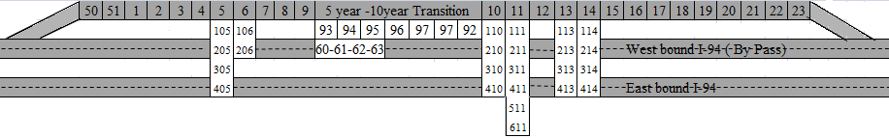
Figure 11: Layout of test cells at the MnROAD facility.
(Adapted from: http://www.dot.state.mn.us/MnROAD/testsections/pdfs/mainline-profile-ls.pdf, February 20th, 2009)

Cell 93 | Cell 94 | Cell 95 | Cell 96 | Cell 97 | Cell 92 | Cell 60 | Cell 61 | Cell 62 | Cell 63
4 in | 3 in | 3 in | 6 in | 6 in | 6 in | 5 in  sealed | 5 in  no seal | 4 in sealed | 4 in  no seal
4 in | 10 in  58-28  1993  HMA | 10 in  58-28  1993  HMA
9 in  58-28 1993 HMA |  |  |  |  |  |  |  | 8 in  58-28 1993 HMA | 8 in  58-28 1993 HMA
 |  |  |  |  |  | 7 in  58-28 1993 HMA | 7 in  58-28 1993 HMA | 8 in  58-28 1993 HMA | 8 in  58-28 1993 HMA
9 in  58-28 1993 HMA | 10 in  58-28  1993  HMA | 10 in  58-28  1993  HMA | 7 in  58-28  1993  HMA | 7 in  58-28 1993  HMA | 7 in  58-28 1993 HMA
 |  |  |  |  |  | Clay | Clay | Clay | Clay
Clay | Clay | Clay | Clay | Clay | Clay
Trans Tined  4-ft x 4-ft  Panel Polypro-pylene | Trans Tined  4-ft x 4-ft Panel  Polypro-pylene | Trans Tined  5-ft x 6-ft Panel  Polyolefin | Trans Tined  5-ft x 6-ft Panel Polypro-pylene | Trans Tined  10-ft x 12-ft Panel Polypro-pylene | Trans Tined 10-ft x 12-ft Panel  Polypro-pylene  1-in dowel | Turf  5-ft x 6-ft  Panel | Turf 5-ft x 6-ft  Panel | Turf 5-ft x 6-ft  Panel | Turf 5-ft x 6-ft  Panel
Oct-97 | Oct-97 | Oct-97 | Oct-97 | Oct-97 | Oct-97 | Oct-04 | Oct-04 | Oct-04 | Oct-04
Oct-04 | Oct-04 | Oct-04 | Current | Current | Current | Current | Current | Current | Current

Figure 12: Test cells constructed during Oct 1997 and 2004.
(Adapted from: http://www.dot.state.mn.us/MnROAD/testsections/pdfs/mainline-profile-ls.pdf, February 20th, 2009)

Cell 14
SC* 114 | SC* 214 | SC* 314 | SC* 414 | SC* 514 | SC* 614 | SC* 714 | SC* 814 | SC* 914
6 in  long  broom | 6 in  long  broom | 6 in  long broom | 6 in  long  broom | 6 in  long broom | 6 in  long broom | 6 in  long broom | 6 in  long broom | 6 in  long broom
5 in  58-28  1993  HMA | 5 in  58-28  1993  HMA | 6 in  58-28  1993  HMA | 6 in  58-28  1993  HMA | 7 in  58-28  1993  HMA | 7 in  58-28  1993  HMA | 7.5 in  58-28  1993  HMA | 8 in  58-28  1993  HMA | 8 in  58-28  1993  HMA
Clay | Clay
Clay | Clay | Clay | Clay
 |  |  |  | Clay | Clay | 7.5 in  58-28  1993  HMA | 8 in  58-28  1993  HMA | 8 in  58-28  1993  HMA
 |  |  |  |  |  | Clay | 8 in  58-28  1993  HMA | 8 in  58-28  1993  HMA
 |  |  |  |  |  |  | Clay | Clay
6-ft x 6-ft Panel  1-in dowels in dr. lane  No dowels in passing lane. | 6-ft x 6-ft Panel  No dowels | 6-ft x 6-ft  Panel  1-in dowels in dr. lane  No dowels in passing lane. | 6-ft x 6-ft  No dowels | 6-ft x 6-ft  Panel  1-in dowels in dr. lane  No dowels in passing lane. | 6-ft x 12-ft  Panel Flat dowels in dr. lane  No dowels in passing lane. | 6-ft x 6-ft  Panel  1-in dowels in dr. lane  No dowels in passing lane. | 6 x 6  Panel  No dowels | 6-ft x 6-ft  Panel  1-in dowels in dr. lane  No dowels in passing lane.
Oct-08 | Oct-08 | Oct-08 | Oct-08 | Oct-08 | Oct-08 | Oct-08 | Oct-08 | Oct-08
Current | Current | Current | Current | Current | Current | Current | Current | Current
*SC: Sub Cell, dr. - driving

Figure 13: Test cells constructed during 2008.
(Adapted from:http://www.dot.state.mn.us/MnROAD/testsections/pdfs/mainline-profile-ls.pdf, February 20th, 2009)

4.1.1 Design features
The design features of the 1997 and 2004 MnROAD whitetopping sections are summarized in Table 4. The original thickness of the existing full-depth asphalt pavement was 13 in. It was constructed in 1993 on a silty-clay subgrade. This pavement was serving as a transition zone that separated the 5- and 10 year design mainline test cells (Vandenbossche and Rettner, 1998). It should also be noted that the condition of the existing HMA layer was sound with few transverse cracks. The HMA layer was constructed with a Superpave Grade 58-28 mix. Before the overlay was placed, the existing HMA layers were milled to an equivalent thickness of the whitetopping to ensure sufficient bonding between the HMA and PCC layers.

Both thin and ultra-thin whitetopping sections were constructed at MnROAD and they represent a range of thickness and panel sizes. Cells 93, 94 and 95 ranged between 3- to 4-in thick with 4-ft × 4-ft and 5-ft x 6-ft panels. The joints were sealed but the sections were not doweled. Cells 92, 96 and 97, which were also constructed in 1997, are 6-in thick with 5-ft x 6-ft to 10-ft x 12-ft joint spacings. These cells were also sealed and undoweled with the exception of Cell 92. Cell 92 contained 1-in diameter dowel bars. Cells 60 through 63 were constructed in 2004. These overlays were 4- to 5-in thick with a 5-ft x 6-ft joint spacing and no dowels. Some of the sections were sealed while others were left unsealed.

The concrete mixture design, as well as the measured plastic and hardened concrete properties, are given in Table 5. Fibers were included in the concrete mixture used for constructing the overlay in 1997 but not in 2004.

Table 4: Summary of the design features for the MnROAD whitetopping cells.
Cell No. | Age | Thickness of PCC slab (in) | Thickness of HMA layer (in) | Type | Slab size  (ft × ft) | Sealed joint  (Y/N) | Doweled joint  (Size/N) | Type of fiber reinforcement
92 | Oct 97- Current | 6 | 7 | TWT | 10 × 12 | Y | 1 in | Polypropylene
93 | Oct 97-  Oct 04 | 4 | 9 | UTW | 4 × 4 | Y | N | Polypropylene
94 | Oct 97-  Oct 04 | 3 | 10 | UTW | 4 × 4 | Y | N | Polypropylene
95 | Oct 97-  Oct 04 | 3 | 10 | UTW | 5 x 6 | Y | N | Polyolefin
96 | Oct 97- Current | 6 | 7 | TWT | 5 x 6 | Y | N | Polypropylene
97 | Oct 97- Current | 6 | 7 | TWT | 10 x 12 | Y | N | Polypropylene
60 | Oct 04- Present | 5 | 7 | TWT | 5 x 6 | Y | N | None
61 | Oct 04- Present | 5 | 7 | TWT | 5 x 6 | N | N | None
62 | Oct 04- Present | 4 | 8 | UTW | 5 x 6 | Y | N | None
63 | Oct 04- Present | 4 | 8 | UTW | 5 x 6 | N | N | None

Table 5: Concrete mixture design information for MnROAD whitetopping cells.
(Vandenbossche and Rettner, 1999; Burnham 2006; Snyder, 2008)
 | Cell 92-94, 96-97 | Cell 95 | Cells 60-63
Water to cementitious ratio | 0.38 | 0.41 | 0.40
Cement (lb/yd³) | 650 | 650 | 400
Class C fly ash (lb/yd³) | 0 | 0 | 170
Fine aggregate (lb/yd³) | 1,187 | 1,287 | 1,206
CA (1.5 in minus) (lb/yd³) | 0 | 0 | 1,059
CA (3/4 in minus) (lb/yd³) | 1,600 | 1,500 | 866
CA (3/8 in minus) (lb/yd³) | 277 | 277 | 0
Fiber content (lb/yd³), (percent by volume) | 3, 0.059 | 25, 0.53 | 0, 0
Admixtures (oz/100 lb cement) | Conchem Air  Polyheed N | Conchem Air Polyheed N | KB-1000, 34.0
Measured air (percent) | 5.75 | 7.2 | 7.6
Measured slump (in) | 2.5 | 2 | 1.5
28-day compressive strength (psi) | 6,100 | 5,300 | 4,085

4.1.2 Distress data
The periodic performance evaluation of the MnROAD cells showed that TWT and UTW sections with different design features experienced different types of distresses. The extent of the severity of the distresses is also a function of the design variables. The performance and distress data collected and reported [Vandenbossche and Fagerness (2002), Burnham (2005 and 2008) and Snyder (2008)] as well as recently collected distress data is described below.

The distress surveys conducted for the 1997 cells revealed that Cells 93, 94 and 95, which included overlays that ranged from 3- to 4-in thick, exhibited cracking by June 1998. Most of the cracks were corner cracks, and very little transverse (mid-slab) cracks developed until January 1999, when a couple of reflection cracks developed. It can be seen in Figure 14 that Cell 94 (3-in thick and 4-ft x 4-ft square panels) exhibited a significant increase in cracking near the end of 2000, which was not exhibited by the other Cells. Similar increases in cracking occurred in 2003 for Cells 93 and 95 (Burnham, 2005).

Thirty percent of the slabs in Cell 94 developed cracking, out of which seventy percent were reflected from the underlying HMA layer. Approximately eight to ten percent of the slabs from Cells 93 and 95 were cracked with an equivalent amount of cumulative traffic (3.7 million ESALs, December 2001). The performance of the other cells (6-in thick, TWTs) continues to be good except for Cell 97, which has significant transverse joint faulting until 2001. There were 19 panels in Cell 93 (4.2 percent of all slabs), 22 panels in Cell 94 (4.9 percent) and six panels in Cell 95 (2 percent) that were repaired in 2001 due to excessive deterioration.

In October 2004, Cells 93, 94 and 95 were replaced with Cells 60, 61 and 63, due to the excessive drop in ride quality (Burnham, 2005). The present serviceability rating (PSR) of Cells 93, 94 and 95 went down below the terminal serviceability (PSR=2.5) in 2003, 2002 and 2004, respectively. Table 6 shows the distress summary for each of these cells. The thinnest overlay, Cell 94, exhibited the largest number of cracked panels, (94 percent in the driving lane) some of which were shattered. By the spring of 2004, 6.1 million ESALs (annual average daily traffic (AADT) of 26,400 with 14 percent heavy commercial traffic) had been accumulated on these sections, which is a remarkable feat given the fact that the slabs were only 3- or 4- in thick.

(a) Cell 93

(b) Cell 94

(c) Cell 95

Figure 14: Performance history for (a) Cell 93, (b) Cell 94 and (c) Cell 95 from 1997 to 2001.
(Vandenbossche and Fagerness, 2002)

Table 6: Summary of cracks for MnROAD test sections.
Cell | Age (yrs/ESALs) | Corner cracks |  | Transverse cracks |  | Longitudinal cracks |  | Panels cracked (percent)
Cell | Age (yrs/ESALs) | Driving lane | Passing lane | Driving lane | Passing lane | Driving lane | Passing lane | Driving  lane | Passing lane | Total
93 | 4/6.4 million | 43 | 6 | 9 | 4 | 0 | 0 | 23¹ | 4¹ | 27
94 | 4/6.4 million | 391 | 84 | 8 | 8 | 0 | 0 | 94¹ | 34¹ | 64
95 | 4/6.4 million | 30 | 16 | 5 | 2 | 0 | 0 | 32¹ | 16¹ | 20
92 | 11.5/9.8 million | 0 | 0 | 0 | 0 | 3 | 6 | 17 | 35 | 26
96 | 11.5/9.8 million | 0 | 0 | 0 | 0 | 1 | 0 | 1 | 0 | 0
97 | 11.5/9.8 million | 0 | 0 | 0 | 0 | 7 | 0 | 42 | 0 | 21
60 | 4.5/3.8 million | 0 | 0 | 0 | 0 | 3 | 0 | 3 | 0 | 2
61 | 4.5/3.8 million | 0 | 0 | 2 | 0 | 5 | 4 | 7 | 5 | 6
62 | 4.5/3.8 million | 0 | 0 | 0 | 2² | 0 | 0 | 1 | 1 | 1
63 | 4.5/3.8 million | 7 | 1 | 3 | 0 | 8 | 5 | 15 | 8 | 11
¹Panels repaired in 2001 are not included in the calculated percentage.
²Both cracks propagated off the same reflection crack.

The most recent distress surveys conducted for the MnROAD cells were performed in March 2009. The distresses observed were analyzed with respect to the accumulated traffic loads. Trends between cracking (longitudinal, transverse and corner), faulting and IRI with the cumulative ESALs were established. By the end of March 2009, Cells 60 through 63 (4.5 years in service) and Cells 92, 96 and 97 (11.5 years in service) had been subjected to 3.8 and 9.8 million ESALs, respectively. Figure 15 through Figure 17 present the history of the development of longitudinal, transverse and corner cracking, respectively. A summary of the distresses observed through March 2009 are presented in Table 6. Among the cells constructed in 1997, the performance of Cell 96 is still the best with only two percent longitudinal cracks. Cells 92 and 97 developed longitudinal cracking in 27 and 24 percent of the slabs, respectively. In Figure 18, it shows that the longitudinal cracks are progressive and merge with each other. It is surprising to see that these cells have not experienced any transverse or corner cracks even after 11.5 years of service. Significant transverse joint faulting has occurred in Cell 97 (undoweled). This will be discussed later.

D: Doweled; UD: Undoweled; S: Sealed; US: Unsealed

Figure 15: Longitudinal cracking history for Cells 92, 96 and 97 (11.5 years, 9.8 million ESALs); 60-63 (4.5 years, 3.8 million ESALs).

Figure 16: Transverse cracking history for Cells 92, 96 and 97 (11.5 years, 9.8 million ESALs); 60-63 (4.5 years, 3.8 million ESALs).

Figure 17: Corner cracking history for Cells 92, 96 and 97 (11.5 years, 9.8 million ESALs); 60-63 (4.5 years, 3.8 million ESALs).

Cells 60 and 62, which were constructed in 2004 and have a 6-ft x 5-ft joint spacing and are 5- and 4-in thick, respectively, developed a relatively small amount of longitudinal cracks after 3.8 million ESALs. Both cells are undoweled and unsealed. It can be seen in Figure 19 that the longitudinal cracks in these cells also went through multiple panels similar to those in Cell 97. The severity of the cracks is still low; however, some spalling has occurred in Cell 60 (Figure 19). It is interesting to note that the longitudinal cracking that developed in Cells 61 and 63 are comparable, indicating that the longitudinal cracking is associated with the panel size for these TWT sections (Figure 20).

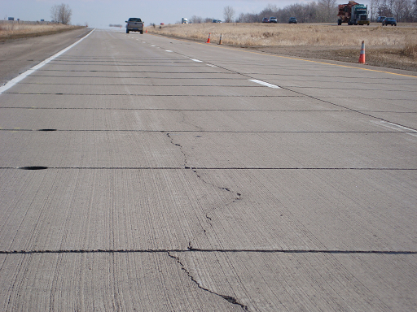
March 2009
Figure 18: Longitudinal cracks in Cell 97.

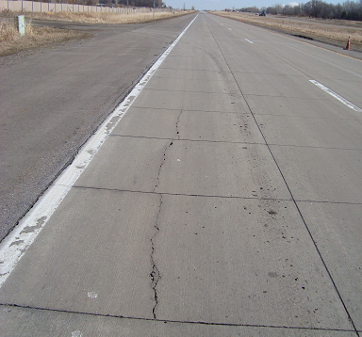 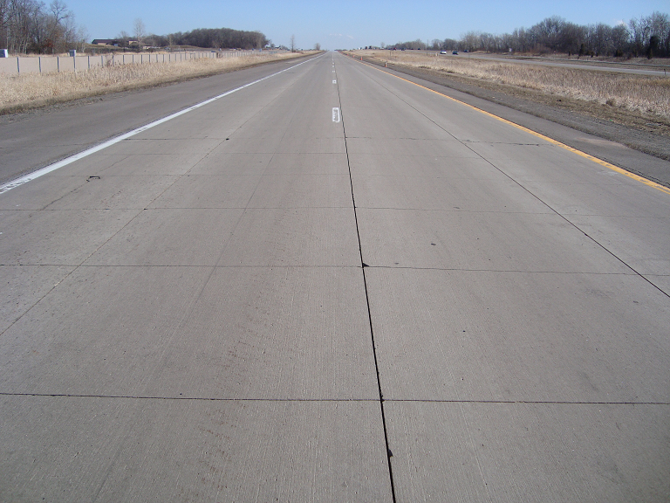 (a) Cell 60 (b) Cell 62
Longitudinal Cracks
March 2009
Figure 19: Longitudinal cracks in Cells 60 and 62.

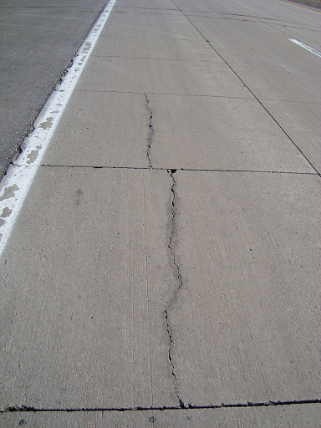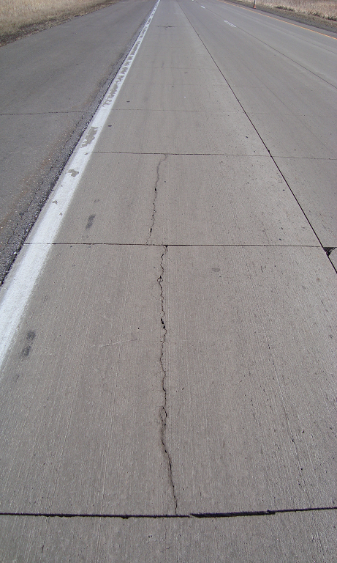
Longitudinal Cracks
March 2009
(a) Cell 61 (b) Cell 63
Figure 20: Longitudinal cracks in Cells 61 and 63.

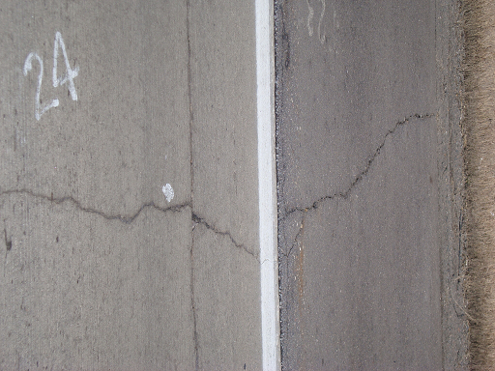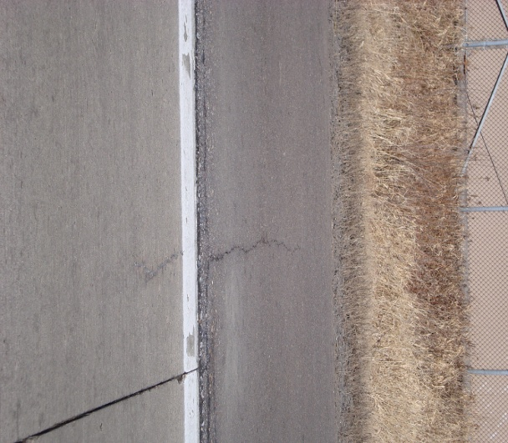
March 2009
Reflection transverse cracks
Figure 21: Reflection transverse cracks in Cell 61.

Cell 60 is performing reasonably well, while Cells 62 and 63 developed transverse cracks at an early age. Cell 61 developed its first transverse crack after 1.8 million ESALs. Until March 2009 (3.8 million ESALs), two out of 176 slabs (1.4 percent) in Cells 61 and 62 were cracked. Out of 176 slabs, six (3.4 percent) low to medium severity transverse cracks developed in Cell 63 after the same period of time. In Cell 61, both cracks were reflected from the underlying asphalt layer, while three out of six cracks in Cell 63 were reflected. This can be seen in Figure 21 and Figure 22. Cell 63 also experienced one corner break after 2.2 million ESALs (Figure 17).

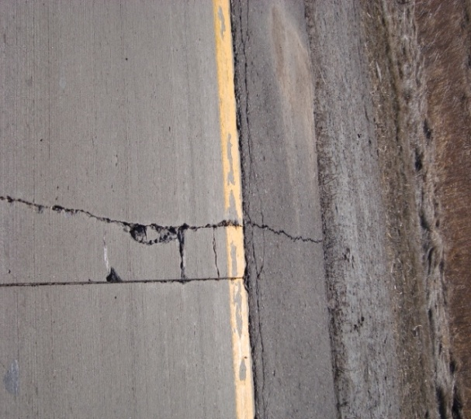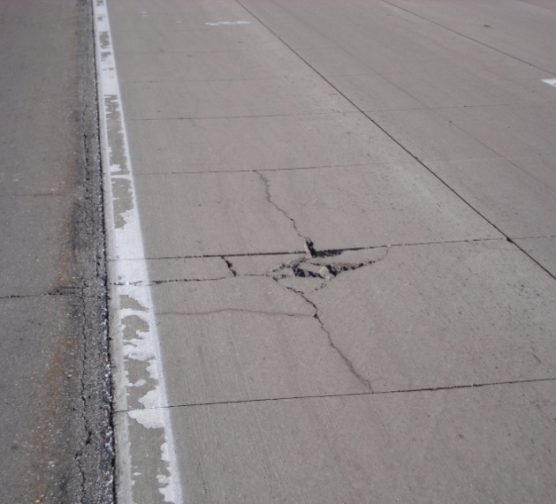
March 2009
Reflection transverse cracks
Figure 22: Reflection transverse cracks in Cell 63 at two locations.

The faulting data for the MnROAD cells, as presented in Figure 23, revealed that there is still no faulting in Cells 60 through 63. Among all of the cells still in place, Cell 97 has the most severe faulting. Although Cell 97 has been in service on the interstate for 11.5 years, its magnitude has not yet reached 0.25 in, which is still considered to be low severity.

The IRI history of all the cells is presented in Figure 24. The rideability of Cells 93 through 95 experienced a period of rapid decline in the last two years of their service lives. The IRI for Cells 60 through 63 is still quite low after five years of service on the interstate. Among remaining sections constructed in 1997 (Cells 92, 96 and 97), Cell 92 provides the best rideability. Between Cell 96 and Cell 97, Cell 96 exhibited a lower IRI which is a result of the lower amount of distress observed in this section. Cell 97 has significant joint faulting.

Figure 23: Faulting history for MnROAD cells until October 2007.

Figure 24: IRI history for MnROAD cells until March 2008.

4.1.3 Factors affecting performance
The distress history of the bonded whitetopping sections at MnROAD verifies that design features such as joint spacing, overlay thickness, HMA thickness, joint sealing and the use of dowel bars influence the performance. The following subsections describe the effect of each parameter.

Joint layout
The amount of cracking and the cracking patterns that develop in each section were directly influenced by the joint layout and the stresses that developed as a function of the joint layout. For example, one of the longitudinal joints of a 4-ft x 4-ft joint layout (Cells 93 and 94) was located at the inside wheel path (Figure 25), which resulted in high edge stresses. This resulted in corner cracking for both the 3-in and 4-in overlays. Figure 25 shows two distress photos in Cell 94 in 2001 and 2003.

In Cell 95, the performance of the 3-in overlay with 5-ft x 6-ft panels was significantly better than the 3-in overlay in Cell 94 with 4-ft x 4-ft panels. For the 5-ft x 6-ft panels, the longitudinal joint was moved outside of the wheel path and the loads were applied in the interior portion of the slab (Figure 26).

Cells 92, 97 (10-ft x 12-ft panel size) and 96 (5-ft x 6-ft panel size) have not exhibited any corner cracks after 11.5 years. Cells 60 through 63 (5-ft x 6-ft panel size) have been in service for 4.5 years and also show excellent performance in regards to corner cracks. A comparable performance was obtained with the 3-in overlay with 5-ft x 6-ft panels (Cell 95) and the 4-in overlay with 4-ft x 4-ft panels (Cell 93). This indicates that an optimum joint layout can provide an increase in the performance of the overlay equivalent to increasing the thickness of the overlay by 1 in. The 3-in overlay with 5-ft x 6-ft panels is also more economical than the 4-in overlay with 4-ft x 4-ft panels, because it requires less concrete and fewer joints The curling stress in the slab increases with an increase in panel size; however, the tensile stress due to the combination of wheel loads and curling in the slab with a 5-ft x 6-ft joint spacing is still less than that in a slab with a 4-ft x 4-ft joint spacing. A study conducted by Vandenbossche and Fagerness (2002) also analytically verifies this fact. In that study the finite element program , ISLAB2000 was used to model two panel sizes, 4-ft × 4-ft and 5-ft × 6-ft, for the 3-in overlay test sections at MnROAD. The maximum tensile stress generated in each panel size was within 1 psi (0.01 MPa), indicating that the two panel sizes respond similarly to temperature gradients of the same magnitude.

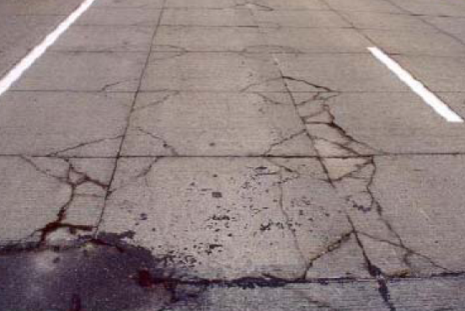
4 ft x 4 ft panels
(a) Cell 94 during 2001 (b) Cell 94 during 2003

Figure 25: Corner cracks along the inside wheelpath on Cell 94.
(Vandenbossche, 2001 and Burnham, 2005)

Figure 26: Distress is reduced with the 5-ft x 6-ft panels because the wheelpath is not located adjacent to the longitudinal joint (Burnham, 2005).

Dowel bars
Among all of the MnROAD whitetopping sections, only Cell 92 has doweled joints. The faulting history of the cells, as mentioned in Section 4.1.2, shows that the presence of dowel bars helps to reduce the joint faulting in Cell 92. Cell 92 and Cell 97 have a similar configuration except that Cell 92 contains 1-in dowel bars. Figure 27 clearly shows the presence of faulting in Cell 97, whereas no faulting is visible in the adjacent Cell 92. Dowels are not typically used for TWT or UTW since these overlays are commonly constructed on lower volume roads. The results show that there is potential to extend the range of applications for these overlays since they have the potential to perform for extended periods of time (11.5 years), even on the interstate. This increase in performance was observed with only a 1-in diameter dowel bar. It is interesting to see that the performance of the joints in Cell 92 (doweled, 10 ft x 12 ft) and Cell 96 (undoweled, 5 ft x 6 ft) are comparable. Decreasing the joint spacing exhibited a similar improvement in joint performance as the addition of 1-in dowels.

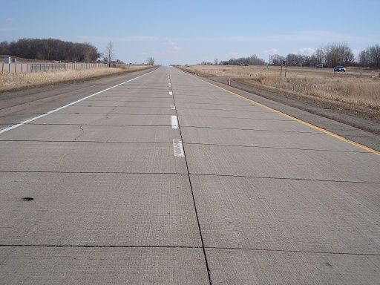
March/2009
Cell 97, undoweled
Cell 92, doweled
Figure 27: Faulting of panels in Cell 97(undoweled) but no faulting in Cell 92 (1-in dowels).

Sealing of joints
All of the UTW and TWT cells, except for Cells 61 and 63, were constructed with joints filled with hot pour sealant. The larger amount of longitudinal and transverse cracks (Figure 15 and Figure 16) in Cells 61 and 63 compared to Cells 60 and 62 clearly shows that sealing the joints reduces the amount of cracking. It may also be noted that Cell 63, which is unsealed, developed a corner crack at 2.2 million ESALs. Figure 28 is a photo of the sealed and adjacent unsealed sections while it was raining. It can clearly be seen that the unsealed joints allow the water to enter the pavement structure while the rain puddles on the surface for the sealed joints. The infiltration of the water into the pavement structure facilitates the degradation of the asphalt and hence the bond between the HMA and the overlay. This is not as critical for thicker PCC overlays; but, a good bond is essential for the long-term performance of these thin overlays. The shorter panel spacing also increases the area (due to more joints) for potential rain infiltration within the overlay, which also increases the need to seal the joints to maintain the integrity of the underlying asphalt. The infiltrated water though the unsealed joints may also increase the probability of durability cracks (due to freeze/thaw) near the corners of the panels, although signs of this were not observed at MnROAD.
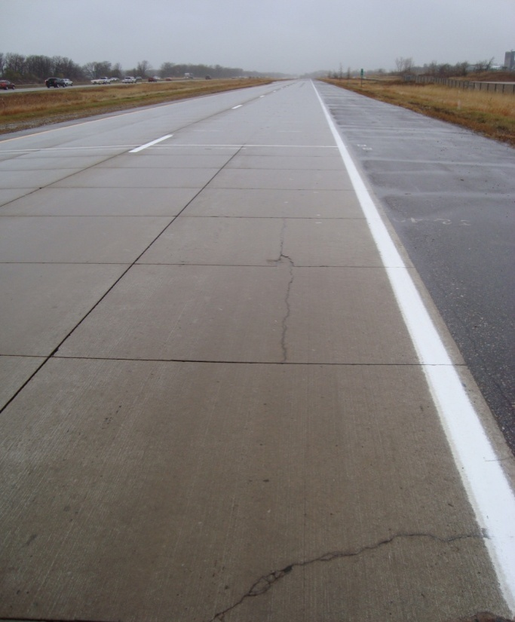
March/2009
Unsealed
Sealed
Figure 28: Difference in the amount of water infiltrating the surface for the sealed
and unsealed sections.

Thickness of the PCC layer
The performance of Cells 93, 94 and 95 compared to Cells 92, 96 and 97 verifies the fact that thicker PCC slabs enhance the life of the pavement. The performance of Cells 60 and 61 compared to Cells 62 and 63 also indicates that thicker slabs offer better resistance against fatigue cracking due to increased stiffness, as would be expected. The thickness of the overlay also affects the potential for reflection cracking, as will be discussed in depth in a subsequent section.

Thickness of the HMA layer
The 1997 and 2004 MnROAD sections were constructed on a sound full depth asphalt pavement (no subbase). After milling, the remaining asphalt thickness ranged from 7 to 10 in. Therefore, the sensitivity of the HMA layer thickness is not clearly understood from the performance of these sections. A similarly sound HMA layer was present under each cell. The only fact which is clearly verified is that a stiffer HMA layer contributes more to the development of reflection cracks (discussed in Section 4.1.4 Reflection cracking).

Seasonal variation in HMA resilient modulus
The resilient modulus of the HMA decreases with an increase in temperature. Therefore, the asphalt below the concrete provides less support when the temperature is higher. The PCC overlay must then bear a larger portion of the load, resulting in higher stresses. Vandenbossche (2005) characterized the relationship between changes in strain and changes in the resilient modulus. See Figure 29. In that study, strains were measured at the very bottom of a concrete overlay (3-in with a 5-ft x 6-ft joint layout) and 1 in from the top of the surface, under a 9-kip FWD load in the wheelpath adjacent to a transverse joint. It can be seen that the tensile strain at the bottom of the PCC layer increased rapidly when the resilient modulus of the asphalt fell below 435 ksi (at greater than or equal to 64 °F). The strain in the concrete is close to zero when the resilient modulus of the HMA is between 435 ksi to 580 ksi (60 °F) and the entire concrete overlay is in compression when the resilient modulus of the HMA is above 580 ksi. The average monthly temperature in Minnesota is greater than 43 °F for seven months of the year in Minnesota and greater than 51 °F for five months of the year. Therefore, it can be assumed that the bottom of a UTW overlay will be in tension under an applied load for a larger period of the year. This illustrates the importance of considering seasonal effects when determining the design life of ultra-thin whitetopping.

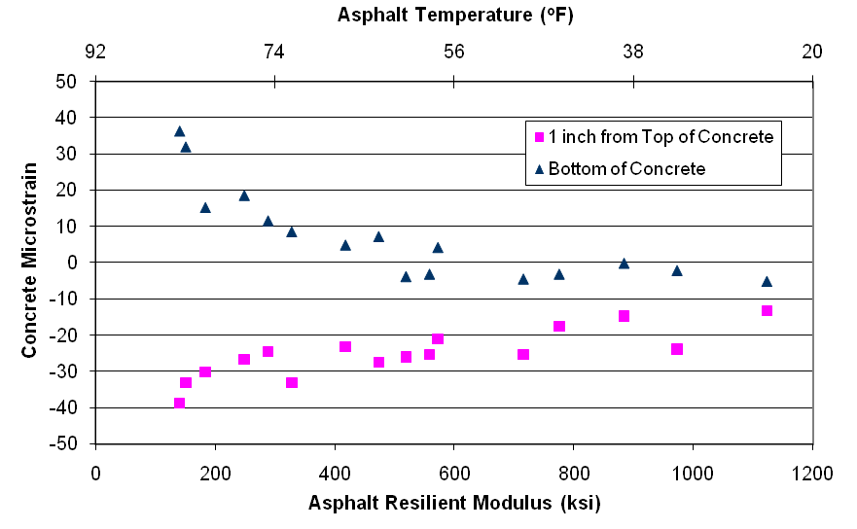
Figure 29: Strain directly under a 9-kip FWD load applied in the wheelpath adjacent to a transverse joint on a 3-in overlay with 5-ft x 6-ft panels. (Vandenbossche, 2005)

4.1.4 Reflection cracking
The investigation of the performance of Cells 93 to 95 shows that many of the transverse cracks were the result of previously existing temperature cracks in the asphalt reflecting up through the concrete. Reflection cracking is a function of both uniform-temperature-induced and load-related stresses. The thermal contraction of the asphalt in the winter creates a stress concentration at the bottom of the concrete layer in the region near the tip of the crack in the asphalt. The magnitude of the tensile stress at the bottom of the concrete can be further increased as a result of vehicle loads. The combination of both uniform-temperature-induced and load-related stresses can cause the crack in the underlying asphalt to propagate up through the concrete overlay (Vandenbossche and Fagerness, 2002). As the magnitude of stress at the bottom of the concrete layer is also a function of the design features of the overlay, it is worth to reviewing the reflection crack pattern of the existing whitetopping projects to understand the correlation of the design features.

The reflection cracking history for the 1997 and 2004 MnROAD cells is presented in Table 7. The distress survey conducted for 1997 MnROAD cells in 2001 revealed that the 6-in overlays (Cells 92, 96 and 97) did not experience any reflection cracking. Thirty-two percent of the pre-existing cracks in the asphalt propagated up through the overlay in the 3-in section with 5-ft x 6-ft panels (Cell 95). In the 3-in section with 4-ft x 4-ft panels (Cell 94), fifty-six percent of the pre-existing cracks reflected through the overlay. Fifty percent of the cracks reflected up through the concrete in the 4-in overlay with 4-ft x 4-ft panels (Cell 93). All but two of the reflection cracks developed during the spring and winter. It is possible that these two cracks also initiated during the winter or spring but were not noticed until the following summer. Reflection cracking typically occurred earlier in the driving lane than in the passing lane indicating that the accumulated traffic volume affects the development of reflection cracks. In the most recent distress survey in March 2009, it was found that 4-in sealed (Cell 62) and 4-in unsealed sections (Cell 63) developed two and three reflection cracks, respectively. It is interesting to see that Cell 61, which is unsealed and comparatively thicker (5 in), also developed two reflection cracks.

Table 7: Summary of transverse reflection cracking for1997 and 2004 MnROAD cells.
Cell | Age (yrs)/ESALs | Thickness of PCC slab (in) | Slab size  ft×ft | Transverse cracks | Transverse cracks that are reflective (%) | HMA transverse cracks reflected (%)
93 | 4/3.7 million | 4 | 4×4 | 27 | 19 | 50
94 | 4/3.7 million | 3 | 4×4 | 19 | 47 | 56
95 | 4/3.7 million | 3 | 5x6 | 4 | 100 | 32
92 | 11.5/9.8 million | 6 | 10×12 | 0 | 0 | 0
96 | 11.5/9.8 million | 6 | 5x6 | 0 | 0 | 0
97 | 11.5/9.8 million | 6 | 10×12 | 0 | 0 | 0
60 | 4.5/3.8 million | 5 | 5x6 | 0 | 0 | N/A
61 | 4.5/3.8 million | 5 | 5x6 | 2 | 100 | N/A
62 | 4.5/3.8 million | 4 | 5x6 | 2 | 100 | N/A
63 | 4.5/3.8 million | 4 | 5x6 | 3 | 100 | N/A

The panel size and overlay thickness also affect the development of reflection cracks. Among Cells 92 to 97, the section with the shortest joint spacing and the thinnest overlay (3 in with 4-ft x 4-ft panel spacing) experienced the highest percentage of reflection cracks while no reflection cracking occurred in the 6-in overlays. The 4-in overlay with the same panel size, 4 ft x 4 ft, had a slightly lower percentage, but this difference was not statistically significant. The 3-in section with larger panels, 5 ft x 6 ft, had the lowest percentage of thermal cracks propagating through the overlay among the three UTW test sections. However, the performance of Cells 60 to 63 indicates that 4-in and 5-in thick slabs with 5-ft x 6-ft joint spacing are also vulnerable to reflection cracking when the stiffness of the HMA layer becomes greater than the stiffness of the PCC layer.

The stiffness of the asphalt as well as the quality of the bond between the concrete overlay and the asphalt has a significant effect on the performance of the overlay. The stiffness of the asphalt layer changes with temperature. During the winter, the stiffness of the HMA layer increases until a threshold value is reached. Temperatures ranging between 100 °F and 4 °F have been measured using thermocouples embedded in the middle of the asphalt layer during construction of the MnROAD sections (Vandenbossche and Fagerness 2002). Cores taken from the MnROAD sections were used to determine the resilient modulus of the asphalt layer. The resilient modulus of the asphalt layer for the MnROAD pavement sections at various temperatures can be found in Table 8.

Table 8: Asphalt resilient modulus at different temperatures for MnROAD sections.
Temperature (°F) | -5 | 0 | 10 | 20 | 30 | 40 | 50 | 60 | 70 | 80 | 100
Resilient modulus (million psi) | 1.78 | 1.68 | 1.40 | 1.04 | .80 | .60 | .48 | .32 | .20 | .18 | .168

HMA layers and the accumulated heavy traffic loads. The relative stiffness of the PCC and HMA layers can be determined using the equation given below. Based on the investigation of the reflection cracks that developed in the MnROAD Cells, it was found that reflection cracks were a function of the relative stiffness of the concrete.
(i)
Where,
is the relative stiffness of the PCC and HMA layer;
and are the elastic modulus of the PCC layer and resilient modulus of the HMA layer, respectively;
and are the thicknesses of the PCC and HMA layers, respectively;
and are the Poisson’s ratio of the PCC and HMA layers, respectively.

If is equal to 1, then the stiffness of PCC layer is equal to that of the HMA layer. The reflection cracks are expected to occur when the value of is below 1. Using the above equation was calculated for the MnROAD UTW and TWT test sections for a range of HMA temperatures and is presented in Figure 30 and Figure 31. It is interesting to observe that the for Cells 94 (PCC=3 in and HMA = 10 in) and 95 (PCC = 3 in and HMA = 10 in) is below the critical value of 1 for most of the temperature ranges measured in the HMA layer for the MnROAD sections, which indicates that the PCC slabs were vulnerable to reflection cracking for most of the year. Cell 93 (PCC= 4 in and HMA = 9 in) has a value less than 1 at a temperature below 60 °F. The occurrence of a significant amount of transverse reflection cracks in these cells was discussed in Section 4.1.2. Cells 92, 96 and 97, which are 6-in thick, did not suffer any reflection cracks which makes sense because the was always greater than 1. This theory can be validated further by considering the recent performance data for Cell 61; the value for this cell is below 1 at 5 °F. As of March 2009, two reflection transverse cracks developed in Cell 61. Cells 62 and 63, which were constructed with 4-in PCC slabs over 8-in HMA layers, had athat dropped below one at 50 °F. Two and three reflection cracks have developed in Cells 62 and 63, respectively. The performance of the MnROAD sections also revealed that heavy traffic loads in the driving lane accelerate the progression of these kinds of cracks. Further verification of this concept will be provided when discussing the performance of the UTW constructed at Elk River, Minnesota.

Figure 30: Relative stiffness of PCC and HMA layers for Cells 92 through 97.

Figure 31: Relative stiffness of PCC and HMA layers for Cells 60 through 63.

4.2 Intersections on US-169, Elk River
An ultra-thin whitetopping was constructed in 1997 at three consecutive intersections on US-169 in Elk River, Minnesota in 1997. These overlays were constructed in the outer southbound lane of US-169 at the intersections of Jackson (Cell 98), School (Cell 99), and Main Streets (Cell 91). The layout of the whitetopping cells can be found in Figure 32. The southbound lane on US-169 is used by many commercial trucks coming from gravel pits, concrete plants and waste disposal facilities located just north of this intersection. The trucks usually brake heavily as they approach the first traffic signal at Jackson Street. The speed of the traffic is significantly reduced by the time it approaches the third traffic signal at the Main Street intersection. The original pavement was constructed in 1961 on a sandy subgrade and consists of a 4-in HMA surface on top of a 5-in Class 5 densely graded aggregate base and a 6-in Class 4 aggregate subbase. In 1991, 2-in of HMA were milled off and the pavement was overlaid with 1.5-in of HMA. The total HMA thickness at the time the UTW was constructed was established to be 6.25 in, based on a total of ten cores pulled on April 8, 1997 between roadway posts 159.080 and 160.367.

A distress survey was performed prior to the construction of the overlay. It was found that the existing HMA layer experienced low to medium severity cracks, severe rutting (1.25 in), and shoving, especially at the start of the intersection due to the stopping of heavy trucks. FWD testing was performed on the existing HMA layer prior to the construction of the UTW. The analysis indicated that the subgrade is very strong, as would be expected since the subgrade consists of sandy gravel. The base was constructed of Class 5 and Class 4 aggregates containing a large amount of fine material so the stiffness of this material is most likely not as high as is expected. The deflection data also indicated the presence of stripping in several locations. This was verified when forensic cores were pulled from the existing pavement just prior to construction of the overlay. A 3-in fiber reinforced concrete overlay was placed 788 ft north of each intersection. The first 12 ft of each test section was increased to 8 in to minimize the initial impact of the wheel load at the transition. The design features of the UTW and the concrete mixture design can be found in Table 9. Two different types of concrete mixtures were used, one containing polypropylene and the other polyolefin fibers (Table 10). The overlays at the first two intersections with the polypropylene fibers consisted of 4-ft x 4-ft panels while the last intersection with the polyolefin fibers had 6-ft x 6-ft panels.

Table 9: Summary of the design features for the US-169 cells.
(Vandenbossche, 2003)
Cell No. | Life span | Thickness of PCC slab (in) | Thickness of HMA layer (in) | Type | Slab size (ft×ft) | Sealed Joint (Y/N) | Doweled joint  (Dia./N) | Type of fiber reinforcement
98 | Sept 97-  Sept 99 | 3 | 3 | UTW | 4 × 4 | Y | N | Polypropylene  (3 lb/yd³)
99 | Sept 97-  Sept 99 | 3 | 3 | UTW | 4 × 4 | Y | N | Polypropylene  (3 lb/yd³)
91 | Sept 97-  Sept 99 | 3 | 3 | UTW | 6 × 6 | Y | N | Polyolefin  (25 lb/yd³)

Table 10: Concrete mixture design for the US-169 cells.
(Vandenbossche, 2003)
Category of data | Concrete with polypropylene  fibers (Cells 98 and 99) | Concrete with  polyolefin fibers (Cell 91)
Water to cement ratio | 0.43 | 0.37
Cement, (lb/yd³) | 450 | 550
Class C Fly Ash, (lb/yd³) | 120 | 100
Fine aggregate, (lb/yd³) | 1,287 | 1,287
CA (19 mm minus), (lb/yd³) | 1,552 | 1,500
CA (10 mm minus), (lb/yd³) | 277 | 277
Fiber content, (lb/yd³) | 3 | 25
Measured air, (percent) | 6 | 6
Measured slump, (in) | 2.25 | 2

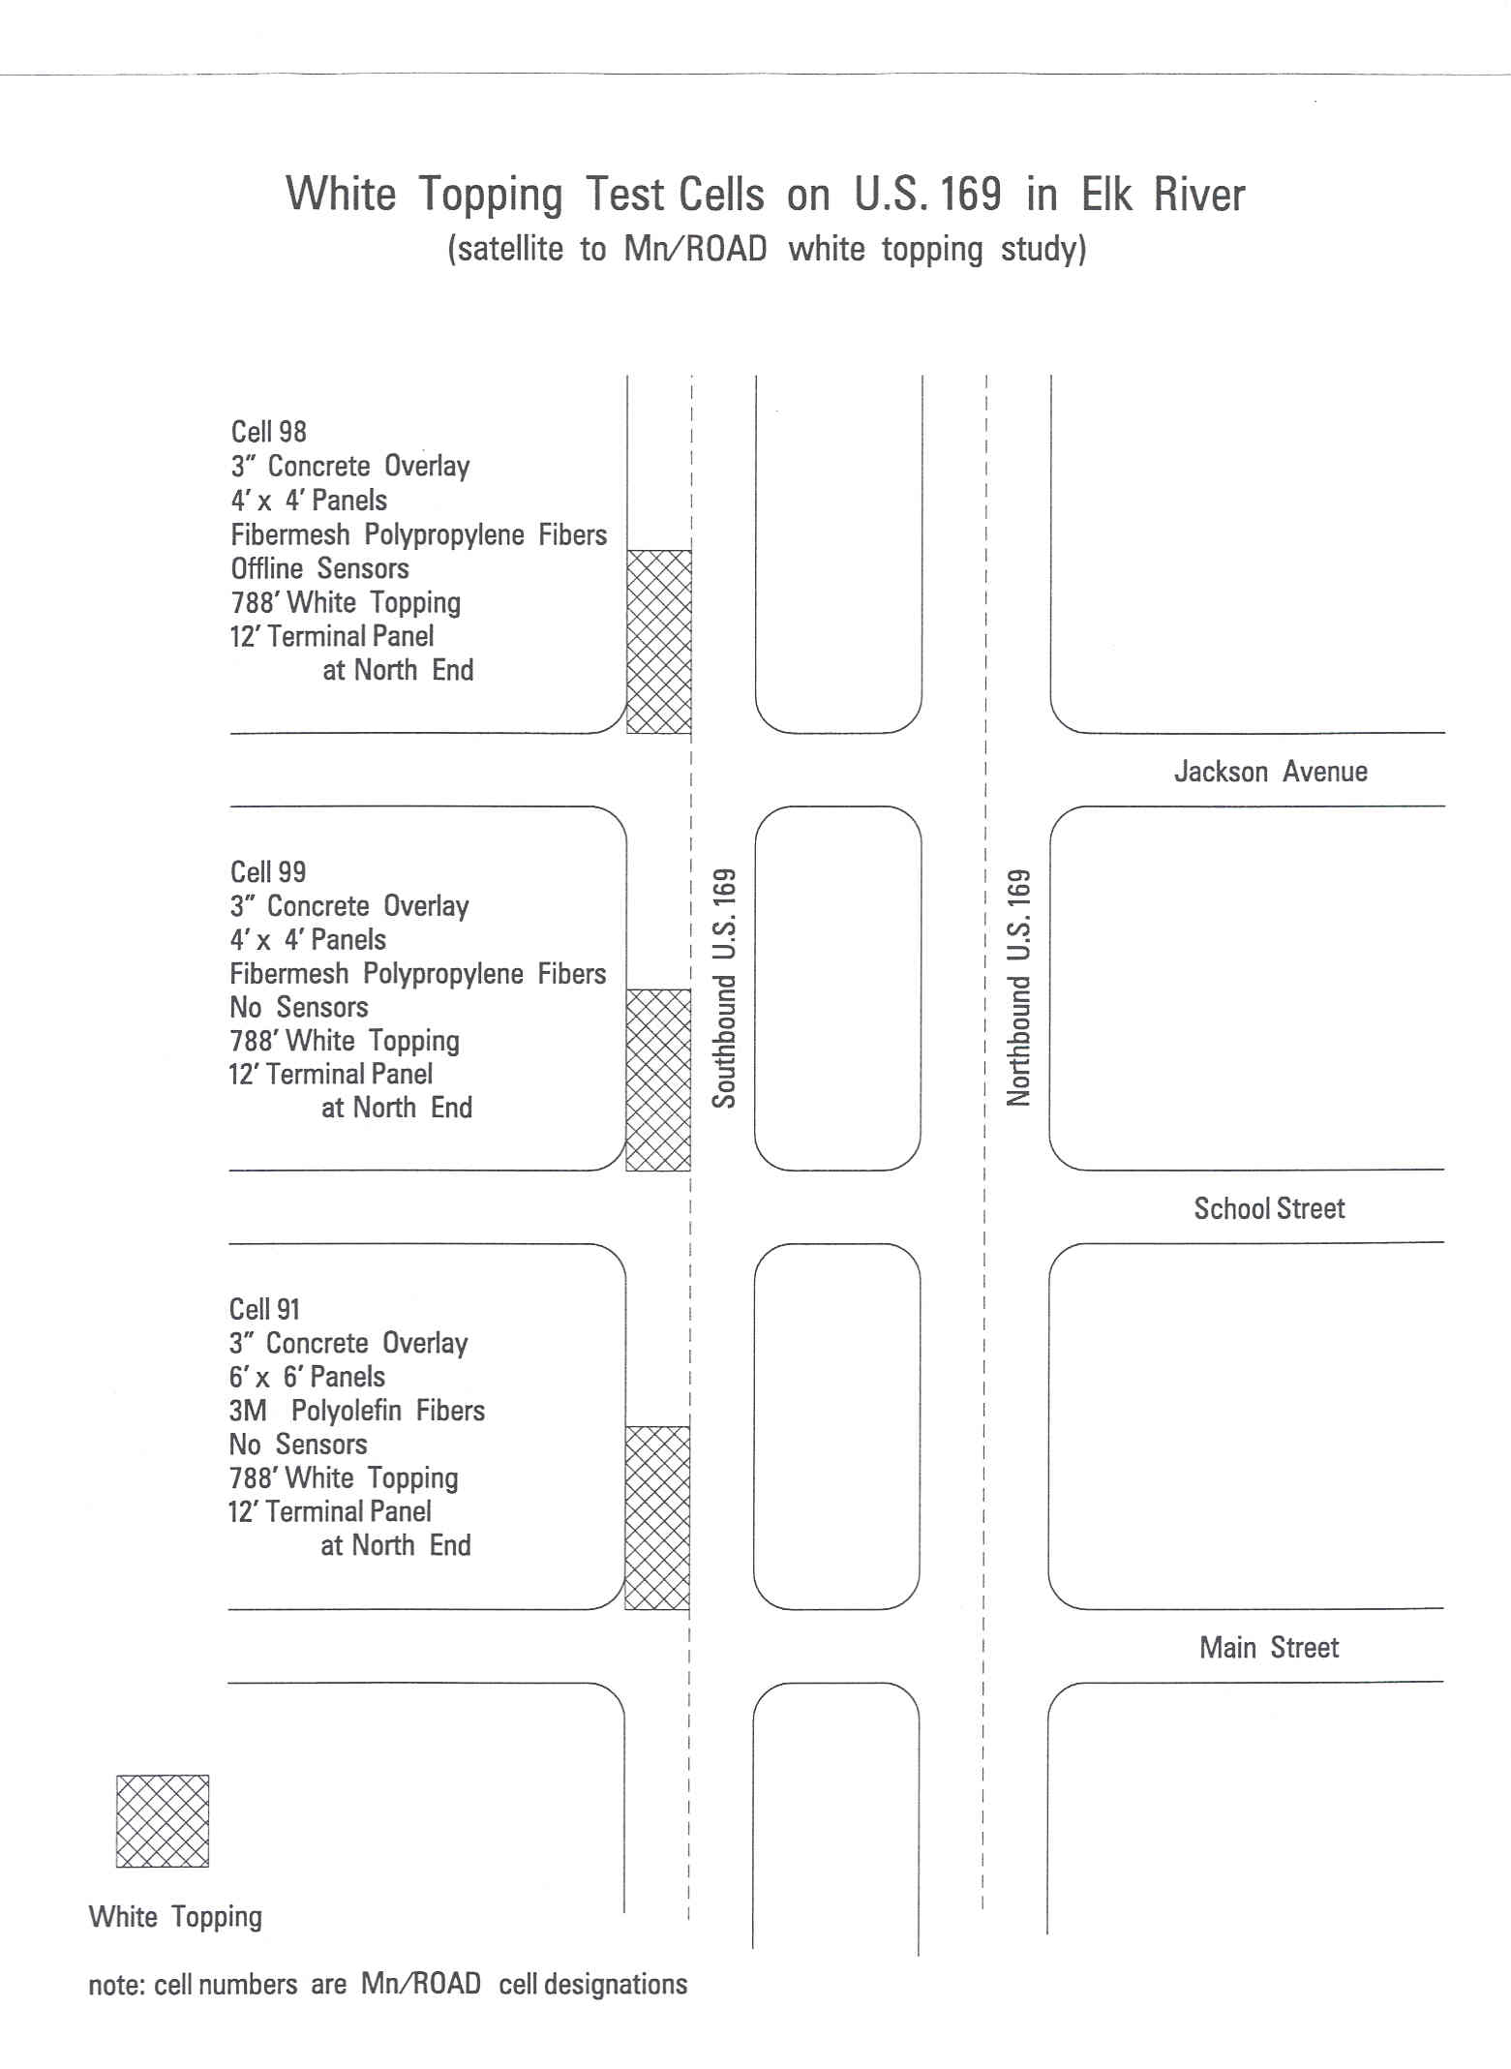
N
Figure 32: Layout of the UTW sections at the intersections of US-169.
(Vandenbossche, 2003)

4.2.1 Analysis of performance
The sections on US-169 were in service between September 1997 and September 1999. During this period, the sections accumulated approximately 670,000 ESALs. The one-way AADT was 16,000 in 1997 with eight percent trucks. The AADT grew to 17,000 by 1999. Forty-nine percent of these trucks are categorized as five-axle semis. The correlation between the performance and the design features of this UTW project is analyzed in the following subsections.

Increased depth of concrete at the approach
Increasing the concrete thickness of the first 12 ft of each test section to 8 in successfully prevented any distresses from occurring at each of the test sections as the vehicles transitioned from the HMA onto the UTW. The most heavily distressed area in each of the test sections was just prior to the approach of the intersection. The change in vehicle speed is the greatest in this location as the vehicles accelerate and decelerate when the traffic light changes.

Joint layout
Cracks observed in the ultra-thin whitetopping test sections with a 4-ft x 4-ft joint pattern included corner breaks and transverse cracks. The corner breaks occurred primarily along the inside longitudinal joint and the lane/shoulder (L/S) longitudinal joint. Many of the corner breaks that developed along the inside longitudinal joint did not appear until 1999. The inside longitudinal joint lies directly in the inside wheelpath resulting in high edge and corner stresses. Transverse cracks developed in the panels adjacent to the shoulder. The transverse cracks typically developed 1.3 ft away from the transverse joint, which is approximately one third of the length of the panel. The cracking patterns along the wheelpath are shown in Figure 33 and Figure 34. The Main Street test section was constructed using a 6-ft x 6-ft joint pattern. Corner breaks were the primary distress that developed in this test section, although very little cracking was exhibited compared to the sections with a 4-ft x 4-ft joint layout. The corner breaks were typically located in the outside panel adjacent to the lane/shoulder joint intersecting the transverse joint at the wheelpath. A few corner breaks also developed in the inside panels. Again, the corner break typically intersected the transverse joint at the wheelpath and then intersected the longitudinal joint separating the two panels. Both of the corner breaks exhibited in the inside and outside panels intersected the longitudinal joint at the nearest wheelpath. Figure 35 shows the typical pattern of the corner cracks in the Main Street test section. The pattern of the corner cracks of Cell 98 (4ft x 4ft) is comparable to the performance of Cell 93 to 95 in the MnROAD test sections. The distress pattern in the US-169 test sections validated the fact that joint layout optimization is important to avoid corner cracks.

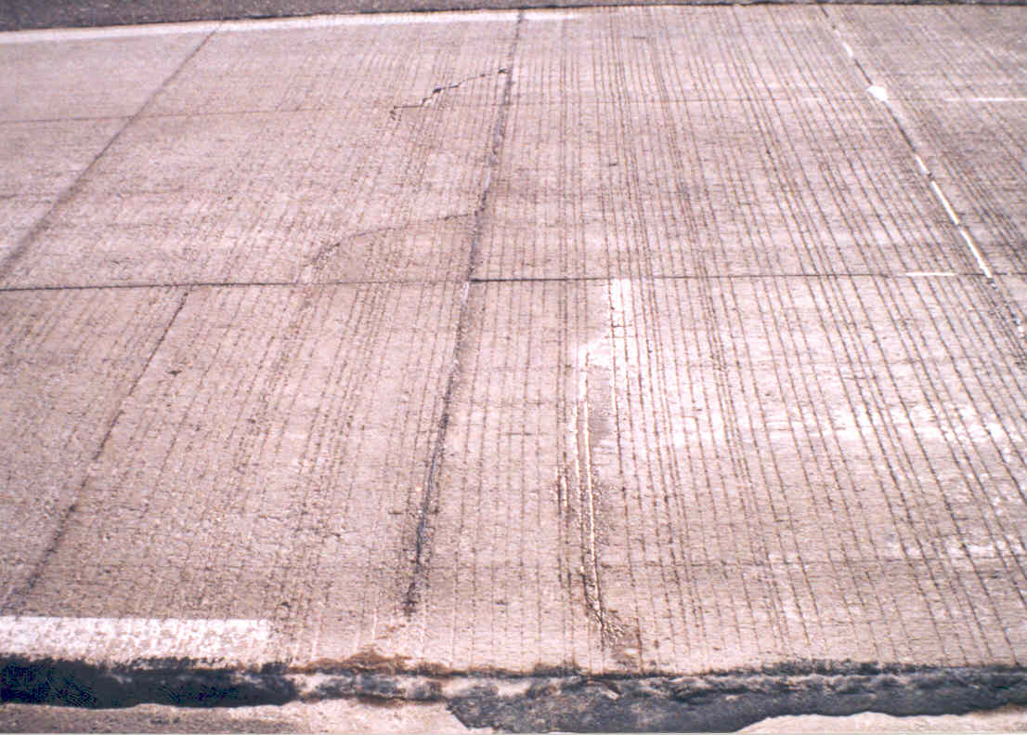
Corner
Breaks

Transverse
Crack
Figure 33: Transverse crack and corner breaks in the Jackson Street test section (03.30.98). (Vandenbossche, 2003)

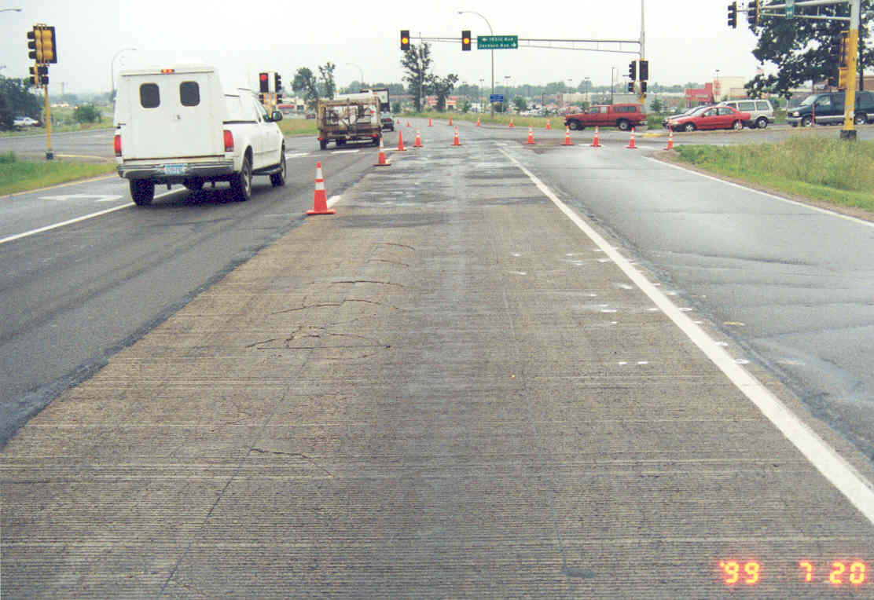
Figure 34: Corner breaks in the inside wheelpath at the Jackson Street test section. (07.20.99) (Vandenbossche, 2003)
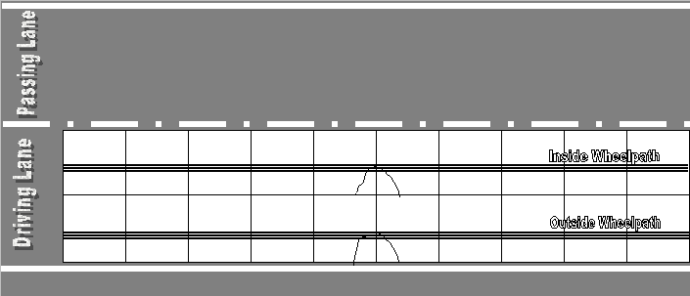
Figure 35: Typical distress patterns that developed at the 6 ft x 6 ft Main Street test intersection. (Vandenbossche, 2003)

PCC and HMA layer thicknesses
The performance of the US-169 sections suggests that insufficient thicknesses of the PCC and HMA layers lead to failure within a short period after construction. A sound HMA layer under the 3-in thick PCC layer could have provided better support to reduce the flexural stress in the PCC layer. The combination of thin HMA and PCC layers was insufficient to provide a suitable service life.

However, comparing the distress surveys prior to and after the overly was placed revealed that none of the transverse cracks in the HMA layer reflected into the overlay for any of the test sections, while reflection cracks did develop in the 3-in and 4-in overlays constructed at MnROAD. The same joint patterns used on US-169 were also employed on I-94. The difference in the performance can be attributed to the fact that the UTW on US-169 was placed on top of 3-in of HMA exhibiting signs of raveling and the UTW at MnROAD was constructed on 10-in or more of high quality HMA. Therefore, at MnROAD, a higher bond strength and structural rigidity in the HMA layer was experienced. In turn, higher tensile stresses at the bottom of the UTW in the regions of the cracks in the HMA were produced As previously discussed, reflection cracking is a function of the relative stiffness of the PCC and HMA layers. The relative stiffness of the PCC compared to the HMA layer, represented by, for the US-169 UTW test sections was found to be more than one over the possible range of `temperatures at the project site (Figure 36). As a result, no reflective cracking was observed for any of these test sections.

Figure 36: Relative stiffness of PCC and HMA layers for US-169 UTW test sections.

The number of distressed panels in the Jackson Street test section was approximately twice as high as the number of distressed panels at the School Street intersection and four times as high as at the Main Street intersection. The difference between the performances of the School Street and Jackson Street test sections is somewhat surprising because the overlay design is the same. There are several possible explanations. First, raveling of the HMA layer at the Jackson Street intersection was greater than that at the School Street intersection. Second, the speed limit on US-169 changes from 55 mph to 45 mph just north of Jackson Street and the traffic signal at Jackson Street is the first in a series of traffic signals with the School Street intersection following the Jackson Street intersection. The commercial trucks traveling on southbound of US-169 rapidly reduce their speed as they approach the first traffic signal at Jackson Street and the speed of the traffic would have been significantly reduced by the second intersection at School Street. Therefore, it is likely that the dynamic stresses at the School Street test section are significantly lower than the Jackson Street test section.

4.3 LoRay Drive, North Mankato
The LoRay Drive project is located immediately south of the bridge over US-14 in North Mankato, MN. The pavement was rehabilitated with whitetopping in 1995 as part of a MnROAD research project. The roadway was rehabilitated because of significant rutting on both sides of the bridge. The pavement was milled to a depth of 4 to 6 in and concrete was placed to match the existing grade line. Polypropylene fiber reinforced concrete was used on the north side of the bridge. On the south side of the bridge, 6-in and 4.5-in nominally thick slabs were constructed on the southbound and northbound lanes, respectively. A field review was conducted on May 21, 2007. Significant faulting was found on both sides of the bridge. The cause of the faulting is unknown due to the lack of data. The presence of severe faulting is surprising because the PCC slabs are supported by 11-in to 15-in HMA layers. The pumping action from such a thick asphalt layer was not anticipated. However, the percentage of heavy commercial trucks on this road is quite significant.

4.4 TH-30, Mankato
Background: TH-30 in southern Minnesota is a low traffic volume road, 35 miles southwest of Mankato, MN. The project is located in a rural area, with flat to slightly rolling topography. In 1993, the road was overlaid with thin whitetopping in five different sections using various overlay design features.

Existing pavement structure: The original road was a gravel road constructed in 1934 over a silty and clayey subgrade. It was reconstructed in 1955 with a 6-in soil cement treated base and a 1.5-in HMA wearing surface. In 1973, this road was overlaid with a 2.75-in HMA layer.

Construction details: There were five whitetopping and two HMA overlays constructed over approximately 11 miles. The sections consist of two 12-ft wide PCC lanes with a 2-ft HMA shoulder on each side. Transverse joints were skewed with 12-ft joint spacing. The first 10 panels of whitetopping Test Section 3 (TS-3) were doweled to reinforce the transition from the HMA overlay to the whitetopping test sections. Surface preparation was performed only in TS-5, where the existing HMA layer was milled. The PCC overlay for of all the other sections was placed directly on the existing HMA. The HMA thicknesses varied from 5.25 in to 9.75 in.
Overlay design features: The design features for these sections are provided in Table 11. All of the sections but TS-6 were bonded TWT. In TS-6 two coats of curing compound were used as a bond breaker.

Table 11: Design features for sections at TH-30. (Burnham and Rettner, 2002)
Test section | Thickness  of PCC slab | Bonded?  (Y/N) | Location  (station) | Dowelled?  (Y/N) | Special features
TS-3 | 5 in min.  (6 in avg), | Y | 121.98 -122.98 | Y* | *¾ in dia. dowels in first 10 panels only
TS-4 | 5 in min.  (6 in avg) | Y | 124.00 - 124.48 | Y | ¾ in dia. dowels throughout
TS-5 | 6 in | Y | 122.98  - 124.30 | N | placed over milled hot-mix asphalt
TS-6 | 5 in min.  (6 in avg) | N | 124.48  -124.58 | N | bond breaker: two coats of curing compound
Control  section | 5 in min. (6 in avg) | Y | 124.58  - 130.40 | N | N/A

Traffic: In 1992, the AADT and the average daily truck traffic (ADTT) were 385 and 90, respectively. The projected 20-year-design average daily traffic (ADT) and ADTT were taken as 710 and 110, respectively.

Material testing: The concrete used in these sections had lower strength than specified. The 28-day compressive strength (90th percentile) of the concrete was 2,972 psi compared to the design value of 3,900 psi. The 28-day flexural strength was 507 psi compared to the design value of 675 psi.

Performance data: The performance of the test sections through June 2002 was reported by Burnham and Rettner (2002). The observations from the visual distress survey performed in 2002 are presented in Table 12. Test Sections 3, 5, 6 and the Control Section all have very few visual distresses. In TS-4, several joints were found to have spalling. The most noticeable distresses in the whitetopping sections are the longitudinal cracks near the centerline in a small number of panels in the control section. No considerable joint faulting was observed in the 12-ft x 12-ft panels. The ride quality of the sections measured from 1994 to 2001 is shown in Figure 37. TS-4 experienced a lot of transverse joint spalling and its measured IRI was greater than the other test sections. However, the measured IRI was still below the Mn/DOT critical value (120 in/mile).

Table 12: Summary of visual distresses for the sections of TH-30. (Burnham and Rettner, 2002)
Test sections | Cracking/spalling | Rutting/faulting | Comments
TS-3 | Low spalling | Very low | Very little cracking in HMA shoulders
TS-4 | Spalling and cracking in many transverse joints | None | Dowels causing joint distress
TS-5 | Low spalling | Very low | Very little cracking in HMA shoulders
TS-6 | Low spalling | Very low | Very little cracking in HMA shoulders
Control | Some longitudinal cracks | Very low | Very little cracking in HMA shoulders

Mn/DOT criteria
Figure 37: Plot of IRI data for TH-30 from 1994 to 2001.

The load transfer efficiency (LTE) at the joints was measured in July 2002 and all joints had a LTE of approximately 90 percent. It was reported that the minimum pavement temperature was 86 °F during the time the FWD testing was performed. It is anticipated that these high LTEs are a function of the high slab temperatures present at the time of testing.

4.5 Conclusion
The whitetopping projects in Minnesota provided a vast amount of information for a large range of design scenarios. The Elk River project on US-169 has provided the foundation for the performance analysis of the UTW on thin HMA. On the other hand, the I-94 project includes both UTW and TWT on the significantly thicker HMA. The TH-30 project provides information on the performance of whitetopping in rural road applications. A range of design variables were evaluated at each location. The performance data from these projects was used to achieve a better understanding of the cause of different types of distresses in the UTW and TWT. FWD data and distress data from these projects is valuable information and will be used in the future tasks of the current project.

5 PENNSYLVANIA
The state of Pennsylvania has several whitetopping projects; but many of them, were placed on an asphalt overlay which was placed over a pavement that was originally concrete. The following sections describe the background, existing pavement structure, design features, concrete mixture design, traffic, and performance data for a couple of more standard whitetopping placed over an asphalt pavements.

5.1 Intersection of State Route (SR)-133 and SR-100, Chester County
Background: The intersection of SR-133 and SR-100 in District 6 of the Pennsylvania Department of Transportation (PennDOT) was deteriorated due to rutting. In September 1998, a whitetopping project was constructed at this intersection.

Existing pavement structure: The underlying layers are 10 in of an ID-3 bituminous concrete base and 6-in of a densely graded 2A subbase. Detailed specifications in regards to these materials can be found in the PennDOT Materials Specification Manual, Publication 408 (2003).

Overlay design features: A 4-in overlay was placed with 4-ft x 4-ft panels. No dowel bars or tie bars were used. The joints were not sealed.

Concrete mixture design: The 7- and 28-day compressive strengths for the mixture were 4,770 psi and 5,550 psi, respectively. The PCC mixture design is given in Table 13.

Table 13: Concrete mixture design information.
Cement type | Type - I (Lafarge)
Cement content (lb/yd³) | 650
Water to cement ratio | 0.41
Coarse aggregate content (lb/yd³) | 1,870
Fine aggregate content (lb/yd³) | 1,178
Air content (percent) | 5.5
Fiber type and dosage (lb/yd³) | Polypropylene, 3

Traffic: In 1998, the two-way ADT was 36,079 with approximately six percent truck traffic. A linear traffic growth rate of one percent is typical for this section of roadway.

5.2 SR-30, Lancaster County
Background: In Lancaster County, the westbound lanes of SR-30, in front of the PennDOT District 6 Maintenance building, were rehabilitated with a 3-in overlay in 1997. The original asphalt pavement failed mainly due to rutting. The overlay consisted of a 14-ft wide section that was 300-ft in length.

Existing pavement structure: The existing structure consisted of a 4.5-in bituminous wearing course on an 8-in bituminous base course over a 10-in densely graded 2A subbase.

Overlay design features: The overlay was a 3-in mill and fill with 3-ft x 3-ft panels. No dowel bars or tie bars were used and the joints were left unsealed.

Traffic: In 1999, the two-way ADT was 17,482 with approximately 19 percent truck traffic. The traffic growth rate is about one percent.

5.3 Conclusion
A complete data set for the projects in Pennsylvania is not available. However, the data for two projects presented in this report show UTW is constructed for a considerably high volume of traffic.

6 TEXAS
Two UTW projects were constructed in Odessa, Texas. Both projects were at different intersections on Loop (LP)-250. The following subsections present the details of both projects. One project consists of UTW at three different intersections and the other project consists of two different intersections.

6.1 Intersections on LP-250 at Wadley Road, Holiday Hill Road and Midland Drive, Midland
Background: Three intersections on LP-250, at Wadley Road, Holiday Hill Road and Midland Drive in the City of Midland, were rehabilitated with UTW in May 2005. The length of the project was approximately 300 ft.

Existing pavement structure: The original pavement was an 8-in HMA pavement over a base course. The bituminous layer and base layer were milled to a depth of 9 in. Then, a 7-in HMA layer was placed in a single lift just prior to laying the whitetopping.

Overlay design features: The design features for the UTW at each of the three intersections are similar. The overlay is 3-in thick with 3-ft x 3-ft panels. Milling was performed on the newly overlaid HMA layer. The HMA layer was milled up to a depth of 3 in before placing the PCC layer. No dowel or tie bars were used. The longitudinal and transverse joints were not sealed.

Concrete mixture design: The concrete mixture design used to construct the overlay is provided in Table 14, but there is no information regarding the fine and coarse aggregate contents as well as the water to cement-ratio.

Table 14: Concrete mixture design information.
Cement type | Type III
Cement content(lb/yd³) | 658
Coarse aggregate type | Grade No.4
Fine aggregate type | Grade 1 with fineness modulus of 2.6 to 3.0
Entrained air (percent) | 6 +/- 1.5
Fiber type, dosage(lb/yd³) | Polypropylene fiber, 3

Traffic: The ADT of the LP-250 in 2001, 2006 and 2007 was 25,000, 26,650 and 31,180, respectively with 2.1 percent trucks. The 20-year design ESALs for the same is 2.4 million.

Distress data: The panels in this project were reported to have experienced mid-slab and corner cracks one to two years after construction. Heavy traffic (>25,000 ADT) and the fact that the wheelpath was directly adjacent to a longitudinal joint are possible reasons for corner crack development. The corner crack development observed at this project is comparable to that observed in Cell 93 and 94 at MnROAD.

Figure 38 and Figure 39 are two pictures of the intersections at Midland Drive and Wadley Avenue obtained from Google Street View in February of 2009. The figures clearly show that the inside wheel path is along the longitudinal joints.

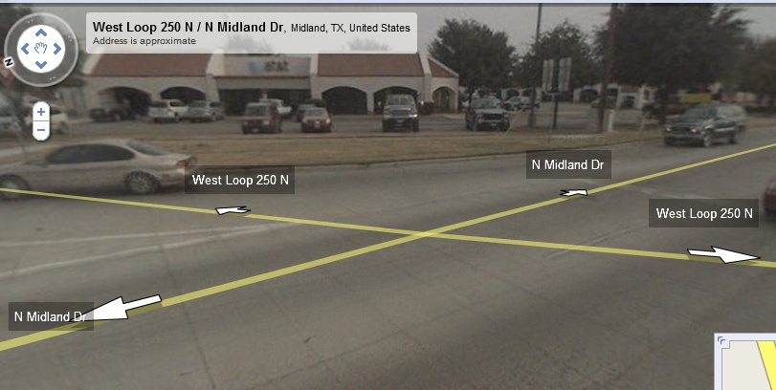
Inside wheel path
Figure 38: UTW at the intersection of LP-250 and Midland Drive at Odessa District.
(Google Street view (February/2009))

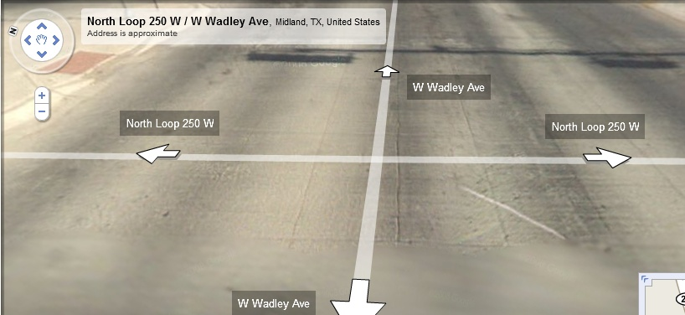
Inside wheel path
Figure 39: UTW at the intersection of LP-250 and Wadley Avenue at Odessa District.
(Google Street view (February/2009))

6.2 Intersection of LP-250 at Midkiff Road and Garfield Road, Midland
Background: The UTW at the intersection of LP-250 at Midkiff Road and Garfield Road is 3-in thick. These sections were constructed in September 2001.

Existing pavement structure: The original pavement structure of this project is similar to the project described in Section 6.1. The original bituminous layer and base layer were removed to a final depth of 9 in. A 7-in Type-D dense graded bituminous mix was then placed in two 3.5-in lifts as a preparation for the whitetopping. A PG 64-22 asphalt binder was used in the HMA layer.

Overlay design features: The thickness of the UTW is 3 inches and the panel size is 3-ft x 3-ft. No dowel or tie bars were used and the joints were not sealed. The HMA layer was milled to a depth of 3 in prior to placing the PCC overlay.

Concrete mixture design: High early strength concrete with polypropylene fibers was used to construct the UTW. Some of the details in regards to the PCC mixture design used as well as its compressive strength are given in Table 15.
Table 15: Concrete mixture design information
Cement type | Type III
Cement content (lb/yd³) | 658
Coarse aggregate type | Grade No.4
Fine aggregate type | Grade 1 with fineness modulus of 2.6 to 3.0
Entrained air (percent) | 6 +/- 1.5
Fiber type, dosage (lb/yd³) | Polypropylene fiber, 3
24-hour Compressive strength (psi) | 2,400

Traffic: The ADT of LP-250 in 2001, 2005, 2006 and 2007 were 25,000, 32,000, 31,470 and 23,460，respectively. The truck traffic is 2.4 percent. The 20-year design ESALs for the same is 2.0 million.

Distress data: Detailed distress data is not available. However, it is known that the pavement suffered from mid-slab and corner cracking six to twelve months after construction.

6.3 Conclusion
The UTW projects in Texas were constructed at intersections that are subjected to heavy traffic volumes. Longitudinal joints along the wheelpath caused corner and mid-slab cracks two years after construction. High early strength concrete was used on the project that exhibited distress six months after construction.

7 MISSOURI
In the state of Missouri, both ultra-thin (3.5 in) and conventional (10 in) whitetopping overlays were constructed at The Spirit of St. Louis Airport in St. Charles County in 1995. A 3.5-in UTW was constructed in the light aircraft area, which has an area of 14,000 yd². Another 15,000-yd² area of the airport was overlaid with conventional 10-in whitetopping, which is used for parking heavy aircrafts. Several thin and ultra-thin whitetopping projects have been constructed in Missouri since this original project. This section presents the performance histories of six different projects constructed in Missouri.

7.1 Intersection of SR-291 and SR-78, Independence
Background: This project was constructed in September 2000 on the severely rutted intersection of SR-291 and SR-78. All of the approaches along with the turning lanes were overlaid for a total length of 900 ft.

Existing pavement structure: Initially, the center lanes of the intersection were a concrete pavement, while the other sections were HMA. The intersection had been overlaid many times with HMA afterwards. Cores were pulled in May 2009 to establish the thickness of each layer. Laboratory testing on the cores also provided additional information such as the bond shear strength (Iowa shear test) and the unit weight of the PCC. A summary of this information is provided in Table 16.

Table 16: Layer properties of the project at SR-291 and SR-78.
Route | Direction | Location | PCC overlay thickness (in) | HMA thickness  (in) | Old PCC layer (in) | Iowa shear strength* (psi) | Unit weight of PCC (lb/ft³)
SR-291 | NB | 1+44 | 4.8 | Thin stripped layer | 8.5 | 43 | 141
SR-291 | NB | 2+04 | 4.9 | 3 | N/A | 137 | 136
SR-291 | NB | 2+64 | 4.7 | Thin stripped layer | 8.4 | Debonded | 144
SR-78 | EB | 0+52 | 4.8 | 8 | N/A | Debonded | 139
SR-78 | EB | 1+00 | 5.2 | 8 | N/A | Debonded | 139
NB: Northbound, EB: Eastbound
* Iowa shear test measures the bond shear strength at the interface.

Overlay design features: The UTW is 4-in thick with 4-ft x 4-ft panels and contains no dowel or tie bars. The HMA layer was cold milled up to a depth of 4 in before placing the overlay.

Concrete materials: Information regarding the concrete and its compressive strength is given in Table 17.

Table 17: Concrete mixture design information.
Cement type | Type I
Coarse aggregate type | ½ in crushed limestone
Fine aggregate type | Missouri river sand
Fiber type and dosage (lb/yd³) | Polypropylene, 3
28-day Compressive strength (psi) | > 4,000

Traffic: The ADT in both 2002 and 2008 was 30,000 with 10 percent trucks.

Distress data: Only 131 out of 7,786 panels (1.7 percent) have exhibited distress through June 2009. Laboratory testing of the cores indicated that debonding occurred between the PCC and HMA layers at several locations. The laboratory testing also revealed that any bond that was present was not very high.

7.2 US-60, between US-71 and BUS-71, near Neosho
Background: A 4,200-ft long UTW project was constructed on US-60, between US-71 and Business (BUS)-71 near Neosho in 1999. The original pavement was constructed in 1960 and it was rehabilitated in 1974. Before the construction of the whitetopping, the HMA pavement exhibited both longitudinal and transverse cracking.

Existing pavement structure: The original thickness of the HMA layers was 7 in. The HMA binder is AC-20 grade. The base is a 10-in rolled stone layer that lies on a silty clayey subgrade. Table 18 summarizes the data obtained from cores pulled in 2009.

Table 18: Layer properties of US-60 project.
Route | Direction | Location | PCC overlay thickness (in) | HMA thickness  (in) | Iowa shear strength (psi) | Unit weight of PCC (lb/ft³)
US-60 | EB | 18+683 | 4.5 | 4.5 | 112 | 136
US-60 | EB | 18+695 | 4.6 | 4.5 | 137 | 137
US-60 | EB | 18+707 | 4.6 | 4.5 | 115 | 138
US-60 | EB | 18+985 | 4.9 | 4.5 | 64 | 136
US-60 | EB | 18+998 | 4.6 | 4.5 | 130 | 133
US-60 | EB | 19+911 | 4.6 | 4.5 | 158 | 135
US-60 | WB | 19+476 | 5.0 | 4.5 | 157 | 140
US-60 | WB | 19+516 | 5.2 | 4.5 | Debonded | 141
US-60 | WB | 19+556 | 5.0 | 4.5 | 63 | 141
US-60 | WB | 19+596 | 5.1 | 4.5 | 49 | 140
US-60 | WB | 19+636 | 5.1 | 4.5 | Debonded | 135
WB: Westbound, EB: Eastbound

Overlay design features: The design thickness of the overlay was 4 in with 4-ft x 4-ft panels. No dowel or tie bars were used and the joints were not sealed. The HMA layer had 2 to 4 in milled off prior to the placement of the overlay.

Concrete materials: Information about the material types and the 28-day compressive strength is given in Table 19.

Table 19: Concrete mixture design information.
Cement type | Type I
Coarse aggregate type | 1-in crushed limestone
Fine aggregate type | Arkansas river sand
Fiber type, dosage (lb/yd³) | Polypropylene, 3
28-day Compressive strength (psi) | > 4,000

Traffic: ADT in 1998 and 2008 were 7,000 and 8,200, respectively with 10 percent truck traffic. The linear traffic growth rate is one percent.

Distress data: The distress data shows that this project experienced more corner cracks than mid-slab cracks. Present performance data indicates that 132 out of 6,000 panels (2.2 percent) developed either corner cracks or mid-slab cracks. Results from Iowa shear strength tests show the bond strength to be low in some areas.

7.3 US-169 and SR-YY intersection, St. Joseph
Background: This intersection was originally constructed of concrete pavement in 1931 and it was widened with HMA in 1961. All of the lanes were rehabilitated with HMA overlays in 1977 and 1989. Finally, an UTW was constructed at this intersection in September 2000 after the flexible layers had exhibited severe rutting and shoving.

Existing pavement structure: The outer lanes consist of full-depth HMA and an unknown base layer over a silty-clay subgrade. An AC-20 grade binder was used in the HMA. The center lanes were originally PCC. Survey and laboratory testing was conducted in May 2009. Table 20 contains the thicknesses of the PCC and HMA layers, Iowa shear strength at the interface, and the unit weight of the PCC.

Table 20: Layer properties for the US-169 project.
Route | Direction | Location | PCC overlay thickness (in) | HMA thickness  (in) | Old PCC layer (in) | Iowa shear strength (psi) | Unit weight of PCC (lb/ft³)
US-169 | NB | 0+33 | 3.5 | 11 | N/A | Debonded | 135
US-169 | NB | 0+69 | 4.0 | 11 | N/A | Debonded | 141
US-169 | NB | 1+08 | 4.0 | 11 | N/A | 31 | 133
SR-YY | EB | 0+51 | 4.0 | Thin stripped layer | 6.5 | Debonded | 139
SR-YY | EB | 0+96 | 4.0 | 10 | N/A | Debonded | 140
SR-YY | EB | 1+41 | 4.0 | 10 | N/A | Debonded | 137
NB: Northbound, EB: Eastbound

Overlay design features: The thickness of the UTW ranged from 3.5 to 4 in with a panel size of 3-ft x 3-ft. No dowel or tie bars were used and the joints were not sealed. The HMA layer was milled to a depth of 3 in before construction of the overlay.

Concrete materials: Information about the concrete is given in Table 21. It is worth noticing that the concrete mixture contains a high cement content of 752 lb/yd³.

Table 21: Concrete mixture design information.
Cement type | Type I
Cement content (lb/yd³) | 752
Coarse aggregate type | ½-in crushed limestone
Fine aggregate type | Missouri river sand
Fiber type, dosage (lb/yd³) | Polypropylene, 3
28-day Compressive strength (psi) | 5,810

Traffic: The ADT in 2000 and 2008 were 22,000 and 24,000, respectively with an eight percent truck percentage. The linear traffic growth rate is one percent.

Distress data: In one of the turning lanes, where the thickness of the UTW was approximately 1.25 in, the pavement experienced some cracks resembling the shape of a spider web. Similar to other UTW projects in Missouri, this project also experienced more corner cracks than mid-slab cracks. Of the 4,520 slabs, 499 slabs (3 percent) are cracked. No other forms of distress have been observed. One great concern for this project is the occurrence of debonding between the layers, which was verified by the Iowa shear tests.

7.4 Other projects in Missouri
In Missouri, there are many other TWT projects. This subsection briefly presents the information collected on the projects at (i) Missouri (MO)-5, railroad crossing in Lebanon; (ii) BUS-13 in Branson West and (iii) the Intersection of BUS-13 and MO-14. A complete set of data for these projects is not available; but, the information that is available for all three projects is summarized in the tables below. All three projects are comparatively new. Cores were pulled and the thicknesses of the HMA and the overlays are given in the Table 22 through Table 24 along with the shear strength at the interface, which was measured using the Iowa shear test. No visible distresses have been observed after five to six years of service.

Table 22: Layer properties for the project at MO-5, railroad crossing in Lebanon.
Route | Direction | Location | PCC overlay thickness (in) | HMA thickness  (in) | Iowa shear strength (psi) | Unit weight of PCC (lb/ft³)
MO-5 | Left turn lane | 0+22 | 4.5 | 7 | Debonded | 139
MO-5 | Left turn lane | 0+44 | 4.5 | 7 | 148 | 139
MO-5 | Left turn lane | 1+44 | 4.8 | 7 | Debonded | 139
MO-5 | Left turn lane | 1+84 | 4.4 | 7 | Debonded | 136

Table 23: Layer properties for the project at BUS-13 in Branson West.
Route | Direction | Location | PCC overlay thickness (in) | HMA thickness  (in) | Iowa shear strength (psi) | Unit weight of PCC (lb/ft³)
BUS- 13 | NB | 0+37 | 5.6 | 7 | 150 | 141
BUS-13 | NB | 0+88 | 4.4 | 7 | 18 | 141
BUS-13 | NB | 1+28 | 5.4 | 7.0 | 415 | 139
BUS-13 | SB | 0+52 | 5.9 | 7.0 | Debonded | 139
BUS-13 | SB | 1+00 | 4.6 | 7.0 | 213 | 139
BUS-13 | SB | 1+40 | 5.2 | 7.0 | 246 | 138
NB: Northbound , SB: Southbound

Table 24: Layer properties for the project at the Intersection of BUS-13 and MO-14.
Route | Direction | Location | PCC overlay thickness (in) | HMA thickness  (in) | Iowa shear strength (psi) | Unit weight of PCC (lb/ft³)
MO-13 | SB | 0+44 | 4.2 | 4 | Debonded | 140
MO-13 | SB | 0+68 | 5.1 | 4 | 18 | 139
MO-13 | SB | 0+92 | 4.4 | 4 | Debonded | N/A
MO-14 | WB | 0+24 | 4.6 | 4 | 87 | 137
MO-14 | WB | 0+40 | 5.3 | 4 | 72 | 136
MO-14 | WB | 0+64 | 4.5 | 4 | Debonded | 135
SB: Southbound, WB: Westbound

7.5 Conclusion
All of the projects, except the whitetopping section at US-169 and SR-YY intersection in St. Joseph, are TWT applications. The Iowa shear test indicated that the bond strength for all of the TWT sections, except the Branson West project was low. For both the TWT and UTW sections, the bond between the HMA and whitetopping was poor; yet, to date, very little cracking has occurred. This could indicate that the bond was damaged when the core was pulled or that the overlays will begin to deteriorate quickly.

8 MISSISSIPPI
Several roads and intersections in Mississippi were rehabilitated with whitetopping. The three which will be discussed in this report include (i) US-80 at SR-15 in Newton (constructed in 2003), (ii) Intersections of 22nd Avenue and North Frontage Road (constructed in 2008) and (iii) Intersection of SR-35 and US-80 (constructed in 2008).

8.1 Intersection of SR-15 and US-80, Newton County
Background: The thin whitetopping on SR-15 and US-80 was constructed in Newton County in 2003. The approaches of SR-15 and US-80 had significant rutting, oxidation, and fatigue cracking before the construction of the thin whitetopping.

Existing pavement structure: On SR-15, a HMA pavement was constructed in 1977 on a 4-in asphalt stabilized base with a 6-in granular subbase. The subgrade is classified as A-6 and A-7 with the upper 8 in being lime treated. On US-80, the HMA layer was constructed in 1976 with 6-in of asphalt stabilized base and a 7-in granular subbase. The subgrade is also A-6 and A-7 with a lime treated upper 8 in. The intersection was overlaid many times with HMA.

Overlay design features: The thickness of the overlay varied between 5 and 6 in with 5-ft x 6-ft panel size. The HMA layer was milled off up to a depth of 6 in. The existing thickness of the HMA layers (after milling off) on SR-15 and US-80 were 6.25 in and 7 in, respectively. No dowel or tie bars were provided and the joints were not sealed.

Distress data: The distress survey conducted in December, 2009 revealed that this project is performing well without any noticeable distress even after 6 years.

8.2 Intersection of 22nd Avenue and North Frontage Road, Lauderdale, MS
Background: This project was constructed in 2008. A considerable amount of rutting was observed in the asphalt pavement before the construction of the whitetopping.

Existing pavement structure: The southbound section of 22nd Avenue consists of a 3.5-in HMA layer on top of an 8-in PCC slab and a 10-in granular base. The northbound section of 22nd avenue consists of a 6-in HMA layer on top of an 8-in asphalt treated base and a 10-in granular subbase. Frontage road consists of a 6-in HMA layer at the northeast approach and a 13-in HMA layer at the northwest approach. Both approaches have 6-in asphalt treated bases and 5-in of subbase. The intersection was overlaid many times with HMA.

Overlay design features:The thickness of the overlay varied from 5 to 6 in as shown in Table 25. Approximately 6 in of HMA was milled off where it was possible. The existing concrete at the southbound approach of the 22nd Avenue was also milled off by 1.5 in.

Distress data: The distress survey conducted in December, 2009 revealed that this project experienced longitudinal, transverse and corner cracks. Table 25 presents a summary of the distress experienced by the different sections in this project.

Table 25: Overlay design features and observed distress type for the project at
the Intersection of 22nd Avenue and North Frontage Road.
Location of  section | Year of construction | Thickness of PCC (in) | Size of Panel  (ft x ft) | Observed distress
22nd. Ave.-NB-OSL1 | 2008 | 5 to 6 | 8,9 x 6 and 9,10 x 6 | Long. crack, long. jt. spalling, trans. crack, corner crack
22nd. Ave.-NB-ISL2 | 2008 | 5 to 6 | 8,9 x 6 and 9,10 x 6 | Trans. crack, long. crack
22nd. Ave.-SB-ISL3 | 2008 | 5 to 6 | 8,9 x 6 and 9,10 x 6 | Long. crack, trans. crack, corner crack
22nd. Ave.-SB-OSL4 | 2008 | 5 to 6 | 8,9 x 6 and 9,10 x 6 | Trans. crack, corner crack, long. crack
Frontage Rd.-EB | 2008 | 5 to 6 | 8,9 x 6 and 9,10 x 6 | Diagonal crack
Frontage Rd.-WB | 2008 | 5 to 6 | 8,9 x 6 and 9,10 x 6 | Corner crack
NB: Northbound, SB: Southbound, EB: East bound, WB: Westbound, OSL: Outside lane, ISL: Inside lane, Ave.: Avenue, Rd.: Road. The digit at the end of each approach indicates lane number.

8.3 Intersection of SR-35 and US-80, Scott County
Background: The intersection of SR-35 and US-80 in Scott County has recently been rehabilitated with thin whitetopping during 2008. The asphalt pavement exhibited considerable rutting, oxidation, and fatigue cracking before the thin whitetopping was placed.

Existing pavement structure: Details of the existing HMA layers are unknown; however, it is known that the underlying base is asphalt treated and the subbase layers are of granular material. The northbound approach of SR-35 has a 7.5-in thick base on top of a 6-in subbase. The upper 8-in of the subgrade is treated with lime and is classified as either A-6 or A-7. The southbound approach of SR-35 consists of a 4.5-in base with a 6-in thick subbase. The upper 8-in of the subgrade is treated with lime and is classified as either A-6 or A-7. The base of the pavement of US-80 is 7-in thick with a 7-in subbase. Again, the upper 8-in of the subgrade is treated with lime and is classified as either A-6 or A-7.

Overlay design features: The design features of this project are given in the Table 26. The thickness of the overlay varied from 5 to 6 in. No dowel or tie bars were used and the joints were not sealed. The HMA layer was milled up to a depth of 6 in prior to the whitetopping.

Distress data: The distress survey conducted in December, 2009 revealed that this project experienced only a longitudinal crack in one of the lanes. Apart from this, a few longitudinal joints are found to be spalled (Table 26).

Table 26: Overlay design features and observed distress type for the project at
the Intersection of SR-35 and US-80.
Location of  section | Year of construction | Thickness of PCC (in) | Size of Panel  (ft x ft) | Observed distress
MS-35-NB-OSL1 | 2008 | 5 to 6 | 6 x 6 | Long. crack
MS-35-NB-ISL2 | 2008 | 5 to 6 | 6 x 6 | No distress
MS-35-SB-ISL3 | 2008 | 5 to 6 | 6 x 6 | Long. jt. spalling
MS-35-SB-OSL4 | 2008 | 5 to 6 | 6 x 6 | Long. jt. spalling
US-80-EB-OSL1 | 2008 | 5 to 6 | 6 x 6 | No distress
US-80-EB-ISL2 | 2008 | 5 to 6 | 6 x 6 | Long. jt. Spalling
US-80-WB-ISL3 | 2008 | 5 to 6 | 6 x 6 | Long. jt. spalling
US-80-WB-OSL4 | 2008 | 5 to 6 | 6 x 6 | Long. jt. spalling
MS: Mississippi, US: United States, NB: Northbound, SB: Southbound, EB: East bound, WB: Westbound, OSL: Outside lane, ISL: Inside lane, Ave.: Avenue, Rd.: Road. The digit at the end of each approach indicates lane number.

8.4 Conclusion
These projects are relatively new. Since the design features of the projects are very similar, they can be treated as companion sections. The performance study of these companion sections could potentially provide useful information.

9 NEW YORK
Two whitetopping projects were constructed in New York. One is located at the intersection of Waldon Avenue and Central Avenue and the other is located on two different roadways, specifically New York (NY)-408 and State Highway (SH)-622 in Livingston County. The information collected is incomplete since distress data is not currently available. The following subsections present the details for both projects.

9.1 Intersection at Waldon Avenue and Central Avenue, near Buffalo
Background: This project consists of UTW and was constructed in 2002. The UTW was placed across four thru lanes plus a turning lane. Rutting and shoving occurred in the original HMA primarily due to the truck traffic lining up at this intersection.

Overlay design features: The whitetopping is 4-in thick with 4-ft x 4-ft panels. No dowel or tie bars were used and the joints were not sealed. After the existing surface layer was milled off, the subbase was exposed in some spots. Fresh HMA was placed prior to construction of the UTW overlay to cover up the spots of exposed subbase. Polypropylene fibers were used in the concrete mixture.

Traffic: In 2002, the ADT was 12,250 with one percent trucks.

Distress data: The distress data is not available in detail; however, there is information that corner cracks occurred along the free longitudinal edge of the overlay.

9.2 NY-408 and SH-622, Rochester
Background: An UTW project on NY-408 and SH-622 in Livingston County was constructed in 2002. Four lanes of NY-408, two lanes of SH-622 and partial area on the on and off ramps were rehabilitated.

Existing pavement structure: Limited information was received concerning the layer details; but, it is known that the total thickness of the HMA layer was 13.6 in on average.

Overlay design features: The thickness of the whitetopping is 4 in with 4-ft x 4-ft panels. No dowel or tie bars were used and the joints were not sealed. The existing HMA surface was milled up to 4 in. Polypropylene fibers were used in the concrete mixture.

Traffic: In 1997, the ADT was 9,350 with 14 percent trucks. In 2007, the ADT increased by 10,500 with 15 percent trucks.

Distress data: Similar to the project discussed earlier in Section 9.1, this project also experienced some corner cracks at the free longitudinal edge of the pavement.

9.3 Conclusion
These projects are companion sections and are still performing well seven years after construction. Detailed distress data is not available. The development of corner cracks at the free longitudinal edge of the pavement may draw attention for the investigation.

10 ILLINOIS
The Illinois Department of Transportation (IDOT) started experimenting with thin and ultra-thin whitetopping starting in 1974 and 1998, respectively (Roesler et al., 2008). Along with other design features, concrete mixtures were varied in terms of cement content, mineral admixture content, fiber content, water to cement ratio and air content in the experimental studies. Table 27 presents a summary of the nine whitetopping projects in Illinois.

Table 27: Whitetopping project information in Illinois.
(Winkelman, 2005 and Roesler et al., 2008)
Project location | Route number | Project length | Construction date | Overlay thickness (in) | Overlaid surface
Anna | IL-146 | Intersection | June 2001 | 3 | Asphalt concrete and exposed brick
Decatur | US-36 and Oakland Avenue | Intersection | April 1998 | 3.5 | 1/3 PCC and 2/3 AC
Tuscola | US-36 | 0.80 miles | May 1999 | 4-7.5 | Asphalt concrete
Cumberland County | CH-2 | 3.54 miles | September 2001 | 5.75 | Asphalt concrete
Piatt County | CH-4 | 4.94 miles | September & October 2000 | 5 | Asphalt concrete
Decatur | US-36 County Club Road | Intersection | April & May 1998 | 3.5 EB  2.5 WB | PCC
Carbondale | US-51 Pleansant Hill Road | Intersection | June & July 1998 | 3.5 | 1/2 PCC and 1/2 AC
Clay County | CH-33 | 7.85 miles | August 1998 | 5 and 6 | Asphalt concrete
Harrisburg | US-45 and IL- 13 | Intersection | May & June 2000 | 3 | Asphalt concrete

10.1 IL-146, Anna
Background: The project in Anna, on IL-146, was constructed in 2001 over a severely rutted asphalt pavement at the intersection of Vienna and Main Streets. Rutting and shoving were the main distresses noted in the intersection with higher severity in the area around the stop sign.

Existing pavement structure: The existing pavement at this intersection consisted of brick pavers with an HMA overlay of variable thicknesses. The special feature of this project is that whitetopping was laid on exposed brick pavers in addition to the milled HMA layer. The project layout can be seen in Figure 40.
Figure 40: Anna project layout (Winkelman, 2005).

Overlay design features: The thickness of the bonded overlay is 3 in. The panel size is 3ft x 3-ft; however, some joints were slightly shifted to accommodate manholes and the geometrics of the intersection. The existing HMA surface was milled up to 3 in. Hot-poured sealant was used on the full-depth relief joints.

Concrete mixture design: Proportions of the materials, properties of the plastic and hardened concrete are given in Table 28.

Table 28: Concrete mixture design information.
(Winkelman, 2005 and Roesler et al., 2008)
Cement type | Type I
Cement content (lb/yd³) | 755
Water to cement ratio | 0.36
Coarse aggregate content (lb/yd³) | 1805
Coarse aggregate type | 022CAM11
Fine aggregate content (lb/yd³) | 1008
Mineral admixture type/content | None
Water reducer | Daracem 65
Air entraining admixture | Daravair 1400
Retarder | (Daratard 17, Hot Days)
Fiber type and dosage (lb/yd³) | Synthetic fibers, 3
7 days compressive strength (psi) | 3550

Traffic: The whitetopping section had been subjected to 0.54 million ESALs up through 2004. Details of the traffic data can be found in Table 29. It is worth noticing that IL-146 makes a 90 degree turn in this intersection and many heavy commercial vehicles make turns at this intersection.

Table 29: Traffic details for the Anna Project.
(Winkelman, 2005 and Roesler et al., 2008)
Year | 2002 | 2003 | 2004
ADT | 14,700 | 13,800 | 13,500
ADTT (8 to 9 percent truck traffic) | 1,150 | 1,275 | 1,050
Annual ESALs (million) | 0.18 | 0.20 | 0.16
Cumulative ESALs (million) | 0.18 | 0.38 | 0.54

Distress data: The performance of this intersection indicates a successful application of whitetopping in the distressed areas that exhibit shoving. This intersection did not have any maintenance performed on it until four years after construction, although distresses were observed. Table 30 presents the distress summary of the intersection from 2002 to 2004. Figure 41 presents the trends of the cracks with respect to the ESALs. It may be noted that more than half of the distressed panels appear to be in areas where the concrete inlay was bonded directly to the underlying brick pavers. The debonding rate for this intersection has consistently been five percent for each of the three years surveyed.

Table 30: Distress summary until 2004. (Winkelman, 2005)
Year of survey | 2002 | 2003 | 2004
Number of panels | 1,706 | 1,706 | 1,706
Number of panels cracked | 201 | 272 | 340
Percent panels cracked | 11.8 | 16 | 19.9
Corner cracks | 12.70 percent
Diagonal cracks | 0.45 percent
Longitudinal cracks | 2.74 percent
Transverse cracks, | 3.18 percent

Figure 41: Distresses with respect to ESALs.

Figure 42 shows some of the distressed panels with high severity. It seems that the cracks developed in the shape of a spider web. A little bit of depression is observed as well. The distress initiation at this location is unknown; but, it was reported that the underlying layers did not show any considerable defects. The severe distresses indicate that non-uniform support conditions may have been the trigger. Additionally, the progression of the debonding between the layers might have caused the distresses to spread across multiple slabs.

Figure 42: Distressed panels at the intersection. (Winkelman, 2005)

Thinner slabs, which were 3-in thick, might be a concern considering the loads of the heavy commercial vehicles. It can be concluded that 3 in of whitetopping is insufficient for intersections with more than 10,000 ADT. Moreover, it seems that it is not a wise decision to place whitetopping on top of poor supporting layers, such as brick pavers. The other concern is the drying shrinkage of the concrete mixture. The drying shrinkage test on a similar mixture by Roesler et al. (2008) found that a high cement content of 755 lb/yd³ and a low water to cement ratio of 0.36 would result in considerable free drying shrinkage, which facilitates the occurrence of cracking.

10.2 Intersection of US-36 and Oakland Avenue, Decatur
Background: The intersection of US-36 and Oakland Avenue, located on the west side of the city of Decatur, IL, was rehabilitated with UTW during the spring of 1998. The rehabilitation included the two eastbound lanes of US-36 only.

Existing pavement structure: The existing pavement consists of a concrete layer and a brick paver layer that were both overlaid with HMA. The milling of the HMA layer exposed the concrete layer in some parts. On the brick paver sections, the HMA layer was still several inches thick.
Overlay design features: The thickness of the overlay was 3.5 in. Panels vary in size with an average dimension of 3.6 ft x 4.3 ft. Some relief joints were placed to avoid reflection cracks. Hot-poured joint sealant was used in those joints.

Construction details: The existing bituminous surface had 3.5 in milled off. This was followed by brooming and high-pressure water cleaning. In some locations, full-depth and partial-depth patches were monolithically overlaid.

Concrete mixture design: Concrete mixture design information and plastic concrete properties are given in Table 31.

Table 31: Concrete mixture design information (Winkelman, 2005 and Roesler et al., 2008).
Cement type | Type I
Cement content (lb/yd³) | 705
Water to cement ratio | 0.34
Coarse aggregate content (lb/yd³) | 1713
Mineral admixture type/content | None
Water reducer | Daracem 65//WRDA 19
Air entraining admixture | Daravair 1400
Retarder | None
Fiber type | Polypropylene

Traffic: ESALs on the overlay up until 2004 were one million. Observed truck traffic was five to nine percent. Traffic details can be found in Table 32.

Table 32: Traffic details for the UTW project (Winkelman, 2005).
Year | 1999 | 2000 | 2001 | 2002 | 2003 | 2004
ADT | 17,800 | 17,150 | 16,500 | 17,000 | 17,500 | 18,000
ADTT (5 to 9 percent trucks) | 1,400 | 1,000 | 1,450 | 1,325 | 1,200 | 1,400
Annual ESALs (million) | 0.18 | 0.13 | 0.19 | 0.17 | 0.15 | 0.18
Cumulative ESALs (million) | 0.18 | 0.31 | 0.50 | 0.67 | 0.82 | 1.00

Distress data: Table 33 shows that the number of cracked slabs increased every year. The majority of the cracks were of low severity and at mid panel. Medium severity mid slab cracks developed in three panels of the whitetopping sections in 2003. A few corner breaks were observed as well. The debonding of the layers was investigated with a sounding rod, which indicated that five percent of the slabs debonded after five years of service. Some of the panels showed movement and as a result, distresses developed. The whitetopping panels in both the driving and passing lanes shifted and moved uphill towards the intersection and can be seen in Figure 43. The sounding rod test revealed that the layers were not debonded at those sections, which would suggest that the HMA layer had been sheared from the brick paver layer.

Table 33: Distress summary until 2004. (Winkelman, 2005)
Year of survey | 1999 | 2000 | 2001 | 2002 | 2003
Number of panels | 181 | 181 | 181 | 181 | 181
Number of panels cracked | 4 | 14 | 21 | 26 | 34
Percent panels cracked | 2.2 | 7.7 | 11.6 | 14.4 | 18.8

Towards intersection
Figure 43: Movement of the panels toward the intersection
(Winkelman, 2005).

10.3 US-36, Tuscola
Background: This project was constructed on the mainline of US-36 near Tuscola. The project was completed in May of 1999. The rehabilitation was performed east of Tuscola in the eastbound and westbound lanes of US-36 to the intersection with I-57.

Existing pavement structure: Several layers were present below the HMA layer at various locations. These layers consisted of brick pavers, full-depth concrete and a granular embankment. The brick pavers and the full-depth concrete were overlaid with 3-in of HMA, while the granular embankment was overlaid with a 4.25- in of HMA.

Overlay design features: The thickness of the overlay varied with the profile and grades of the roadway and ranged from 4 to 7 in. The size of the panels varied with the thickness of the slabs. The average panel dimension was 5.5 ft x 5 ft. The areas with excessive reflection transverse cracks were milled out and a new HMA layer was placed at 18 locations.

Concrete mixture design: Concrete mixture design information can be found in Table 34.

Table 34: Concrete mixture design information.
(Winkelman, 2005 and Roesler et al., 2008)
Cement type | Type I
Cement content (lb/yd³) | 755
Water to cement ratio | 0.34
Coarse aggregate content (lb/yd³) | 1,704
Fine aggregate content (lb/yd³) | 1,035
Mineral admixture type/content | None
Water reducer | Daracem 65
Air entraining admixture | Daravair 1400
Fiber type | Polypropylene

Traffic: Traffic in this project is comparatively lower than most of the other projects. Although the ADT is not huge, there are a considerable amount of trucks (11 to 16 percent) using this particular section of US-36 due to the presence of a stone quarry nearby. Details of the traffic data can be found in Table 35.

Table 35: Traffic details for US-36 in Tuscola (Winkelman, 2005 and Roesler et al., 2008).
Year | 2000 | 2001 | 2002 | 2003 | 2004
ADT | 5,500 | 4,900 | 5,050 | 5,200 | 5,350
ADTT (11 to 16 percent trucks) | 600 | 800 | 800 | 800 | 850
Annual ESALs (million) | 0.11 | 0.15 | 0.15 | 0.15 | 0.16
Cumulative ESALs (million) | 0.11 | 0.26 | 0.41 | 0.56 | 0.72

Distress data: Since there were no surface preparations other than patch repairs, debonding was anticipated; however, only one percent of the slabs debonded at the end of five years. Table 36 shows that 6.1 percent of the slabs developed cracks at the end of five years of service. At the end of 2005, approximately 3.5 percent of the slabs had corner cracks; 1.26 percent had diagonal cracks; 0.39 percent had longitudinal cracks; 1.31 percent had transverse cracks, and 0.58 percent had patching.

Table 36: Distress summary for the project until 2004 (Winkelman, 2005).
Year of survey | 2000 | 2001 | 2002 | 2003 | 2004
Number of panels | 4,09 | 4,809 | 4,809 | 4,806 | 4,805
Number of panels cracked | 51 | 96 | 155 | 230 | 292
Percent panels cracked | 1.1 | 2.0 | 3.2 | 4.8 | 6.1

This project also experienced joint blowup along a full-depth relief joint during the spring of 2003 and 2004. A hypothesis for the cause of this blowup is that the PCC slabs expand during the excessively hot days in spring while some incompressible materials may have clogged up the joint providing resistance that led to the blowup.

10.4 Highway-2, Cumberland County
Background: The Cumberland County Highway-2 project consists of a 5.75-in thin whitetopping overlay. In the fall of 2001, Highway-2 was overlaid with whitetopping between the towns of Bradbury and Janesville in Southeastern Illinois. The existing pavement had several transverse cracks and exhibited considerable rutting in the wheel path.

Existing pavement structure: Limited information about layer compositions is available. It is only known that the thickness of the HMA layer was 6.5 in on top of a 10-in aggregate base.

Overlay design features: The overlay is 5.75-in thick with 5.5-ft x 6-ft panels and skewed transverse joints. The HMA layer was milled off to a depth of 3 in before the construction of the TWT.

Concrete mixture design: Concrete mixture design is presented in Table 37.
Table 37: Concrete mixture design. (Winkelman, 2005 and Roesler et al., 2008)
Cement content (lb/yd³) | 575
Water to cement ratio | 0.34
Coarse aggregate content (lb/yd³) | 1,836
Fine aggregate content (lb/yd³) | 1,256
Mineral admixture type/content | None
Retarder | Daratard 17
Air entraining admixture | Daravair 1400
Fiber type | Polypropylene

Traffic: The highway passes through a rural area where the ADT is not much higher. Since the project is located in an agricultural area, the truck traffic mainly consists of single- and multiple-unit trucks. Nevertheless, the presence of a local stone quarry contributes quite a bit towards the ADTT. The traffic details are presented in Table 38.

Table 38: Traffic details for Highway-2.
Year | 2002 | 2003 | 2004
ADT | 2,050 | 2,050 | 2,150
ADTT (25 percent) | 500 | 500 | 500
Annual ESALs (million) | 0.07 | 0.07 | 0.08
Cumulative ESALs (million) | 0.07 | 0.14 | 0.22

Distress data: Distress surveys were conducted until 2004 and the information is presented in Table 39. It should be noted here that the pavement was comparatively new in 2004 and the low traffic might not have damaged the sections considerably. The distress summary shows that only four cracks developed in four years and all of these cracks were reflection cracks. The thick slab (5.75 in) is also a reason for the excellent performance. Since the cement content (575 lb/yd³) of the mixture is low with a water to cement ratio of 0.34, this may have effectively limited the drying shrinkage, which would greatly reduce the possibility of cracking.

Table 39: Distress summary for the project. (Winkelman, 2005)
Year of Survey | 2002 | 2003 | 2004
Number of panels | 1,400 | 1,400 | 1,400
Number of panels cracked | 4 | 4 | 4
Percent panels cracked | 0.3 | 0.3 | 0.3

10.5 Highway-4, Piatt County
Background: The project is along Highway-4 in Piatt County and it was constructed during the fall of 2000. It lies between the eastern city limits of Monticello and the Champaign County line east of Central Illinois.

Existing pavement structure: The existing HMA layer is 4-in thick after milling and it is on top of a cement treated aggregate base.

Overlay design features: This project consists of a 5-in whitetopping with sections of different skewed joint spacings (5.5-ft or 11-ft square slabs).

Traffic: The section has an ADT of 2,000 (20,000 ESALs) per year.

Distress data: The distress data from 2001 to 2004 is presented in Table 40. At the end of 2004, 0.2 percent of the 5.5-ft x 5.5-ft slabs developed cracks, compared to one percent for the slabs with an 11-ft x 11-ft joint layout.

Table 40: Distress summary for the project. (Winkelman, 2005)
Year of survey | 2001 | 2002 | 2003 | 2004
5-in overlay with 5.5-ft x 5.5-ft panels
Number of panels | 1,912 | 1,912 | 1,912 | 1,912
Number of panels cracked | 0 | 2 | 2 | 4
Percent panels cracked | 0.0 | 0.1 | 0.1 | 0.2
5-in overlay with 11-ft x11-ft panels
Number of panels | 100 | 100 | 100 | 100
Number of panels cracked | 0 | 0 | 0 | 1
Percent panels cracked | 0.0 | 0.0 | 0.0 | 1.0

10.6 US-36 and Country Club Road, Decatur
Background: An UTW was constructed at the intersection of US-36 and Country Club Road during April and May of 1998. Its surface was severely rutted in both directions with the most severe rutting in the westbound direction. It should also be noted that there was reflection transverse cracking and a small amount of longitudinal cracking and block cracking.

Existing pavement structure: The existing HMA pavement consisted of a 1.25-in bituminous concrete overlay on a pervious bituminous concrete surface. Layer details are not available.

Overlay design features: The thicknesses of the PCC layers in the eastbound and westbound approaches are 3.5 in and 2.5 in, respectively. Joint spacing varied according to the layout of the transverse and other cracks of the HMA layer to avoid reflection cracks. In the westbound lane, the spacing ranges from 2.5 ft to 3.75 ft and in the eastbound lane, it was from 3.5 ft to 5.25 ft. The average panel dimension was 2.95 ft x 3.85 ft in the westbound direction and 3.85 ft x 4.5 ft in the eastbound direction.

Construction details: In both directions, the existing HMA was milled off. The thicknesses milled off were 2.5 and 3.5 in in the eastbound and westbound directions, respectively. The milling was followed by brooming and high-pressure water cleaning.

Traffic: Traffic volumes for US-36 and County Club Road are presented in Table 41. Since 2004, the section had accumulated 1.36 million ESALs.

Distress data: The distress data until 2003 (Table 42) for the eastbound and westbound approaches show that more than 70 percent of the slabs had cracked. More importantly, almost 50 percent of the slabs cracked in the first year. This project also experienced slab blowups (Figure 44). Winkelman (2005) suggested that the failure was construction related since the eastbound driving lane was placed after a rain event. The excessive water on the existing pavement reduced the bonding of the concrete overlay and was worked into the plastic concrete, reducing the strength of the concrete overlay.

Table 41: Traffic volumes for the US-36 and County Club Road project. (Winkelman, 2005)
Year | ADT | Single unit trucks | Multiple unit trucks | Passenger vehicles | Annual ESALs  (million) | Cumulative ESALs  (million)
1999 | 25,150 | 650 | 650 | 23,850 | 0.21 | 0.21
2000 | 24,850 | 550 | 550 | 23,750 | 0.18 | 0.39
2001 | 24,550 | 725 | 725 | 23,100 | 0.23 | 0.62
2002 | 24,075 | 750 | 750 | 22,575 | 0.24 | 0.86
2003 | 23,600 | 800 | 775 | 22,025 | 0.25 | 1.11
2004 | 23,125 | 775 | 775 | 21,575 | 0.25 | 1.36

Table 42: Distress survey results for the project. (Winkelman, 2005)
Year of survey | 1999 | 2000 | 2001 | 2002 | 2003
2.5-in overlay with 2.9 -ft x 3.8-ft panels, eastbound
Number of panels | 810 | 810 | 810 | 798 | 798
Number of panels cracked | 376 | 393 | 461 | 508 | 562
Percent panels cracked | 46.4 | 48.5 | 56.9 | 63.6 | 70.4
3.5-in inlay with 3.8-ft x4.5-ft panels, eastbound
Number of panels | 618 | 618 | 618 | 606 | 606
Number of panels cracked | 376 | 393 | 461 | 508 | 562
Percent panels cracked | 46.4 | 48.5 | 56.9 | 63.6 | 70.4

Figure 44: Blow up of the UTW slabs (Winkelman, 2005).

10.7 Conclusion
The performance review of whitetopping projects in Illinois provides a lot of information about distress trends with respect to different design variables. Performance data from the IL-146, Anna project verified that placing whitetopping over brick pavers might not be the best decision. Many projects were constructed with a higher quantity of cement. The distress patterns indicate that drying shrinkage played a role in the development of cracks. Occurrence of the blow up in the US-36 project is quite surprising and contrary to the belief. A large amount of expansion of small size slabs was not expected. However, the projects with thinner slabs experienced more corner cracks which accord with the traditional belief that the thin slabs experience more corner cracks.

11 IOWA
Two whitetopping projects from the state of Iowa are included in this task report. The first one was constructed on a 1-mile section of County Road, R-16 in the Dallas County in 1991. The other one was constructed on a 7.2-mile section of Iowa (IA)-21 in Iowa County in 1994.

11.1 R-16, Dallas County
Background: The primary objective of this project was to investigate the effectiveness of different surface preparation techniques adopted to enhance the interface bonding between the old HMA and the new PCC overlay. The project was constructed in Dallas County, on County Route R-16, from Dallas Center south 4.5 mile to Ortonville. The overlay was laid on top a of severely distorted HMA layer. The distresses like rutting, transverse cracks and alligator cracking were observed in the existing HMA layer (Grove et al., 1993).

Existing pavement structure: The original pavement was built in 1959. It was a 22-ft wide road and was composed of a 2.5-in HMA layer on a 6-in rolled stone base over 4-in soil base. In 1971, the pavement was resurfaced by a 3-in HMA layer.

Overlay design features: The project consists of 12 sections. Overlay thicknesses were varied between 4 to 5 in. The design variables were mainly different HMA surface preparation techniques, such as, brooming, milling, water/air blasting, cement-water grouting and tack- emulsion coating.

Concrete mixture design: Two types of mix were used in the project. The average 28-day compressive strength and flexural strength of concrete were 3,850 and 665 psi, respectively.

Traffic: The ADT in this route ranges from 830 to 1,050.

Interface bonding: Detailed distress data is not available for this project although, interface bond strength data is available. Grove et al. (1993) analyzed the interface bond strengths for the sections with respect to the different surface preparation techniques used. To determine the Iowa shear strength at the interface, cores were pulled out from the sections. Then, a comparative study was conducted to identify the surface preparation technique that resulted in the highest bond strengths. A statistical analysis was performed on the Iowa shear strength data measured for the cores taken from different overlay sections and is presented in Table 43. The two surface preparation techniques that resulted in higher bond strengths were milling, and brooming + water/air blasting. The milling + cement & water grouting technique also exhibited higher bond strength. In general, all techniques that included milling resulted in higher bond strengths than brooming. This helps show the importance of the mechanical bond that can be achieved through milling. The degree of mechanical bonding that can be achieved is a function of the milling machine used.

Table 43: Iowa shear strength for different surface preparation techniques (Grove et al., 2001).
Surface preparation techniques | Iowa shear strength (Psi)
Surface preparation techniques | Maximum | Minimum | Average | Std. Dev. | Total samples
Milling | 341 | 116 | 169 | 56 | 15
Brooming | 189 | 36 | 116 | 66 | 4
Brooming + water/air blasting | 268 | 109 | 169 | 86 | 3
Milling + cement & water grouting | 152 | 138 | 145 | 10 | 2
Brooming + cement & water grouting | 174 | 94 | 134 | 56 | 2
Brooming + tack emulsion coating | 102 | 65 | 87 | 19 | 3

11.2 IA- 21, Iowa County
Background: This project is located on IA-21 from US-6 to IA-212, south of the City of Belle Plaine in Iowa County. The portion of IA-21 is a two-lane roadway, 24-ft wide with 9-ft granular shoulders and ditch drainage. The project was heavily instrumented and periodically monitored for performance evaluation. The effect of HMA surface preparation and usage of fibers were studied after a period of 3- and 5-years. FWD testing was conducted to determine the deflection responses.

Existing pavement structure: The existing alignment was graded in 1958. In 1961, the original subgrade, which consisted of A-6 and A-7-6 soil, was replaced by a 24-in selected soil fill. A 6-in layer of granular material and a 7-in cement treated sand layer were laid on top of the selected soil fill. A layer of chip seal that was 0.75-in thick and 24-ft wide was used as the driving surface until 1964 when it was overlaid by a 3-in Type B asphalt layer. In 1987, a seal coat of negligible thickness was applied to the asphalt surface (Cable et al., 2001). The shoulders, which are 9 ft, were constructed with granular materials.

Overlay design features: The project consists of 65 sections; 35 test sections, 27 transition sections, and three control sections. The design variables are HMA surface preparation (milled, patch only, and cold in place recycle (CIPR)), PCC thickness (2, 4, 6, or 8 in), synthetic fiber reinforcement usage (fiber or no fiber), and joint spacing (2-, 4-, 6-, or, 12-ft square panels). One of the important features of this project was the heavy instrumentation of the test sections to obtain the strain and temperature measurement over time.

Traffic: In this project, weigh in motion (WIM) data was collected to calculate the ESALs based on AASHTO damage factors for 6-in PCC. Table 44 shows the ESALs from 1995 to 1999.

Table 44: ESALs from 1995 through 1999 (Cable et al., 2001).
Year | Northbound ESALs | Southbound ESALs
1995 | 2,865 | 9,328
1996 | 10,468 | 14,394
1997 | 12,337 | 23,394
1998 | 28,248 | 41,379
1999 | 57,410 | 42,456
Total | 111,328 | 130,744

Distress data: A limited amount of data was collected because there were not that many distresses that developed after three and five years. A particular section, which was constructed with 2-in, 2-ft x 2-ft PCC panels on top of a milled HMA surface, experienced more longitudinal cracks. A section constructed with 2-in, 4-ft x 4-ft PCC panels on CIPR surface experienced more corner cracks. Since the wheel path coincides with the longitudinal joints for the 4-ft x 4-ft panels, this may result in more corner cracks and fractured slabs. Overall, the distresses were found to be localized and some may have occurred due to construction issues; therefore, it does not seem possible to conclude that there is a strong relationship between distresses and design variables.

Interface bonding: An elevated average strains were observed for all PCC thicknesses where patch-only was implemented compared to the other two surface preparation techniques. In other words, milling and CIPR resulted better interface bonding compared to patch-only. Direct shear tests conducted on the cores helped to better understand the interface bond strength and the bond condition. A much higher percent of bonded cores compared to unbonded cores from both 3- and 5- year tests indicated that sufficient interface bonding was present regardless of the age and other variables. During testing, some of the cores were found to break in the HMA layer indicating the HMA layer was weaker than the interface. The average direct shear strengths of the cores that failed at the interface were 128 and 165 psi for the 3- and 5- year samples, respectively. On the other hand, lower average direct shear strengths, 75 and 53 psi, were obtained for the cores that were broken in the HMA layer. Moreover, the cores that provided the best direct shear strength were from the sections where 2.5-in of HMA were milled off.

Usage of fiber: The strains observed in the test sections did not show any discernable trends with respect to synthetic fiber reinforcement usage. Therefore, the benefit of use of fibers could not be told based on this study.

FWD data: Higher percent reduction in deflection responses were obtained as the PCC thickness increased. For a 3-in PCC overlay, percent reduction in deflection responses decreased as joint spacing increased. For 5- and 7-in PCC, percent reduction in deflection responses increased as joint spacing increased. It is understood that the thinner PCC slabs dissipate pressures more effectively with smaller joint spacings while thicker PCC slabs dissipate pressures more effectively with larger joint spacings (Cable et al., 2001). In terms of HMA surface preparation, for 3- and 7-in PCC, elevated percent reduction in deflection responses were observed for a patch only surface preparation while milled and CIPR surface preparations had lower, similar percent reduction in deflection responses. The reason is that milling results in less strength due to the removal of HMA material while CIPR yields less strength because it is recently placed and has not yet hardened.

11.3 Conclusion
Both of these studies reveal the effect of some of the most important overlay design variables for whitetopping pavements. Whitetopping sections that included milling in the surface preparation achieved a better interface bonding when compared to the sections that were broomed without milling. Although the minimum required bond strength is not yet known, a value of 100 psi can be considered as an indication of a good interface bonding (Grove et al., 1993 and NHRCP 338, 2004).

12 MICHIGAN
There are many whitetopping projects scattered all over the state, out of which data has been collected for three projects. The data was obtained through communications with the Michigan chapter of ACPA. Among the three projects, distress data is only available for the project on Patterson Avenue. However, all three projects are included in this report with the expectation that a complete data set will be available in the near future.

12.1 Patterson Avenue, from 44th Street to 36th Street, Kentwood
Background: This whitetopping project is 33,000 yd². The original pavement was constructed during the 1960’s followed by multiple HMA overlays until 2006 when the pavement was suffering rutting at the intersection approaches and some low severity thermal cracks. There may have been some other isolated distresses, but there was no fatigue cracking. The top layer was also worn and oxidized. Figure 45 shows the HMA layer condition before the construction of the Patterson Avenue project.

Existing pavement structure: Several overlays were placed before the whitetopping overlay. The details of the layer composition can be found in Table 45.
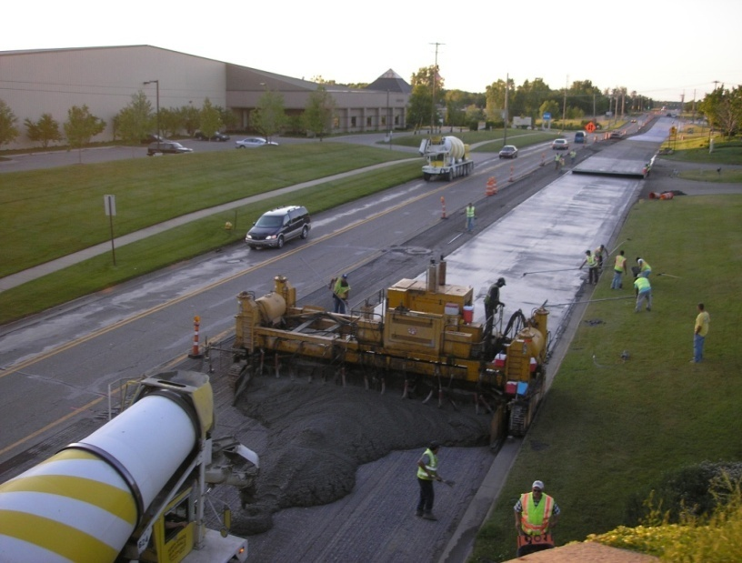
Courtesy: Steven M. Waalkes, 2006
Figure 45: Condition of the original HMA layer at the time of construction.

Table 45: Details of pavement layers at Patterson Avenue, from 44th
Street to 36th Street.
Layers | Thickness (in) | Date of construction | Description of layers
Layer 1 | 4 | 2006 | PCC-UTW
Layer 2 | 1.5 | 1987 | Bituminous mixture No. 1500T, 20AAA, AC10 binder
Layer 3 | 1.5 | N/A | Bituminous mixture No. 1300L, 20AAA, AC5 binder
Layer 4 | 1.75 | N/A | Bituminous mixture No. 12B modified, AC10 binder
Layer 5 | 5.5 |  | Bituminous base Mixture No. 500 modified 20C, AC5 binder
Base | 7 to 8 | 1967 | 22A and 21A aggregate base course originally used as gravel road until 1967
Subbase | 18 | N/A | Probably a Michigan Class II
Subgrade | N/A | N/A | Probably a sandy loam

Overlay design features: The overlay is 4-in thick and the panel size is 4ft x 4ft. Approximately 4 inches of the existing HMA layers were milled before the construction of the whitetopping. In the concrete mixture, 1.5 lb/yd³ of standard, fibrillated polypropylene was used.

Traffic: In 2008, ADT was 31,891 with 17 percent truck traffic and a directional distribution of 50 percent.
Distress data: There are two distressed areas: the intersection at Patterson Avenue and 36th Street and the southbound lanes of Patterson Avenue at Danvers Drive. The intersection at Patterson Avenue and 36th Street was widened in 2006 along with the application of whitetopping. The underlying asphalt edge did not line up properly with the joint between the whitetopping and the full-depth widening. The southbound lanes of Patterson Avenue at Danvers Drive were gapped halfway when the whitetopping was placed. This area coincides with a manhole. There is some distress around the manhole that is indicative of poor support/poor compaction of the base/subbase/asphalt around the structure, as well as de-bonding of the PCC from the asphalt. However, the overall condition of the project is good. A photograph taken in 2008 as shown in Figure 46 presents the condition of the road.

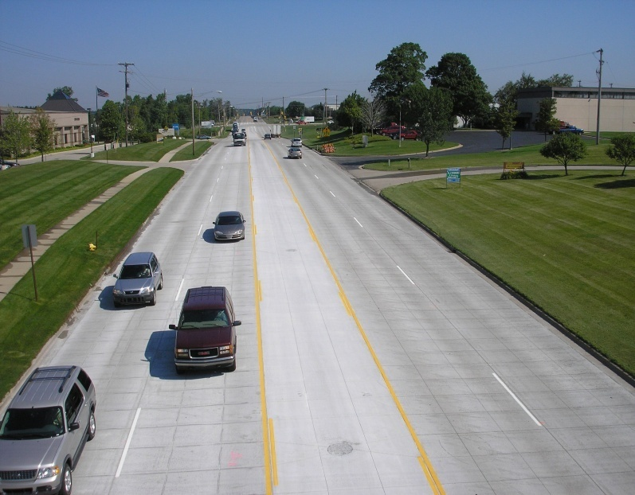
Courtesy: Steven M. Waalkes, 2008
Figure 46: Condition of the UTW after two years (2008).

12.2 Zeeb Road, Ann Arbor, Washtenaw
Only limited information is available about this project. The original HMA pavement was constructed 8 years before the construction of a TWT in 2000. The thickness of the overlay is 6 in with 6-ft x 6–ft panels.

12.3 Schaefer Highway, Detroit, Wayne County
The existing asphalt pavement was in extremely poor condition. The 3-in whitetopping with 4-ft x 4-ft panels was constructed during 1996. Fibers were used in the concrete mixture, but details are not available.

12.4 Conclusion
The performance of the Patterson avenue project is well after three years even with a high traffic volume. Even though the longitudinal joints coincide with wheel path, no information about the corner cracks was received.

13 OKLAHOMA
The Oklahoma chapter of ACPA was contacted for data regarding whitetopping projects in the state of Oklahoma. This section of the report includes three different projects on US-69 in Oklahoma. The first project is located in Atoka County, north of Stringtown. This was newly constructed in 2007 and has experienced no distress. The second project on US-69, north of McAlester is performing excellent even after seven years. The other project is also performing well after 8 years of construction.

13.1 US-69, North of Stringtown, Atoka County
The 47,850-yd² project was constructed in 2007. The existing HMA pavement experienced rutting and fatigue cracking before the construction of whitetopping. The overlay thickness is 5 in with 6-ft x 6-ft and 6-ft x 7-ft joint spacings. The concrete mixture has 564 lb/yd³ cement content with 20 percent fine aggregates. Polypropylene fiber at 3l lb/yd³ was used in the mixture. The required 28-day compressive strength was 3,000 psi. In 2007, the ADT was 12,900 with 30 percent truck traffic. Directional and lane distributions are 50 and 80 percent, respectively. The overlay has yet to experience any distresses.

13.2 US-69, North of McAlester, NB and SB Lanes, Pittsburg County
In the southbound lane, whitetopping was constructed during the fall of 2001 over a 21,500 yd² area. An equivalent area in the northbound lane was rehabilitated with a similar type of whitetopping one year later. The original pavement had already been around for 23 years by the time the whitetopping was constructed. The total thickness of the HMA layers was 12 in. The existing layers had been milled and overlaid with HMA approximately every four years over the last twelve years. The existing HMA pavement experienced severe rutting and shoving before the construction of the whitetopping. The TWT overlay thickness of this project is 6 to 7 in. The inside and outside lanes have 6-ft x 6-ft and 6-ft x 7-ft joint spacings, respectively. Surface preparation was done with cold milling and sweeping of the existing layers. Synthetic Fiber (polypropylene) was added at a dose rate of 3 lb/yd³ in the concrete mixture for both of the approaches. The 3-day compressive strength of the mixture from the northbound was 3,000 psi and for the southbound it was 5,000 psi. In 2007, the ADT was 28,000 with 30 percent truck traffic. Directional and lane distributions were 50 and 80 percent, respectively.

The northbound approach is performing well without any issue but the southbound approach developed a few hairline longitudinal cracks within weeks after construction. These non-working cracks have not spalled over time.

13.3 Conclusion
The US-69 project north of Stringtown is relatively new and no distress data is available. The performance of the other project is excellent considering the fact that the ADT is 28,000 (in 2007) with 30 percent truck traffic.

14 OVERALL CONCLUSIONS
Data has been collected from many projects in the states included in this pooled fund study. Although the data received for some of the projects is incomplete, they are still included in this report with the expectation that in the near future a complete set of data will be available for further analysis. A summary of the projects reviewed is provided in Table 46. The review of the performance data of the existing whitetopping projects has been carried out keeping in mind the objectives of Task 1. The conclusions drawn for each of the questions presented in the objectives of Task 1 is summarized below.

Table 46: Summary of projects evaluated.
State | Roadway | HMA thickness, (in) | Overlay thickness- panel size (in:ftxft) | Bond shear strength (psi) | Observed distress
Virginia | FHWA ALF - Lane 5 | 5.5 | 3.25:4x4 | N/A | Corner and trans. cracks; long. jt. faulting.
Virginia | FHWA ALF - Lane 7 | 5.5 | 3.25:3x3 | N/A | Cracks in the transition zone.
Virginia | FHWA ALF - Lane 8 | 5.5 | 3.25:3x3 | N/A | Corner cracks; long. jt. faulting.
Virginia | FHWA ALF - Lane 9 | 4.5 | 4.5:6x6 | N/A | Corner and long. cracks; long. jt. faulting.
Virginia | FHWA ALF - Lane 11 | 4.5 | 4.5:4x4 | N/A | Corner, trans. and long. cracks.
Virginia | FHWA ALF - Lane 12 | 4.5 | 4.5:4x4 | N/A | Trans. cracks.
Minnesota | I-94 (MnROAD) Cell:92 | 7 | 6:10x12 | N/A | Long. cracks in 26 % of the panels.
Minnesota | I-94 (MnROAD) Cell:93 | 9 | 4:4x4 | N/A | Corner cracks in 10 % of the panels; Trans. cracks in 3 % of the panels; 19 % of trans. cracks are reflective.
Minnesota | I-94 (MnROAD) Cell:94 | 10 | 3:4x4 | N/A | Corner cracks in 56 % of the panels; Trans. cracks in 4 % of the panels; 47% of trans. cracks are reflective.
Minnesota | I-94 (MnROAD) Cell:95 | 10 | 3:5x6 | N/A | Corner cracks in 19 % of the panels; Trans. cracks in 3 % of the panels; 100 % of trans. cracks are reflective.
Minnesota | I-94 (MnROAD) Cell:96 | 7 | 6:5x6 | N/A | Long. cracks in 1 % of the panels.

Table 46: Summary of projects evaluated (continued).
State | Roadway | HMA thickness, (in) | Overlay thickness- panel size (in:ftxft) | Bond shear strength (psi) | Observed distress
Minnesota | I-94 (MnROAD) Cell:97 | 7 | 6:10x12 | N/A | Long. cracks in 21 % of the panels.
Minnesota | I-94 (MnROAD) Cell:60 | 7 | 5:5x6 | N/A | Long. cracks in 2 % of the panels.
Minnesota | I-94 (MnROAD) Cell:61 | 7 | 5:5x6 | N/A | Trans. cracks in 2 % of the panels;  Long. cracks in 5 % of the panels;  100 % of trans. cracks are reflective.
Minnesota | I-94 (MnROAD) Cell:62 | 8 | 4:5x6 | N/A | Trans. cracks in 1 % of the panels;  Long. cracks in 1 % of the panels;  100 % of trans. cracks are reflective.
Minnesota | I-94 (MnROAD) Cell:63 | 8 | 4:5x6 | N/A | Corner cracks in 1 % of the panels;  Trans. cracks in 3 % of the panels;  Long. cracks in 7 % of the panels;  100 % of trans. cracks are reflective.
Minnesota | US-169 (Elk River) Cell:98 | 3 | 3:4x4 | N/A | Corner and trans. cracks.
Minnesota | US-169 (Elk River) Cell:99 | 3 | 3:4x4 | N/A | Corner and trans. cracks.
Minnesota | US-169 (Elk River) Cell:91 | 3 | 3:6x6 | N/A | Corner and trans. cracks.
Minnesota | LoRay Drive at US-14, N. Mankato | 11 to 15 | 4.5 to 6:6x6 | N/A | Significant faulting. Panels are moving.
Minnesota | TH-30 (35 miles southwest of Mankato) TS:3 | 5.25 to 9.75 | 6:12x12 | N/A | Very low faulting; low spalling.
Minnesota | TH-30 (35 miles southwest of Mankato) TS:4 | 5.25 to 9.75 | 6:12x12 | N/A | Trans. jt. spalling.

Table 46: Summary of projects evaluated (continued).
State | Roadway | HMA thickness, (in) | Overlay thickness- panel size (in:ftxft) | Bond shear strength (psi) | Observed distress
Minnesota | TH-30 (35 miles southwest of Mankato) TS:5 | 5.25 to 9.75 | 6:12x12 | N/A | Very low faulting; low spalling.
Minnesota | TH-30 (35 miles southwest of Mankato) TS:6 | 5.25 to 9.75 | 6:12x12 | N/A | Very low faulting; low spalling.
Minnesota | TH-30 (35 miles southwest of Mankato) Control section | 5.25 to 9.75 | 6:12x12 | N/A | Long. cracks, very low faulting.
Pennsylvania | Intersection of SR-133 and  SR-100, Chester County | 10 | 4:4x4 | N/A | N/A
Pennsylvania | SR-30, Lancaster County | 11.5 | 3:3x3 | N/A | N/A
Pennsylvania | SR-8031(Segment 0510) and SR-0022(WB ramp to SR-0083) | 3.5 | 2:3x3 | N/A | N/A
Pennsylvania | SR-30, Uniontown, Fayette County | 8 | 4:4x4 | N/A | 1 corner crack.  Spalling in a few trans. jts.
Texas | Intersections on LP-250 at Wadley Road, Holiday Hill Road and Midland Drive | 4 | 3:3x3 | N/A | Corner and trans. cracks.
Texas | Intersection of LP-250 at Midkiff Road and Garfield Road | 4 | 3:3x3 | N/A | Corner and trans. cracks.
Missouri | Intersection of SR-291 and SR-78, Independence | 3 to 8 | 4:4x4 | Min.: 43  Max.: 137  Ave.: 90  Stan. dev.: 66  n = 2 | 1.7 % of slabs cracked.

Table 46: Summary of projects evaluated (continued).
State | Roadway | HMA thickness, (in) | Overlay thickness- panel size (in:ftxft) | Bond shear strength (psi) | Observed distress
Missouri | US-60, between US-71 and BUS-71, near Neosho | 4.5 | 4:4x4 | Min.: 49  Max.: 158  Ave.: 109  Stan. dev.: 41  n = 9 | Corner and trans. cracks in 2.2 % of the panels.
Missouri | US-169 and SR-YY intersection, St. Joseph | 10 to 11 | 4:3x3 | Min.: 31  Max.: 31  Ave.: 31  Stan. dev.: 0  n = 1 | Corner and trans. cracks in 3 % of the panels.
Missouri | MO-5, railroad crossing, Lebanon | 7 | 4:N/A | Min.: 148  Max.: 148  Ave.: 148  Stan. dev.: 0  n = 1 | No distress
Missouri | BUS-13, Branson West | 7 | 4.4 to 5.9:N/A | Min.: 18  Max.: 415  Ave.: 208  Stan. dev.: 145  n = 5 | No distress
Missouri | Intersection of BUS-13 and MO-14 | 4 | 4.2 to 5.3:N/A | Min.: 18  Max.: 87  Ave.: 59  Stan. dev.: 36  n = 3 | No distress

Table 46: Summary of projects evaluated (continued).
State | Roadway | HMA thickness, (in) | Overlay thickness- panel size (in:ftxft) | Bond shear strength (psi) | Observed distress
Mississippi | Intersection of SR-15 and US-80 | SR-15: 6.25; US-80:7 | 5 to 6:5x6 | N/A | No distress
Mississippi | Intersection of 22nd Avenue and North Frontage Road | SB and NB section of 22nd Avenue:  3.5 and 6;  NE and NW approach of Frontage Road: 6 and 13 | 5 to 6:8,9x6 and 9,10x6 | N/A | Long., trans., diagonal and corner cracks; long. jt. spalling
Mississippi | Intersection of SR-35 and US-80 | N/A | 5 to 6:6x6 | N/A | Long. crack; long. jt. spalling
New York | Intersection of Waldon and Central Avenues, near Buffalo | N/A | 4:4x4 | N/A | Corner cracks along the lane/shld. jt.
New York | NY-408 and SH-622, Rochester | 9.6 | 4:4x4 | N/A | Corner cracks along the lane/shld. jt.
Illinois | IL-146, Anna | N/A | 3:3x3 | N/A | Corner cracks in 13 % of the panels;  Diagonal cracks in 1 % of the panels;  Long. cracks in 3 % of the panels;  Trans. cracks in 3 % of the panels.
Illinois | Intersection of US-36 and Oakland Avenue, Decatur | N/A | 3.5:3.6x4.3 | N/A | Corner and trans. cracks in 19% panels.

Table 46: Summary of projects evaluated (continued).
State | Roadway | HMA thickness, (in) | Overlay thickness- panel size (in:ftxft) | Bond shear strength (psi) | Observed distress
Illinois | Mainline of US-36, near Tuscola | 3 to 4.25 | N/A:5.5x5 | N/A | Corner cracks in 3 % of the panels;  Diagonal cracks in 2 % of the panels; Long. cracks in 1 % of the panels; 1 % of trans. cracks are reflective;  Patching: 1 %.
Illinois | Highway-2, Cumberland County | 3.5 | 5.75:5.5x6 | N/A | Reflection cracks in 1% of panels.
Illinois | Highway-4, Piatt County | 4 | 5:5.5x5.5  and  5:11x11 | N/A | <1 % of slabs cracked in the 5.5-ft x 5.5-ft jt. layout;1 % of slabs cracked in 11-ft x 11-ft jt. layout.
Illinois | US-36 and Country Club Road, Decatur | WB: 2.5 and  EB: 3.5 | 2.5:2.95x3.85 and  3.5:3.85x4.5 | N/A | Cracks in 70 % of panels. 50% cracks developed in the first year.
Iowa | IA-21 from US-6 to IA-212, south of the City of Belle Plaine, Iowa County | 3 | 2:2x2,  4:4x4,  6:6x6,  and  8:12x12 | Min.: N/A  Max.: N/A  Ave.: 128 and 165 for 3and 5 years respectively  St. dev.: N/A  n = N/A | Localized failure.
Michigan | Patterson Avenue, from 44th Street to 36th Street | 4.75 | 4:4x4 | N/A | Localized failure.
Oklahoma | US-69, North of Stringtown, Atoka County | N/A | 5:6x6  and  5:6 x 7 | N/A | No distress.
Oklahoma | US-69, North of McAlester, NB and SB Lanes, McAlester, Pittsburg County | 5 to 6 | 6:6x6  and  7:6x7 | N/A | No distress in N.B. approach; Hairline long. cracks developed within a few weeks after construction in S.B.ound approach.

- What is the minimum required HMA thickness and maximum allowable distress level?
The performance of the thin whitetopping section depends upon the support conditions to a large extent. The performance of the UTW sections (Cells 98, 99 and 91) on US-169 clearly indicates that the minimum thickness of the HMA layer should not be less than 3 in. The whitetopping sections at the MnROAD testing facility were constructed over a sound HMA layer underneath. As a result, these sections did not experience any distresses that usually initiate because of the thinner supporting HMA layer. Reviewing the design features from all the other projects, the HMA layer thickness (after milling) was more than 3 in unless a concrete layer was available underneath. Corner crack development in LP-250 whitetopping sections in Texas within the first year of construction indicates that a thicker (> 4 in) asphalt layer is required if the traffic volume is higher.

The life of a whitetopping overlay is not only dependent on the thickness of the HMA layer but also on the remaining life or severity of the distress of the existing HMA layer. Recall, the performance of the US-169 test sections. The failure of those sections was caused by debonding at the interface of the PCC and HMA layers and between lifts of the HMA layers. It can be concluded that the minimum required thickness of the HMA layer should be decided based on the anticipated traffic, the severity of the existing distresses, the design life of the whitetopping, and temperature variation in the region.

- Are there modes of failure other than corner cracks that frequently develop and what common parameters are present when these additional modes of failure occur?

The review of the performance of the existing TWT and UTW sections provided a better understanding of distress that develop in these types of overlays. The type of distress that develops is primarily a function of the thickness of the PCC, while the extent of the deterioration appears to be related to the thickness and quality of the existing HMA and the joint layout.

Corner cracks are the primary distress of observed in the UTW projects. For example, corner cracks in the US-169 UTW projects (3-in thick PCC), LP-250 UTW projects (3-in thick PCC), Cell 93 to 95 of MnROAD test sections (3- to 4-in thick PCC), FHWA ALF test lanes (3.25- to 4.5- thick PCC), Anna project in Illinois (3- in thick PCC), US-36 and Country Club Road project at Decatur in Illinois (2.5- to 3.5- in thick PCC) all have PCC layer thicknesses less than 4 in and all exhibited corner cracks. Of the 23 overlays that were less than or equal to 4 in, corner cracking was the primary mode of distress for all but two of the projects reporting cracking. These overlays represent joint layouts ranging from 3 ft x 3 ft to 5 ft x 6 ft and HMA thicknesses ranging from 3 in to 11.5 in. The MnROAD cells help to further differentiate between the effects of overlay thickness and joint layout. For example, the overlay was 3 in thick for Cells 94 and 95 and the primary mode of distress for both cells is corner cracking, but Cell 94 exhibited 34 percent more panels with corner cracks. This is the result of the smaller panels (4 ft x 4 ft) found in Cell 94, which locates the longitudinal joint in the wheelpath compared to that in Cell 95 (5 ft x 6 ft). Cell 96 consisted of a 6-in overlay and also had 5 ft x 6 ft panels. This Cell exhibited only longitudinal cracks, again indicating that the type of crack is a function of the overlay thickness.

Many of these sections also exhibited transverse cracks but these cracks were typically either reflection cracks or secondary cracks that developed from corner cracks. See Figure 47. Although, there are instances when transverse cracks developed independently of the presents of other cracks, as shown in Figure 47.

On the other hand, Cells 60, 62, 92, 96 and 97 from MnROAD did not suffer any corner cracks. Transverse cracks and longitudinal cracks are the dominant distress for these cells. This indicates that corner cracking is the common mode of distress only in the case of UTW sections. For TWT sections, transverse cracks and longitudinal cracks are the main concern.

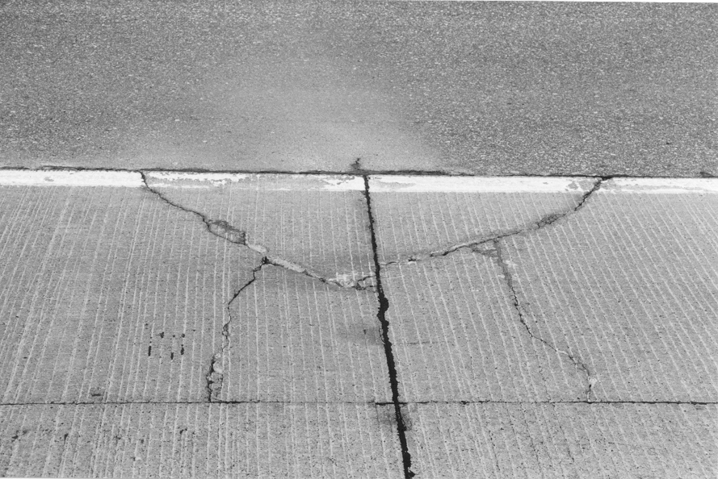
a.) Development from corner cracks. b.) Development independent of other cracking.

Figure 47: Transverse crack development in overlays < 4 in.

Along with corner, transverse and longitudinal cracks, other types of distress observed include reflection cracking, joint faulting, joint spalling, blowups and popouts. It has been shown that dowels will increase the performance of the overlay under interstate traffic levels when an extended service life is desired but they are typically not necessary. The performance of these sections have also shown that joint sealing can help extend the life of the overlay. The sealant helps prevent the infiltration of water, which will penetrate the down to the HMA layer and exacerbate the deterioration of it.

- Under what conditions does reflection cracking typically occur?
The detailed distress data from the Minnesota sections help to provide a better understanding on the development of reflection cracking. If the stiffness ratio of the PCC and HMA layers falls below one, then there is an increase in the potential for an existing crack in the HMA to propagate upwards into the whitetopping overlay. Under this condition, the movement of heavy traffic loads compounds the tensile stress at the bottom of the PCC slab to accelerate the crack propagation.

- What surface preparation techniques have been used and what level of performance was achieved? What is the minimum acceptable level of bond?
A review of the construction of these projects has shown that the surface preparation typically consist of milling a portion of the HMA layer. Typically the depth milled was equivalent to the depth of the overlay. It is widely accepted that milling is the best procedure to ensure the best possible bond between the PCC and HMA layers. The experimental study conducted by Grove et al. (1993) on R-16 and Cable et al. (2001) on IA-21 in Iowa also revealed this. It is difficult to quantify the minimum acceptable level for the shear strength of the bond although it is realized that debonding is the main reason that corner cracks initiate in the UTW sections. The performance of the FHWA ALF sections revealed that even though the bond between the PCC and HMA layer look like intact, corner cracks can still develop. Therefore, it may be concluded that the better the bond, the more resistance there is against corner cracks and this bond must be uniform throughout the bottom of the overlay. A high degree of bonding can be achieved but this is only beneficial when the bond is present throughout the bottom of the overlay.

- What are the acceptable joint patterns?
It appears that joint layout dictates the performance of whitetopping slabs, especially for UTW. Any joint spacing that ensures the longitudinal joints do not coincide with the wheel path is acceptable. Cell 95, which had a slab thickness of 3 in (5-ft x 6-ft panel), exhibited approximately 75 percent less cracks than the 3-in thick Cell 94 (4-ft x 4-ft panel). The dominant percentage of corner cracks in the whitetopping projects of Missouri, which have 4-in thick PCC layers with 4-ft x 4-ft joint layouts, also suggests that this joint configuration should be avoided. Based on the performance of MnROAD Cells 96 (6-in: 5 ft x 6 ft panels) and 97 (6-in: 10 ft x 12 ft panels) it can be stated that the 5 ft x 6 ft panel size is not just the best option for UTW but also TWT.

- Is there evidence from companion test sections that structural fibers help to improve performance beyond providing additional safety once deterioration begins?
It can be assumed that fibers provide additional flexural strength to the slab. The laboratory study conducted by Roesler et al. (2008) suggests that the modulus of rupture of the concrete increases with the introduction of structural fibers. However, the same conclusion could not be drawn in the field due to lack of data from companion projects sites.

- What factors contribute to the development of corner breaks?
Corner breaks occur when the fatigue limit (stress to strength ratio) is exceeded in the concrete. The stress/strength ratio increases with the number of load applications. This is believed to be the result of a change in support conditions, which causes permanent deformation of the support layers (Rasmussen and Rozycki, 2004). The repeated load applications create permanent deformation to the HMA layer beneath the UTW and the voids at the corner of the slabs would result in cantilever action that increases the tensile stress at the top of the concrete surface. Once the fatigue limit is reached, the UTW fails due to corner cracking.

Another reason for corner cracks is the debonding at the concrete and asphalt interface or between lifts of the asphalt layer. Debonding can initiate due to stripping or raveling of the asphalt layer due to moisture infiltration. Debonding of the layers results in an increased tensile stress at the top of the concrete surface; this eventually leads to corner breaks.

- Do fibers help to increase the load transfer efficiency for longer periods of time by keeping the cracks together?
The investigation of the performance of Cell 95, which was constructed with polyolefin fibers, indicated that these types of fibers seem to hold the pieces of concrete in place. However, due to the lack of performance data from other projects, a strong conclusion cannot be drawn. The laboratory study conducted by Roesler et al. (2008) stated that structural fibers are also able to bridge the cracks or increase the post crack performance.

Additional test sections need to be constructed to help quantify the affect of fibers on joint performance. Fibers can assist in keeping the crack widths at the joint narrower for increasing aggregate interlock load transfer potential and limiting water from infiltrating down to the HMA layer. This is an area that needs additional work so that the benefits of the use of structural fibers on the performance of the overlay can be incorporated into the design process.

REFERENCES

AASHTO Guide for Design of Pavement Structures. American Association of State Highway and Transportation Officials, Washington, DC, 1993.

Burnham, T. R. Forensic Investigation Report for MnROAD Ultrathin Whitetopping Test Cells 93, 94 and 95. Report MN/RC-2005-45, Minnesota Department of Transportation, St. Paul, MN, 2005.

Burnham, T. R. MnROAD Lessons learned: Thin and Ultra Thin Concrete Overlay. Minnesota Department of Transportation, St. Paul, MN, 2006. http://www.mrr.dot.state.mn.us/ research/lessons/whitetopping.pdf. Accessed January 2009.

Burnham, T. R. Construction Report for MnROAD Thin Whitetopping Test Cells 60-63. Report MN/RC -2006-18, Minnesota Department of Transportation, St. Paul, MN, 2006.

Cable, J. K., J. M. Hart, and T. J. Ciha. Thin Bonded Overlay Evaluation. Iowa DOT, Project HR-559, Iowa Department of Transportation, Ames, IA, March 2001.

Grove, J. D., G. K. Harris, B. J. Skinner. Bond Contribution to Whitetopping Performance on Low- Volume Roads. Transportation Research Record: Journal of the Transportation Research Board, No. 1382, Transportation Research Board of the National Academics, Washington, DC, 1993, pp. 104-110.

Pavement Policy Manual. Publication 242-September, 2007 Edition. Commonwealth of Pennsylvania Department of Transportation Bureau of Maintenance and Operations, Harrisburg, PA, September, 2007. ftp://ftp.dot.state.pa.us/public/PubsForms/Publications /PUB%20242.pdf. Accessed February 2009.

Rasmussen, A. O., B. F. McCullough, J. M. Ruiz, J. Mack and J. A. Sherwood. Identification of Pavement Failure Mechanisms at FHWA Accelerated Loading Facility Ultrathin Whitetopping Project. Transportation Research Record: Journal of the Transportation Research Board, No. 1816, Transportation Research Board of the National Academics, Washington, DC, 2002, pp. 148-155.

Rasmussen, R.O. and D.K. Rozycki. Thin and Untra-Thin Whitetopping. NCHRP Synthesis of Highway Practice 338, National Cooperative Highway Research Program, National Research Council, Washington, DC, 2004.

R&T update, Concrete Pavement Research and Technology. UTW Scores a Million. Number 4.06, American Concrete Pavement Association, Skokie, IL, June, 2003. http://www.acpa.org/Downloads/RT/RT4.06.pdf. Accessed February 2009.

Roesler, J., A. Bordelon, A. Ioannides, M. Beyer, and D. Wang. Design and Concrete Material Requirements for Ultra-Thin Whitetopping. Publication FHWA-ICT-08-016. Illinois Center for Transportation, IL, June 2008.

Snyder, M. B. Lessons Learned from MnROAD (1992-2006). Final Report prepared for American Concrete Pavement Association, Skokie, IL, October 2008.

Tarr, S. M., M. J. Sheehan, and P. A. Okamoto. Guidelines for the Thickness Design of Bonded Whitetopping Pavement in the State of Colorado. Report No. CDOTDTD- R-98-10, Colorado. Department of Transportation, Denver, CO, December 1998.

Vandenbossche, J. M. The Measured Response of Ultrathin and Thin Whitetopping to Environmental Loads. Presented at 7th International Conference on Concrete Pavements, Orlando, FL, September 2001.

Vandenbossche, J. M. Performance Analysis of Ultrathin Whitetopping Intersections on US-169, Elk River, Minnesota. Transportation Research Record: Journal of the Transportation Research Board, No. 1853, Transportation Research Board of the National Academics, Washington, DC, 2003, pp. 18-27.

Vandenbossche, J.M. Best Practices for the Design and Repair of Thin and Ultrathin Whitetopping Based on MnROAD Findings. Proceeding of the International Conference on Best Practices for Ultra Thin and Thin Whitetoppings”, Federal Highway Administration, Washington, DC, 2005, pp 242-261.

Vandenbossche, J. M. and A. J. Fagerness. Performance, Analysis, and Repair of Ultrathin and Thin Whitetopping at Minnesota Road Research Facility. Transportation Research Record: Journal of Transportation Research Board, No. 1809, Transportation Research Board of the National Academics, Washington, DC, 2002, pp. 191-198.

Vandenbossche, J. M., and D. L. Rettner. The Construction of US-169 and I-94 Experimental Whitetopping Test Sections in Minnesota. Minnesota Department of Transportation, St. Paul, MN, April 1998.

Vandenbossche, J. M. and D. L. Rettner. One-Year Performance Summary of Whitetopping Test Sections at the MnROAD Test Facility. Presented at Accelerated Pavement Testing International Conference, Reno, NV, 1999.

Whitetopping—State of the Practice, ACPA Publication EB210P, American Concrete Pavement Association, Skokie, IL, 1998.

Wu, C.L., S.M. Tarr, T.M. Refai, M.A. Nagai, and M.J. Sheehan. Development of Ultra-Thin Whitetopping Design Procedure. Report RD 2124. Portland Cement Association, Skokie, IL, 1998.

