RDO & MPO Contact Information
The Metropolitan Planning Organizations (MPO) and Regional Development Organizations (RDO) are key partners in the TA solicitation process being responsible for reviewing projects to determine success in the TA program. Any local community applicant who has questions about the application process and is interested in submitting a proposal are encouraged to connect with an RDO or MPO. Contact information may be found on the following pages where project specific questions, eligibility requirements and scoring criteria may be directed.
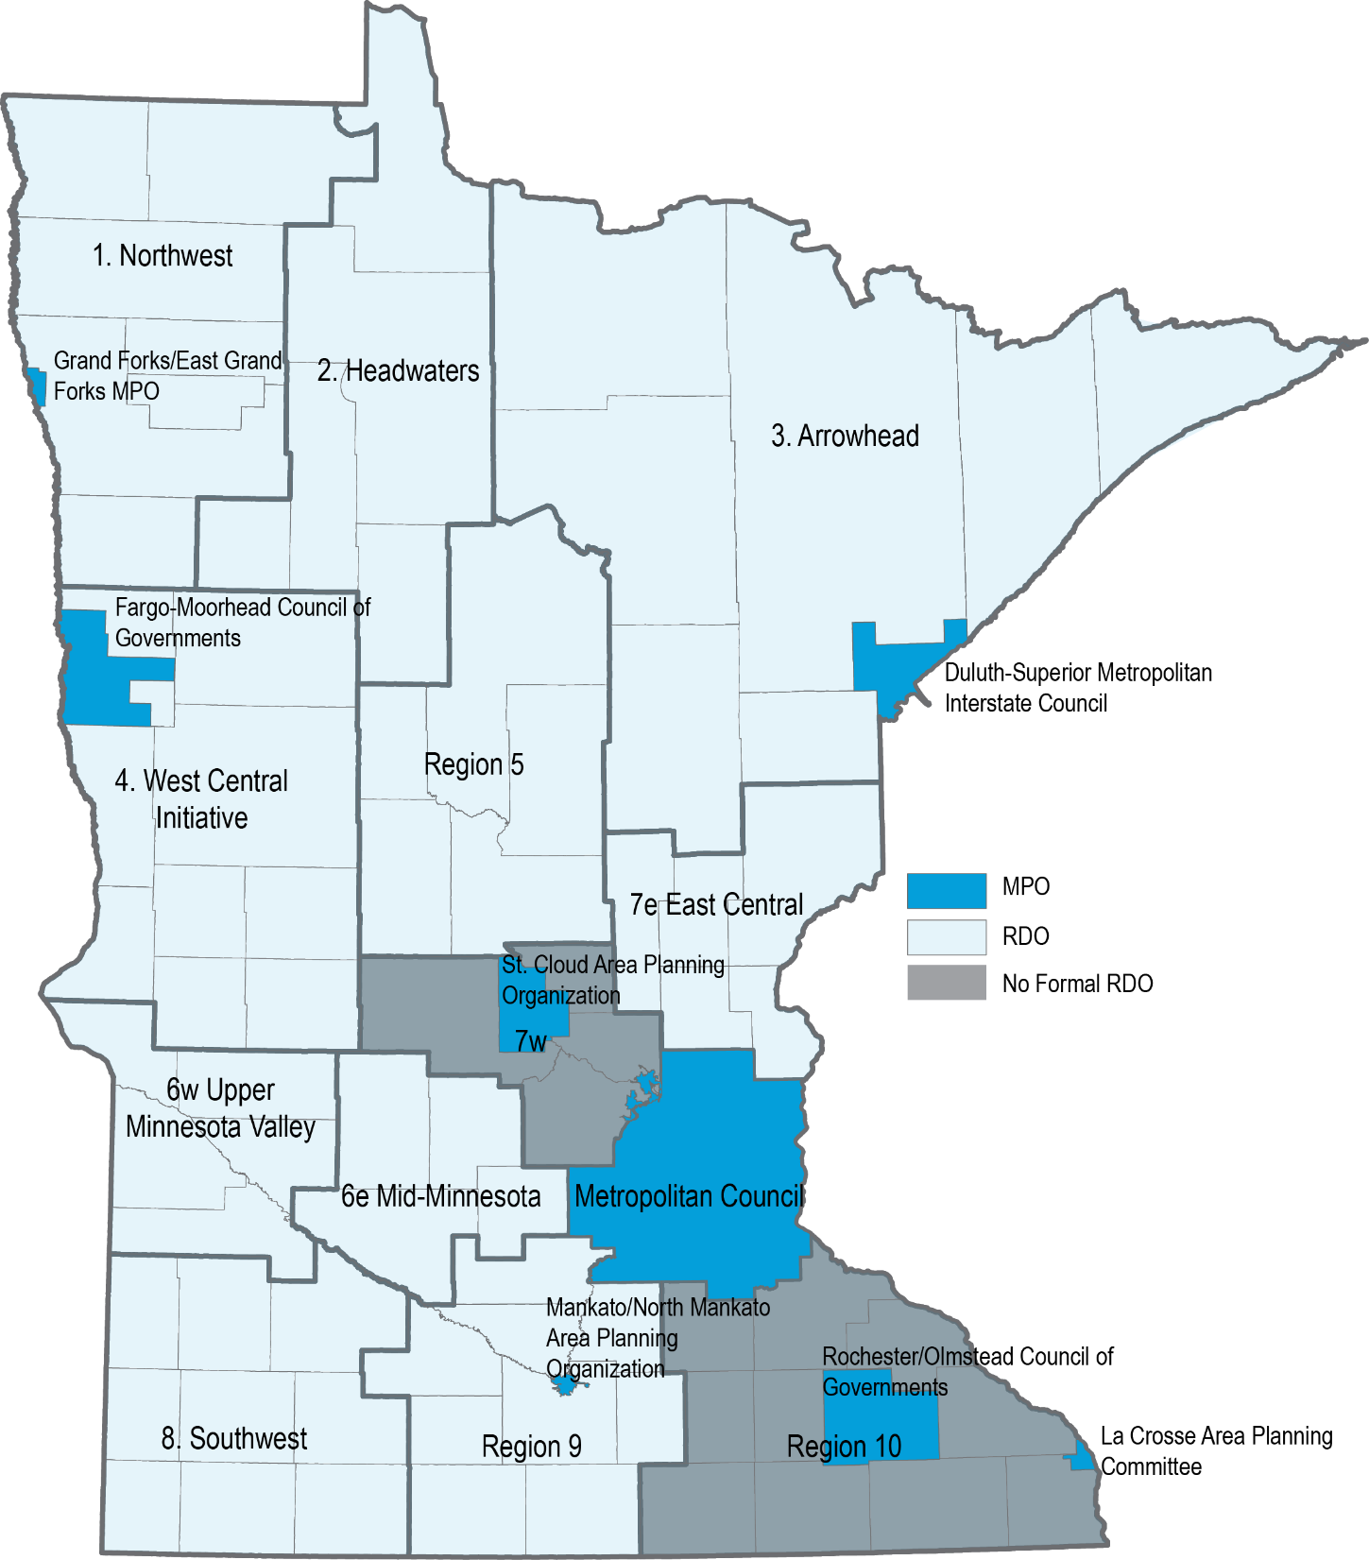

Regional Development Organization Contact Information
Region | Organization name | Counties served | Address & phone | Website
1 | Northwest Regional Development Commission | Kittson, Marshall, Norman, Pennington, Polk, Red Lake, Roseau | 109 S Minnesota St Warren, MN 56762  218-745-9107 | www.nwrdc.org
2 | Headwaters Regional Development Commission | Beltrami, Clearwater, Hubbard, Lake of the Woods, Mahnomen | 403 4th St NW  PO Box 906  Bemidji, MN 56601  218-444-4732 | www.hrdc.org
3 | Arrowhead Regional Development Commission | Aitkin, Carlton, Cook, Itasca, Koochiching, Lake, St. Louis | 221 West 1st St  Duluth, MN 55802  218-722-5545 | www.ardc.org
4 | West Central Initiative | Becker, Clay, Douglas, Grant, Otter Tail, Pope, Stevens, Traverse, Wilkin | 1000 Western Ave  PO Box 318  Fergus Falls, MN 56538  218-739-2239 | www.wcif.org
5 | Region 5 Development Commission | Cass, Crow Wing, Morrison, Todd, Wadena | 200 1st Street NE  Suite 2  Staples, MN 56479  218-894-3233 | www.regionfive.org
6e | Mid-Minnesota Development Commission | Kandiyohi, McLeod, Meeker, Renville | 333 SW 6th St  Suite 2  Willmar, MN 56201  320-235-8504 | www.mmrdc.org
6w | Upper Minnesota Valley Regional Development Commission | Big Stone, Chippewa, Lac qui Parle, Swift, Yellow Medicine | 323 W Schlieman Ave  Appleton, MN 56208  320-289-1981 | www.umvrdc.org
7e | East Central Regional Development Commission | Chisago, Isanti, Kanabec, Mille Lacs, Pine | 100 S Park St  Mora, MN 55051  320-679-4065 | http://www.ecrdc.org/
7W | Administered by MnDOT District 3 | Benton, Sherburne, Stearns and Wright | 7694 Industrial Park Road  Baxter, MN 56425  218-828-5700 | www.dot.state.mn.us/d3/atp
8 | Southwest Regional Development Commission | Cottonwood, Jackson, Lincoln, Lyon, Murray, Nobles, Pipestone, Redwood, Rock | 2401 Broadway Ave  Suite 1  Slayton, MN 56172  507-836-8547 | www.swrdc.org
9 | Region 9 Development Commission | Blue Earth, Brown, Faribault, Le Sueur, Martin, Nicollet, Sibley, Waseca, Watonwan | 3 Civic Center Plaza Suite 310 Mankato, MN 56001  507-387-5643 | www.rndc.org
10 | Administered by MnDOT District 6 | Rice, Goodhue, Wabasha, Steele, Dodge, Olmsted, Winona, Freeborn, Mower, Fillmore, Houston | 2900 48th Street NW  Rochester, MN 55901  507-286-7500 | www.dot.state.mn.us/d6/atp

Metropolitan Planning Organization Contact Information
Organization name | Address & phone | Website
Rochester-Olmstead Council of Governments | 2122 Campus Drive SE  Suite 100  Rochester, MN 55904  507-328-7100 | www.co.olmsted.mn.us
Mankato-North Mankato Area Planning Organization | 10 Civic Center Plaza  Mankato, MN 56001  507-387-8613 | www.mnmapo.org
St. Cloud Area Planning Organization | 1040 County Road 4  St. Cloud, MN 56303  320-252-7568 | www.stcloudapo.org
Fargo-Moorhead Metropolitan Council of Governments | 1 2nd Street N  Suite 232  Fargo, ND 58102  701-232-3242 | www.fmmetrocog.org
Duluth-Superior Metropolitan Interstate Council | 221 W 1st Street  Duluth MN  218-529-7509 | www.dsmic.org
La Crosse Area Planning Committee | 212 6th Street N  Room 1200  La Crosse, WI 54601  608-785-5977 | www.lapc.org
Grand Forks-East Grand Forks Metropolitan Planning Organization | 255 N 4th Street  Grand Forks, ND 58206  701-746-2660 | www.theforksmpo.org
Twin Cities Metropolitan Council | 390 Robert Street N  St. Paul, MN 55101  651-602-1000 | www.metrocouncil.org

ATP Contact Information
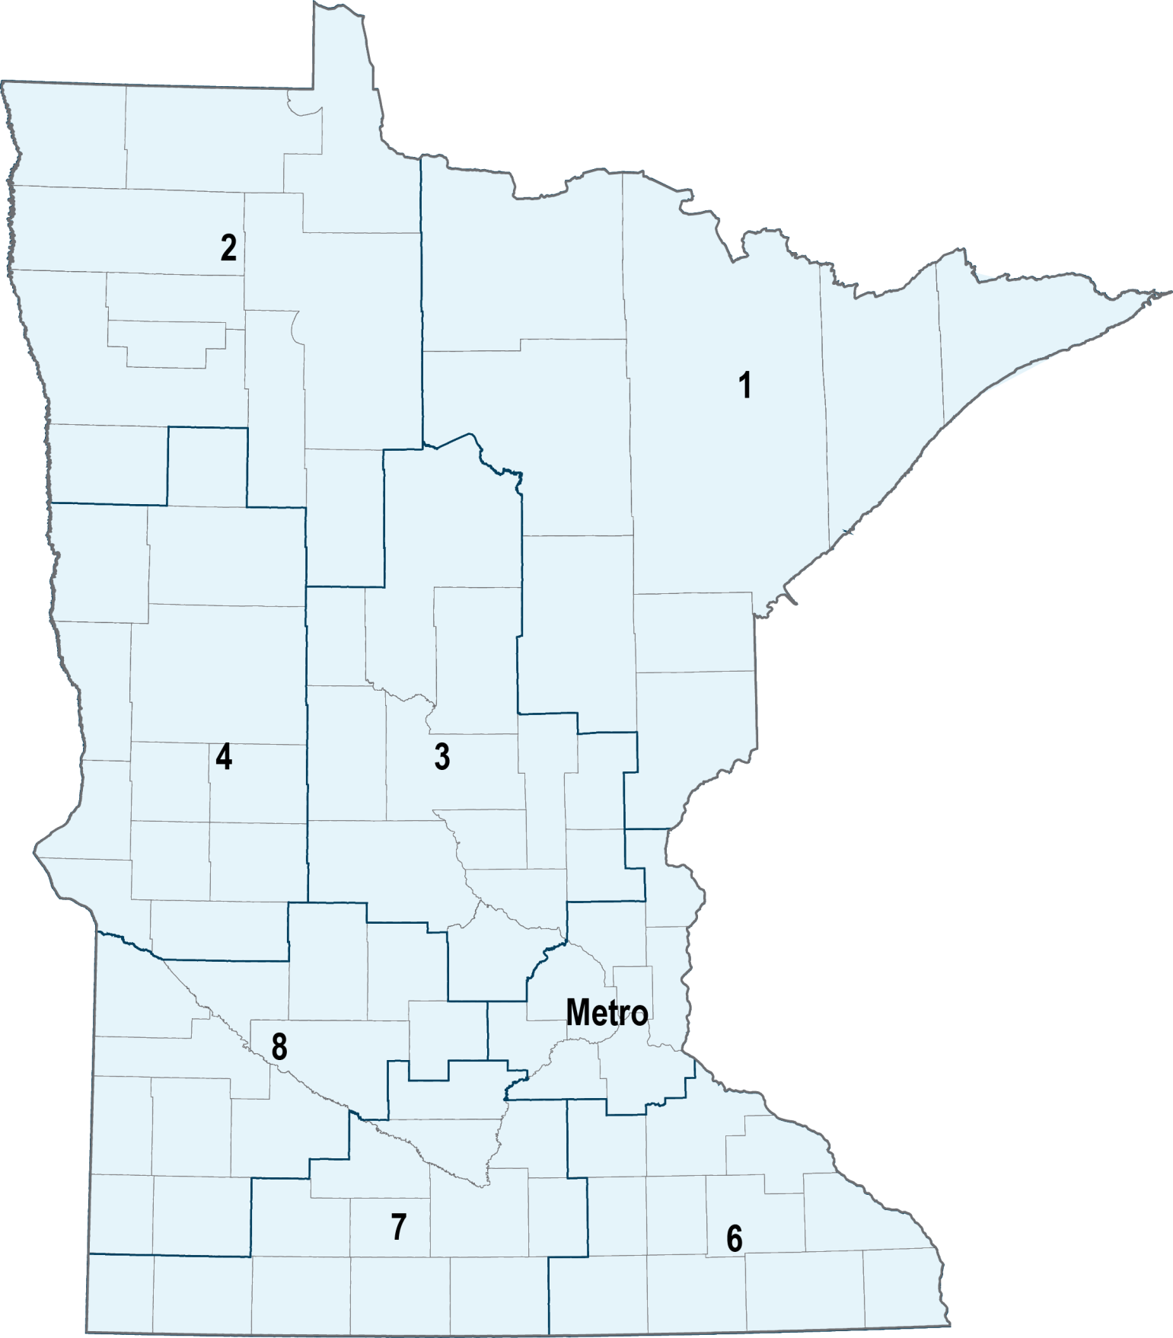

Area Transportation Partnership Contact Information
ATP | Counties served | Address & phone | Website
1 | Aitkin, Carlton, Cook, Itasca, Koochiching, Lake, Pine, St. Louis | 221 West 1st St  Duluth, MN 55802  218-722-5545 | www.nemnatp.org
2 | Beltrami, Clearwater, Hubbard, Kittson, Lake of the Woods, Marshall, Norman, Pennington, Polk, Red Lake, Roseau | MnDOT District 2  3920 Highway 2 West  Bemidji, MN 56601  218-755-6500 | www.dot.state.mn.us/d2/atp
3 | Benton, Cass, Crow Wing, Isanti, Kanabec, Mille Lacs, Morrison, Sherburne, Stearns, Todd, Wadena, Wright | MnDOT District 3  7694 Industrial Park Road  Baxter, MN 56425  218-828-5700 | www.dot.state.mn.us/d3/atp
4 | Becker, Big Stone, Clay, Douglas, Grant, Mahnomen, Otter Tail, Pope, Stevens, Swift, Traverse, Wilkin | MnDOT District 4  1000 Highway 10 West  Detroit Lakes, MN 56501  218-846-3600 | www.dot.state.mn.us/d4/atp
Metro | Anoka, Carver, Chisago, Dakota, Hennepin, Ramsey, Scott, Washington | MnDOT Metro District  1500 West Co Rd B-2  Roseville, MN 55113  651-234-7500 | www.dot.state.mn.us/metro
6 | Dodge, Fillmore, Freeborn, Goodhue, Houston, Mower, Olmsted, Rice, Steele, Wabasha, Winona | MnDOT District 6  2900 48th Street NW  Rochester, MN 55901  507-286-7500 | www.dot.state.mn.us/d6/atp
7 | Blue Earth, Brown, Cottonwood, Faribault, Jackson, LeSueur, Martin, Nicollet, Nobles, Rock, Sibley, Waseca, Watonwan | MnDOT District 7  2151 Bassett Drive  Mankato, MN 56001  507-304-6100 | www.dot.state.mn.us/d7/atp
8 | Chippewa, Kandiyohi, Lac qui Parle, Lincoln, Lyon, McLeod, Meeker, Murray, Pipestone, Redwood, Renville, Yellow Medicine | MnDOT District 8  2505 Transportation Road  Willmar, MN 56201  320-231-5195 | www.dot.state.mn.us/d8/atp
Note: Chisago County submits a Greater Minnesota TA application because it is not part of the seven-county Twin Cities metropolitan area, even though it is part of the Metro ATP. Chisago county TA applications are reviewed and scored by the East Central Regional Development Commission before they are forwarded to the Metro ATP integration committee.

Other Key Contacts

Statewide Transportation Alternatives Contact Information
Name | Role | Address & Phone | Email
Noah Hansen | MnDOT Capital Programs Coordinator | 395 John Ireland Blvd  MS 440  St. Paul, MN 55155  651-366-3742 | Noah.Hansen@state.mn.us

Safe Routes to School, Scenic Byway & Recreational Trails Program Coordinator Contact Information
Name | Role | Address & Phone | Email
Kelly Corbin | MnDOT Safe Routes to School Non-Infrastructure Coordinator | 395 John Ireland Blvd  MS 315  St. Paul, MN 55155  507-286-7590 | Kelly.Corbin@state.mn.us
Steve Prusak | MnDOT Safe Routes to School Engineering Coordinator | 395 John Ireland Blvd  MS 500  St. Paul, MN 55155  651-366-3827 | Steven.Prusak@state.mn.us
Carol Zoff | Interim MnDOT Scenic Byway Coordinator | 395 John Ireland Blvd  MS 620  St. Paul, MN 55155  612-449-0754 | Carol.Zoff@state.mn.us
Dan Golner | MnDNR Recreational Trails Coordinator | 500 Lafayette Road  Box 39  Saint Paul, MN 55155  651-259-5599 | Daniel.Golner@state.mn.us

